# Superhard ceramic material from B4C and TiSi2 powders

## A. Ivanushko1, R. Gladyshevskii1

### 1Department of Inorganic Chemistry, Ivan Franko National University of Lviv, Kyryla i Mefodiya St. 6, 79005 Lviv, Ukraine

### [andriana.ivanushko@lnu.edu.ua](mailto:andriana.ivanushko@lnu.edu.ua)

Ceramic composites based on boron carbide are promising materials for use in the defense industry due to their extremely high hardness, low density, and thermal stability. The introduction of additional components into the ceramic may further improve its mechanical properties. Such modified materials are well-suited for application in modern armor protection systems, impact-resistant elements, and structures capable of withstanding ultra-high loads.

The ceramic material studied here was synthesized from high-purity B4C and TiSi2 powders by spark plasma sintering at a maximum temperature of 1900°C and a pressure of 70 GPa in argon atmosphere. The initial content of TiSi2 in the powder mixture B4C+TiSi2 was 30 wt.%. X-ray powder diffraction patterns collected from the surface of the synthesized pellet, showed four phases: B4C, TiB2, SiC, and Si. Results of the refinement of the crystal structures are shown in Table 1. The crystal structure of B4C synthesized by spark plasma sintering is reported in [1].

The initial powders for the synthesis and the ceramic material were analyzed by scanning electron microscopy. The grain size was evaluated using ImageJ software. The average size of the B4C grains before sintering was 1.2 μm, TiSi2 – 1.8 μm; after sintering TiB2 – 11.2 μm. A SEM-image of the B4C+TiSi2 ceramic material and the TiB2 grain distribution in the B4C+TiSi2 ceramic material are shown in Fig. 1.

By optimizing the synthesis conditions, it was possible to achieve a relative density of 99.5 % and a hardness (measured using the Vickers method) of 43.9 GPa.

###### **Table 1**. Results of the refinement of the crystal structure of the ceramic material (*R*p = 6.01 %, *R*wp = 7.65 %).

|  |  |  |  |  |
| --- | --- | --- | --- | --- |
| Phase | B13.174(11)C1.65(3) | TiB2 | SiC | Si |
| Structure type | B13C2 | AlB2 | ZnS | C |
| Pearson symbol | *hR*51 | *hP*3 | *cF*8 | *cF*8 |
| Space group | *R*-3*m* | *P*6/*mmm* | *F*-43m | *Fd*-3*m* |
| Cell parameters, Å | *a*= 5.6159(6),  *c*= 12.156(2) | *a*= 3.03358(13),  *c*= 3.22856(15) | *a* = 4.3552(3) | *a* = 5.419(2) |
| Cell volume *V*, Å3 | 332.01(7) | 25.731(2) | 82.611(8) | 159.11(11) |
| Formula units per cell *Z* | 3 | 1 | 4 | 8 |
| Density *D*X, g⋅cm-3 | 2.441 | 4.487 | 3.224 | 2.345 |
| Mass fraction, % | 75(3) | 14.7(4) | 9.5(4) | 0.53(6) |
| Reliability factor *R*B, % | 10.8 | 4.01 | 2.87 | 11.8 |

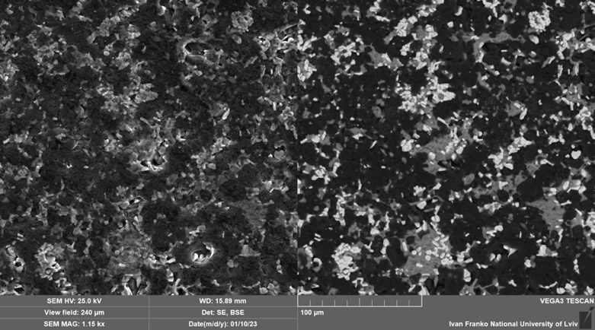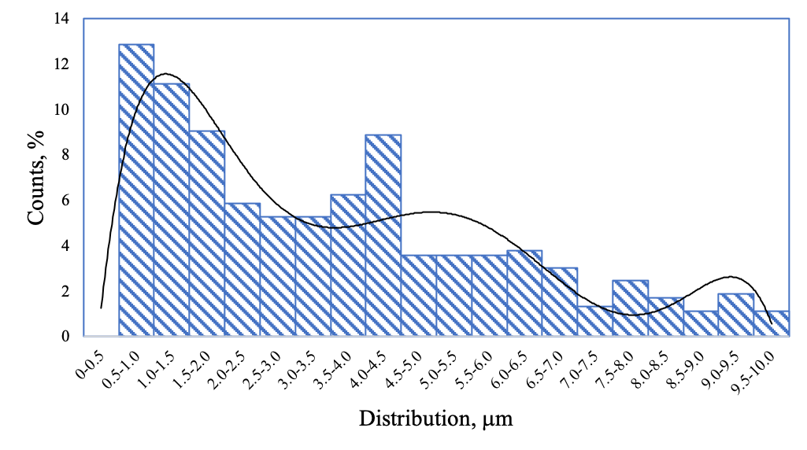

a

b

###### **Figure 1**. (a) SEM-image (left – SE, right – BSE) for the B4C+TiSi2 ceramic material and (b) TiB2 grain distribution.

#### [1] Ivanushko A. & Gladyshevskii R. (2024) *Visn. Lviv Univ., Ser. Khim.* **65**, 102.