## Charge Density Analysis of Halogen Bonding with Heavy Pnictogen Acceptors: Experimental and Computational Insights

### **L. Kumar,1 S.G. Dash,1 K. Rachuy,2 R. Herbst-Irmer,2 D. Stalke,2 M. Arhangelskis1**

### 1Faculty of Chemistry, University of Warsaw, Warsaw, 2Institute of Inorganic Chemistry, Göttingen, Germany

### l.kumar@uw.edu.pl

### Halogen bonds (XBs) are non-covalent interactions involving a region of positive electrostatic potential — the σ-hole — on a halogen atom. This σ-hole interacts with nucleophilic acceptors, enabling the formation of multicomponent solids such as cocrystals. In this context, the interactions of heavier halogens like iodine with heavy pnictogen acceptors (e.g., P, As, Sb) are particularly interesting. [1,2]

### This study primarily employs high-resolution single-crystal X-ray diffraction (SC-XRD) combined with Hansen-Coppens multipole refinement to analyse the electron density distribution in halogen-bonded cocrystals containing heavy pnictogen acceptors. Through Quantum Theory of Atoms in Molecules (QTAIM), the charge density at bond critical points (BCPs) is evaluated, offering direct experimental insight into the nature and strength of halogen bonds. [3]

### In particular, BCP properties such as electron density (ρ at BCP) and its Laplacian (∇²ρ) are extracted from the experimental charge density to characterize and compare halogen bonding interactions involving P, As, and Sb. The observed electronic topological features help to interpret interaction strength and directionality, revealing trends across different pnictogen acceptors.

### To complement these findings, periodic density-functional theory (DFT) calculations were performed using various functionals and dispersion corrections. These calculations provide interaction energies and theoretical BCP properties that can be directly compared with experimental data, enabling the assessment of each functional’s accuracy in describing halogen bonding, particularly for systems containing heavy acceptor atoms.

### Importantly, this experiment-driven approach ensures that theoretical predictions are validated against observed electron density features. Such a framework is crucial, as DFT results can vary significantly depending on the chosen functional — especially in systems involving heavy elements. [4,5] By anchoring the analysis in experimental measurements, this work offers a robust methodology for evaluating halogen bonds and identifying reliable theoretical approaches for future studies.

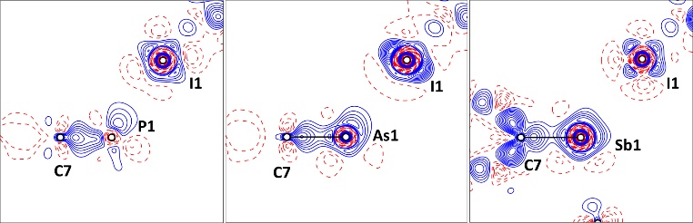

Figure1: Experimental static deformation density map representing the lone pairs on pnictogen atoms in the direction of electron depleted region of iodine

References:

[1] Xu, Y., Huang, J., Gabidullin, B. & Bryce, D. L. (2018). Chem. Commun. 54, 11041–11043.

[2] Lisac, K., Topić, F., Arhangelskis, M., Cepić, S., Julien, P. A., Nickels, C. W., Morris, A. J., Friščić, T. & Cinčić, D. (2019). Nat. Commun. 10, 61.

[3] Bader, R. F. W. (1991). Chem. Rev. 91, 893–928.

[4] Kumar, L., Leko, K., Nemec, V., Trzybiński, D., Bregović, N., Cinčić, D. & Arhangelskis, M. (2023). Chem. Sci. 14, 3140–3146.

[5] Kumar, L., Dash, S. G., Leko, K., Trzybiński, D., Bregović, N., Cinčić, D. & Arhangelskis, M. (2023). Phys. Chem. Chem. Phys. 25, 28576–28580.