**Multi stimuli responsiveness in pyrene-based purely organic dyad crystals**

# **Argha Barman1, Agniezska Huć2, Simone Techert1, Krishnayan Basuroy1**

*1Photon Science - Structural Dynamics in Chemical Systems, Deutsches Elektronen-Synchrotron DESY, Hamburg, 22607, Germany*

*2University of Warsaw, Poland*

*Email id:argha.barman@desy.de*

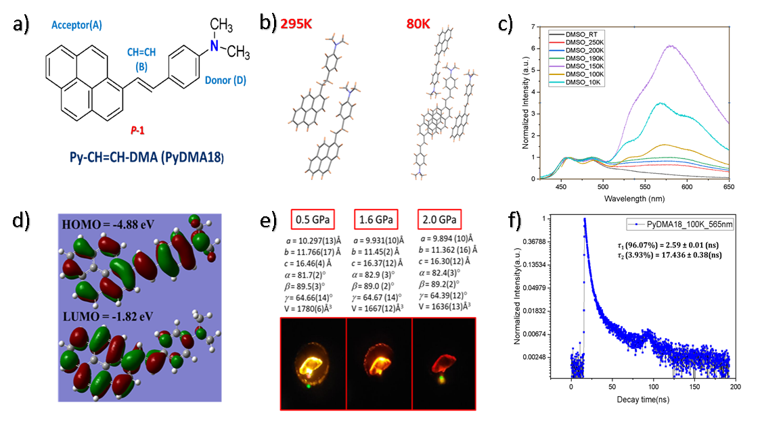Controlling different external stimuli to tune the photophysical properties of purely organic molecular crystals toward designing multifunctional materials remains challenging. Over the years, pyrene-based fluorophores, owing to their high charge carrier mobility and high fluorescence quantum yield, have come up as an attractive choice for researchers while designing luminescent molecular crystals with intramolecular charge transfer (ICT) character. Another interesting aspect of pyrene-based fluorophores is their complex photoelectronic characteristics in the excited state.[1]Therefore, it is only appropriate to explore pyrene-based molecules while getting into the complex task of designing a luminescent molecular crystal that shows highly responsive and tunable excited-state properties under the influence of different external stimuli such as pressure, temperature, or light. In that regard, here, we report the design and photophysical properties of a D-B-A (donor-bridge-acceptor)dyad composed of electron-rich N, N’-dimethylaniline (DMA) as the electron donor and pyrene (Py) as the acceptor, linked via a -CH=CH- chain. The molecule crystallizes in the triclinic space group *P*-1 with four symmetry-independent molecules in the asymmetric unit at 100K, undergoing a reversible structural phase transition at higher temperatures ranging from 180 K to 210 K, where the unit cell volume reduces by half and the number of molecules in the unit cell decreases to two. Structural differences between the molecules, including pyramidalization at the tertiary nitrogen atom and variations in bond lengths, were observed during this transition. Notably, strong π-π stacking interactions were present at all temperatures. TDDFT calculations revealed a smaller HOMO-LUMO gap (3.06 eV) compared to other Py-bridge-DMA systems.[1]Temperature-dependent emission spectra collected at the P66 beamline in PETRAIII show dual fluorescence originating from locally excited (LE) and intramolecular charge transfer/excimer (ICT) states/singlet fission. Additionally, under hydrostatic pressure (0.5–2.0 GPa) using a diamond anvil cell (DAC), the crystals exhibited piezochromic behavior, characterized by a redshift of the emission band.[2] These findings demonstrate the potential of Py-CH=CH-DMA crystals as multifunctional materials responsive to temperature, pressure, and light stimuli, offering insights into the design of tunable luminescent molecular crystals for applications in optoelectronics and pressure sensors.

Figure 1: a)Chemical diagram and b)molecular conformations of Py−CH=CH−DMA with 2 and 4 molecules in the crystallographic asymmetric unit at 295K and 80K, respectively. c ) Emission spectra of Py−CH=CH−DMA crystals at different temperatures while exciting with 277nm radiation. . d) TDDFT calculation provided the HOMO and LUMO for a Py−CH=CH−DMA molecule .e) Unit cell dimensions at different hydrostatic pressure points and the corresponding images of the crystal under the irradiation of green light (545nm).f)Decay profile of Py−CH=CH−DMA at 100K with a lifetime of the excited state species of 2.59 ns and 17.44 ns respectively.

**References:**

[1] K. Basuroy,* J. Velazquez-Garcia, D. Storozhuk, R. Henning, D. J. Gosztola, S. Thekku Veedu, S. Techert*. J. Chem. Phys. 158, 054304. (2023).

[2] Y. Sagara, T. Mutai, I. Yoshikawa, K. Araki*. J. Am. Chem. Soc. 129, 1520–1521 (2007).