Study of structural changes induced by light soaking in mixed-halide perovskites

M. Dopita¹, V. Holý¹, L. Horák¹, P. Machovec¹, J. Holovský², N. Neykova²

¹Department of Condensed Matter Physics, Faculty of Mathematics and Physics, Charles University, Prague, Ke Karlovu 2026/5, 121 16 Prgue 2, Czech Republic, ²Centre for Advanced Photovoltaics, Faculty of Electrical Engineering, Czech Technical University in Prague, Technická 2, 16627 Prague, Czech Republic

milan.dopita@matfyz.cuni.cz
The organometal mixed-halide perovskites ABX₃, where typically A stands for cation like organic MA⁺ = CH₃NH₃⁺, FA⁺ = CH(NH₂)₂⁺ and/or inorganic Cs⁺, B stands for Pb₂⁺ and/or Sn₂⁺, and X stands for halide anion I⁻, Br⁻ and/or Cl⁻, are for their inexpensive manufacturing and very favorable optoelectronic properties materials, well-suited for multi-junction solar cells. Unfortunately, mixed-halide perovskites suffer from a partial de-mixing (phase segregation) during light soaking called the Hoke effect. This operational instability has an unpleasant influence on their absorption spectrum and further optoelectronic properties. Despite intense research, there is still no clear consensus on the origin of the halide ions migration and the forces acting against a concentration gradient. To manufacture reliable long-term operating devices, it is crucial to understand and fully eliminate this effect.
In our contribution we used the combination of in operando and in situ X-ray scattering techniques, to link the evolution of the phase composition, internal strain propagation, and domain morphology to photoelectrical properties, mainly the energetic positions of PL peaks, absorptance measured by photothermal deflection spectroscopy, the concentration of deep defects accessed by FTPS, carrier lifetime extracted from PL spectroscopy and device operation through J-V measurements. The internal strain-field originating from halide-composition inhomogeneity and the halide migration was modelled by kinetic simulations. The model based on numerical solution of phenomenological Cahn-Hilliard formalism was developed and the results of numerical simulation were compared with experimental results obtained from X-ray scattering and optoelectronic measurements. In Fig. 1 the integrated intensity of the 220 diffraction maximum of FA_{0.83}Cs_{0.17}Pb(I_{0.85}Br_{0.15})₃ of single-crystalline sample before, during, after and long after the light illumination is shown. After illumination, the sample begins to relax; however, this relaxation is incomplete, as the diffraction maximum remains broader even after an extended relaxation period. When the cycle of illumination and relaxation is repeated multiple times - effectively increasing the total illumination time, broadening in the direction of lower Q also becomes apparent. The broadening toward higher Q suggests the creation of regions or domains with smaller lattice parameters, which correlates with an increased Br concentration. These observations highlight the complex interplay between illumination, compositional changes, and structural relaxation within the sample.
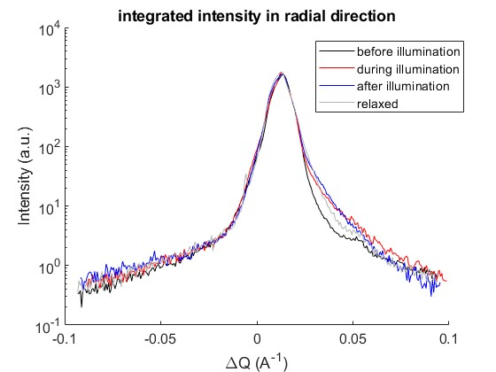

Figure 1. Intensity of the 220 diffraction maximum of FA_{0.83}Cs_{0.17}Pb(I_{0.85}Br_{0.15})₃ before, during, after and long after the light illumination.

The authors acknowledge the support by the Czech Science Foundation GACR, grant no. 23-06543S. XRD experiments were performed in MGML (mgml.eu), which is supported within the program of Czech Research Infrastructures (project no. LM2023065).

