**SIZE DEPENDANCE OF THE PHOTO-INDUCED PHASE TRANSITION IN Ti3O5 NANOCRYSTALS**

**R. Mandal1,2, C. Mariette3, M. Lorenc2**

*1Institut des Matériaux de Nantes Jean Rouxel, 44322 Nantes, France*

*2Institut de Physique de Rennes, 35700 Rennes, France*

*3European Synchrotron Radiation Facility, 38000 Grenoble, France*

Recent studies have explored the possibility of driving ultrafast phase transitions by laser pulses in materials that undergo significant volume change during transition at thermodynamic equilibrium [1, 2]. Such a phase transition driven by laser excitation can be studied in Ti3O5, a material that exhibits exceptional functionalities in data [3] and heat storage [6]. In this work, we have studied the *β-* to *λ-*phase transition in Ti3O5 nanocrystalline pellets using time-resolved X-ray diffraction. We used near grazing angle incidence and investigated the role of external stimuli (laser wavelength and fluence) and sample dependent parameters (crystallite size and initial *λ-*phase content). The pellets were excited with a ps (picosecond) laser pump and probed with X-rays at several delays ranging from 100’s of ps to µs. Beyond the initial “elastic step” occurring in less than 100 ps and transforming a moderate fraction of *β-* to *λ*-phase, a slower transition takes place, predominantly controlled by the establishment of thermal equilibrium. The time evolution of the weight percentage of the *λ*-phase has been plotted for different types of the pellets in the Figure. One conclusion from the time-resolved diffraction measurements is that the smaller the crystallite size, the longer it takes to reach the maximum transformation through heat diffusion. Using a rather simple heat diffusion model based on finite difference method, the trends of thermal transition peak in different samples have been successfully reproduced. These investigations will help in understanding the process of heat diffusion during the photoinduced phase transitions in such oxides.

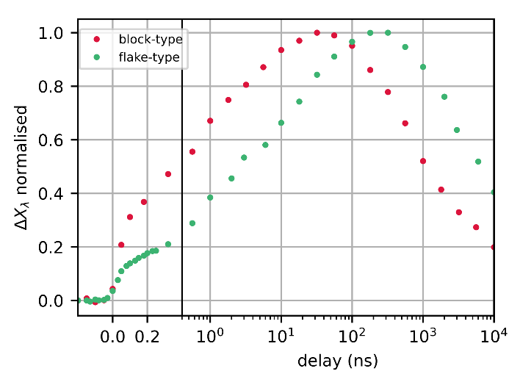

**Figure:** Weight percentage of the λ-phase fraction with delays, obtained from the time resolved diffraction patterns measured at ESRF, ID09 beamline for the flake-type [3] and “block”-type [5] polycrystalline pellets.

[1] Amano, Tatsuya, et al. *Nature Physics* (2024)

[2] Mariette, C. et al., *Nat Commun* **12,** 1239 (2021).

[3] Ohkoshi, Shin-ichi, et al. *Nature chemistry* 2.7 (2010): 539-545.

[4] Tokoro, H.et al.,  *Nat Commun* 6, 7037 (2015).

[5] Ohkoshi, Si. et al. *Sci Rep* 9, 13203 (2019).

[6] Yang, Bo, et al. *Nature* 622.7983 (2023): 499-506.