## The solvothermal formation mechanism of Pd-containing bimetals

**A. B. Borup1*, M. Kløve1, A. D. Bertelsen1, B. B. Iversen1**

*1Center for Integrated Materials Research, Department of Chemistry, Aarhus University, Langelandsgade 140, 8000 Aarhus,, Denmark*

*\*Contact: andersborup@chem.au.dk*

Pd is commonly used as a catalyst in a variety of fields including alcohol oxidation [1], selective hydrogenation/dehydrogenation [2, 3], and direct synthesis of H2O2 [4]. To improve the catalytic performance and abilities of the Pd catalyst, alloying Pd with another element is commonly used since alloying can give rise to three effects; the element can change the electronic nature of the catalytic active atom, it can block neighboring catalytic sites, which alters the bond to poisonous intermediates, and lastly, the metal can catalyze the reaction by itself [5].

However, there exists no general theory for how bimetallic nanoparticles are formed under solvothermal conditions, although they are commonly believed to form as a result of a co-reduction, which among others are the case for Pt3Gd [6] and PbPt [7]. Recently, we unveiled a more complex multistep formation mechanism for the PbxPdy system (Figure 1), where Pd particles are formed first followed by an adsorption and diffusion of Pb into the Pd structure [8]. Using *in situ* X-ray diffraction, it is revealed that this complex mechanism is of a more general character for Pd-containing bimetals, since PdxGay, PdxGey, SnxPdy, and InxPdy are found to obey the same mechanism. Even though both the counter ion of the precursor salt as well as the solvent have been shown to affect the phase outcome for solvothermal synthesis with 3d metals [9, 10], the mechanism for the formation of the Pd-containing bimetals is found to be the same when changing the solvent and utilizing precursors with different counter ions.

The amount of the secondary element incorporated into the Pd-structure can be controlled by temperature, which was shown for the PbxPdy case [8]. In addition to this, the solvent can also be used to control the amount of the secondary element incorporated into the Pd-structure, with, at least for the SnxPdy case, ethanol giving a significantly more Pd-poor phase at the end of the *in situ* experiment compared with ethylene glycol.

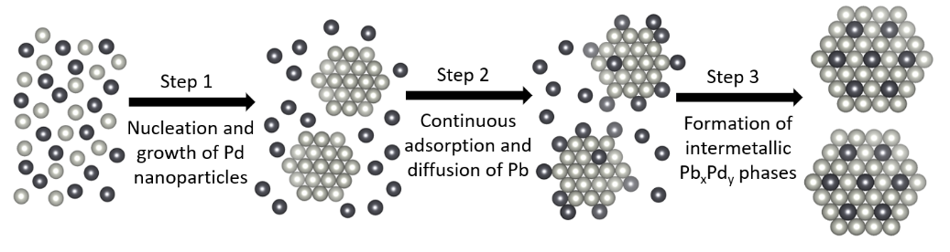

**Figure 1**. Illustration of the proposed mechanism for the formation of intermetallic PbxPdy nanoparticles. The light grey atoms are Pd, while the dark grey atoms are Pb. For simplicity, ions and atoms are shown by the same symbols, and counter ions are omitted. Reproduced from Borup *et al.* [8]

[1] P. Xin, J. Li, Y. Xiong, X. Wu, J. Dong, W. Chen, Y. Wang, L. Gu, J. Luo, H. Rong, C. Chen, Q. Peng, D. Wang & Y. Li. (2018). *Angew. Chem. Int. Ed.* **57**, 4642-4646.

[2] Y. Izawa, D. Pun, & S. S. Stahl. (2011). *Science.* **333**, 209-213.

[3] S. Kidambi, J. Dai, J. Li & M. L. Bruening. (2004). *J. Am. Chem. Soc.* **126**, 2658-2659.

[4] Q. Liu, J. C. Bauer, R. E. Schaak, & J. H. Lundsford. (2008). *Angew. Chem. Int. Ed.* **47**, 6221-6224.

[5] S. Mondal, V. S. K. Choutipalli, B. K. Jena, V. Subramanian & C. R. Raj. (2020). *J. Phys. Chem C.* **124**, 9631-9643.

[6] D. Saha, E. D. Bøjesen, K. M. Ø. Jensen, A.-C. Dippel & B. B. Iversen. (2015). *J. Phys. Chem. C.* **119**, 13357-13362.

[7] D. Saha, E. D. Bøjesen, A. H. Mamakhel, M. Bremholm & B. B. Iversen (2017). *ChemNanoMat.* **3**, 472-478.

[8] A. B. Borup, A. D. Bertelsen, M. Kløve, R. S. Christensen, N. L. N. Broge, A.-C. Dippel, M. R. V. Jørgensen & B. B. Iversen. (2023). *Nanoscale.* **15**, 18481-18488.

[9] N. L. N. Broge, A. D. Bertelsen, I. G. Nielsen, M. Kløve, M. Roelsgaard, A.-C. Dippel, M. R. V. Jørgensen & B. B. Iversen. (2024). *Phys. Chem. Chem. Phys.* **26**, 12121-12132.

[10] N. L. N. Broge, F. Søndergaard-Pedersen, M. Roelsgaard, X. Hassing-Hansen & B. B. Iversen. *Nanoscale*. **12**, 8511-8518.