## Giant piezochromic shift in square planar Rh(I) Complexes: reversible Red-to-NIR optical switching under Pressure

### **Vishnu Vijayakumar-Syamala1, Kinga Potempa1, Krzysztof P. Korona2, Lerato Bosman3, Damian Paliwoda4, Radosław Kamiński1, Alice Brink3, Katarzyna N. Jarzembska1**

### 1University of Warsaw, Faculty of Chemistry, Żwirki i Wigury 101, 02-089 Warsaw, Poland, University of Warsaw; 2Faculty of Physics, Pasteura 5, 02-093 Warsaw, Poland; 3Department of Chemistry, University of the Free State, Nelson Mandela Drive, Bloemfontein 9301, South Africa; 4European Spallation Source ERIC, Partikelgatan2, 224 84 Lund, Sweden

### Email: v.vijayakumar-syamala@uw.edu.pl

Crystalline materials that exhibit reversible changes in their optical properties in response to external stimuli have wide-ranging applications in sensors, memory devices, optical switches, and other optoelectronic technologies [1-3]. In this study, we investigate the high-pressure behaviour of two square-planar Rh(I) complexes (*Rh4X*; Fig. 1a), which are primarily stabilized by metallophilic Rh···Rh interactions forming nearly linear 1D-chains in the crystal packing. Such metallophilic interactions, associated with square-planar d⁸ transition metal centers, are known to play a pivotal role in determining their photophysical properties [4]. Therefore, effective tuning these interactions under high pressure offers an opportunity to explore the structure–property relationships within these materials.

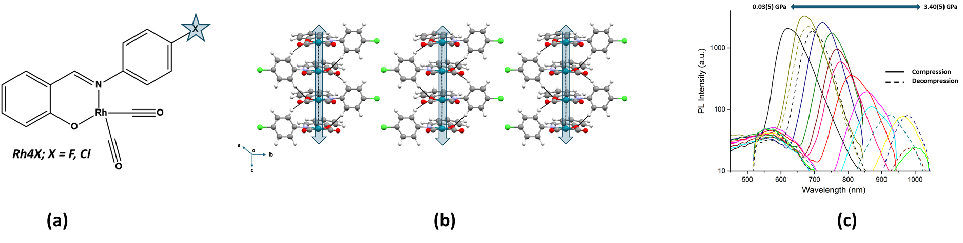

**Figure 1**. (a) Molecular structure of *Rh4X* (X= F, Cl), (b) 1D chains formed via Rh···Rh metallophilic interaction in *Rh4Cl*, and (c) piezochromic shift (luminescence spectra) seen in *Rh4F* from 0.03(5) to 3.40(5) GPa.

The *Rh4X* (X = F, Cl) complexes feature a monoanionic bidentate (N,O)-salicylidene p-bromoaniline ligand and two carbonyl ligands coordinated to the Rh(I) center. Single-crystal X-ray diffraction (SCXRD) studies under ambient conditions revealed that *Rh4X* are isostructural, adopting a nearly square-planar geometry around Rh, with significant Rh···Rh interactions forming almost linear 1D chains along the crystallographic *c*-axis (Fig. 1b). High-pressure SCXRD measurements were conducted from 0.00(5) to 3.57(5) GPa for *Rh4F* and up to 4.84(5) GPa for *Rh4Cl* using a Merrill–Bassett type diamond anvil cell at the Xpress beamline in Trieste, Italy. Under pressure anisotropic compression of the unit cell parameters were observed in both complexes, along with ~0.4 Å reduction in Rh···Rh distances. While structural analysis confirmed that the Rh···Rh contacts remained non-covalent even at the highest pressure, QTAIM-based electronic analysis revealed a transition toward partial covalency under compression, underscoring the importance of combining structural and electronic analyses to fully understand these interactions. Remarkably, both complexes showed giant, reversible piezochromism in the crystalline state, with emission maxima shifting from red (~620 nm) to the NIR (~1000 nm) region, >350 nm bathochromic shift (Fig. 1c). This substantial shift occurred within relatively moderate pressure ranges: P_max = 3.40(5) GPa for *Rh4F* and 5.12(5) GPa for *Rh4Cl*. Additionally, these complexes exhibit dichroism, further enhancing their suitability for polarization-dependent optical sensors. Both complexes display a moderate quantum yield of ~5%, which is though substantial for red-to-NIR-emitting materials. TD-DFT calculations were performed to rationalize the origin of their luminescence, and the experimental findings were further corroborated by theoretical studies.

Overall, this study demonstrates how metallophilic interactions can be harnessed to fine-tune the photophysical properties of square-planar Rh(I) complexes in the solid state, enabling pronounced piezochromic effects.

[1] Bai, L., Bose, P., Gao, Q., Li, Y., Ganguly, R. & Zhao, Y. (2017). J. Am. Chem. Soc. 139, 436–441.

[2] Man, Z., Lv, Z., Xu, Z., Liao, Q., Liu, J., Liu, Y., Fu, L., Liu, M., Bai, S. & Fu, H. (2020). Adv. Funct. Mater. 30, 2000105.

[3] Wang, X., Xu, B. & Tian, W. (2023). Acc. Mater. Res. 4, 311–322.

[4] Donamaría, R., Lippolis, V., López-de-Luzuriaga, J. M., Monge, M., Nieddu, M. & Olmos, M. E. (2018).

Inorg. Chem., 57, 11099–11112.

*Acknowledgements: We thank the SONATA BIS grant (No.2020/38/E/ST4/00400) from the National Science Centre for financial support, WCSS grant No. 285 for providing computational resources, and Elettra (Xpress) beamline staffs for support with high-pressure measurements.*