# Comparative analysis of photoswitching properties of analogous

# nickel(II) and palladium(II) nitrite complexes in the solid state

## K. Paszczyk1, K. Jarzembska1, R. Kamiński1, K. Deresz1, A. Krówczyński1, D. Schaniel2

1University of Warsaw, Department of Chemistry, Żwirki i Wigury 102, 02-089, 2*Université de Lorraine, CNRS, CRM2, 54500 Nancy, France*

### k.paszczyk@student.uw.edu.pl

Photo- and thermally switchable chemical compounds can have various applications, including these in photovoltaics and photonics. The main goal of the project was to investigate and compare properties of two (photo)switchable compounds, i.e. analogous nitro complexes of Ni(II) and Pd(II) with a (N,N,O)-donor supporting ligand (referred to as Ni-1a and Pd-1a) which were synthesized according to the literature procedure [1].

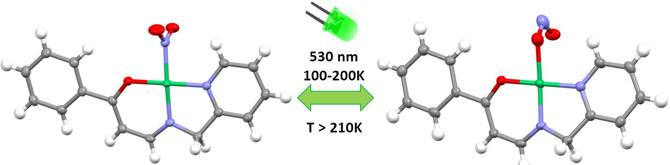

###### **Figure 1**. Schematic representation of the photoisomerization in the studied systems.

Crystallization was carried out by solvent evaporation at room temperature. The highest quality crystals were obtained from DCM, methanol, and ethanol. For both complexes, one polymorphic form proved to be dominant. The dominant crystalline forms were examined for their photo-switching properties using IR spectroscopy, followed by a series of photocrystallographic experiments [2].

Upon irradiation of the Ni-1a crystal, complete or nearly complete conversion to the endo-nitrito isomer was achieved using the 470 nm and 530 nm LED light at 100 K. Over 90% conversion was retained upon heating the sample to 200 K for both wavelengths. In contrast, the dominant Pd-1a crystal form contains two symmetrically inequivalent molecules in the unit cell, out of which only one undergoes photoisomerization. In this case, the reaction efficiency at 100 K remains comparable to that at 200 K under 470 nm irradiation, with maximum conversion exceeding 85%. However, irradiation with the 530 nm LED light results in significantly lower conversion, highlighting the difference in photoresponsiveness between the two systems [3].

Importantly, despite the different space groups, both systems exhibit analogous stacking motifs. A strong linear correlation was observed between the M⋯M distances within these stacking motifs and the population of the *endo*-nitrito isomer (coefficient of determination, *R2 > 0.99*). As a result, based on the derived linear relationship a quick and simple estimation of the isomer composition at 100−200 K temperature range without modelling the disorder.

.

#### [1] Dabrowski, J., Krówczyński, A. (1977). *Z. Naturforsch.*, *32b*, 62– 67.

#### [2] Kamiński, R., Jarzembska, Katarzyna & Kutniewska, Sylwia & Kamiński, Marek. (2016). *Journal of Applied Crystallography*. 49. 1383-1387.

#### [3] Paszczyk, K., Deresz, ., Kamiński, R., Borowski, P., Schaniel, D., Krówczyński, A., Jarzembska, K. N. *Crystal Growth & Design* 2024 *24* (24), pp.10152-10170.

Financial support from the SONATA BIS grant (2020/38/E/ST4/00400) is gratefully acknowledged.