# Co-crystals on stage: time resolved in situ monitoring of multicomponent mechanochemical reactions

## Bacchi, A. Daolio, P.P. Mazzeo, M. Prencipe, R.M. Sundermann

### Dipartimento di Scienze Chimiche, della Vita e della Sostenibilità Ambientale, Università di Parma, Parma (Italy)

### alessia.bacchi@unipr.it

The use of mechanochemical (MC) methods for covalent or supramolecular syntheses has been steadily increasing over the years, thanks to the significant benefits of avoiding the waste of solvents and the possibility of realizing different reaction pathways enabled by mechanical mixing and grinding. Although the mechanism of MC reaction paths is far to be understood, it has been suggested that in some cases proceeding through liquid intermediates may facilitate the activation of the process [1]. This communication focuses on processes enabled by the formation of liquid phases due to the mixing of starting materials. The occurrence of liquid phases during mechanochemical processes may lead to faster conversions towards the final products, as liquid phases can promote mass transport and molecular mobility, which are often critical aspects of mechanochemical reactions. Additionally, liquid mixtures overcome the limitation posed by surface interactions between solid particles inherent in solid-state reactions. A liquid phase may emerge directly from the physical mixture of reactants whenever the melting temperature of their eutectic mixture is lower than ambient conditions. The formation of a liquid eutectic phase during mechanochemical reactions has been indicated as a crucial step for initiating the reactants' conversion, and some examples have recently revealed an active role of the liquid eutectic phase in the formation of binary cocrystals. Recently a tool to investigate the possible occurrence of low-melting mixtures prior to MC synthesis has been presented [2]. This communication will discuss some cases where the evolution of a mechanochemical process through liquid intermediates has been proven by in situ monitoring of the reaction (Figure 1).

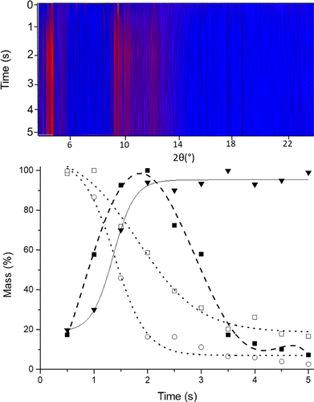

###### **Figure 1**. Time resolved in situ monitoring of the formation of a co-crystal through a liquid intermediate

#### [1] Mazzeo, P. P..; Prencipe, M.; Feiler, T.; Emmerling, F.; Bacchi, A. On the Mechanism of Cocrystal Mechanochemical Reaction via Low Melting Eutectic: A Time-Resolved In Situ Monitoring Investigation (2022). *Cryst. Growth & Des*., **22** (7), 4260–4267.

#### [2] M. Prencipe, P.P. Mazzeo, A. Bacchi, A method to predict binary eutectic mixtures for mechanochemical syntheses and cocrystallizations, *RSC Mechanochem*. (2025), **2**, 61

COMP-HUB and COMP-R Initiatives, funded by the ‘Departments of Excellence’ program of the Italian Ministry for University and Research (MIUR, 2018–2022 and MUR, 20232027). The funding of MIUR PRIN2020 project ‘NICENature Inspired Crystal Engineering’ PRIN2020Y2CZJ2 is acknowledged. Funding by – Missione 4 “Istruzione e Ricerca”–Componente 2– Investimento 1.1 “Fondo per il Programma Nazionale di Ricerca e Progetti di Rilevante Interesse Nazionale (PRIN)” with projects ‘Crystals4Bees’ X4BEES PRIN2022-D53D23010140001 and ‘FLuorInated PePtidEs for Resumption (FLIPPER)’ 202224KAX8 is also acknowledged