# Exploring the crystalline sponge method for the analysis of polyhedral boranes

## M. Kloda1, I. Klenorová1, M. Litecká1

### 1 Institute of Inorganic Chemistry of the Czech Academy of Sciences, Husinec-Řež č.p. 1001, 25068, Husinec-Řež, Czech Republic

### kloda@iic.cas.cz

The crystalline sponge (CS) method, pioneered by Makoto Fujita [1], utilizes well crystalline porous materials to determine the structures of compounds that are difficult to achieve by traditional methods. This can be caused for example by limited availability or difficult crystallization of the desired compound. To overcome those limitations, the compound is adsorbed into the porous crystal, and the structure of the host-guest assembly is determined. The ordering of the guest molecules inside the porous crystal, necessary for the structure determination, is driven by unique host-guest interactions between the particular crystal and guest. For this reason, it is difficult to provide a general procedure for the host-guest assembly and structure determination using the CS method. Thus, exploring different classes of guest compounds is of interest for further development of the method.

In this work, we chose polyhedral boranes for their unique properties and geometry, as well as for their interesting properties such as their luminescence [2]. Those compounds, however, are often obtained in low quantities and difficult to crystallize, which makes them ideal candidates for the CS method. To test the viability of CS method for the analysis of polyhedral boranes, we performed the adsorption experiments and obtained the structures of the host-guest composites of [(ZnI2)3(tpt)2·*x*(solvent)]*n* and polyhedral boranes, such as *anti*-B18H22.

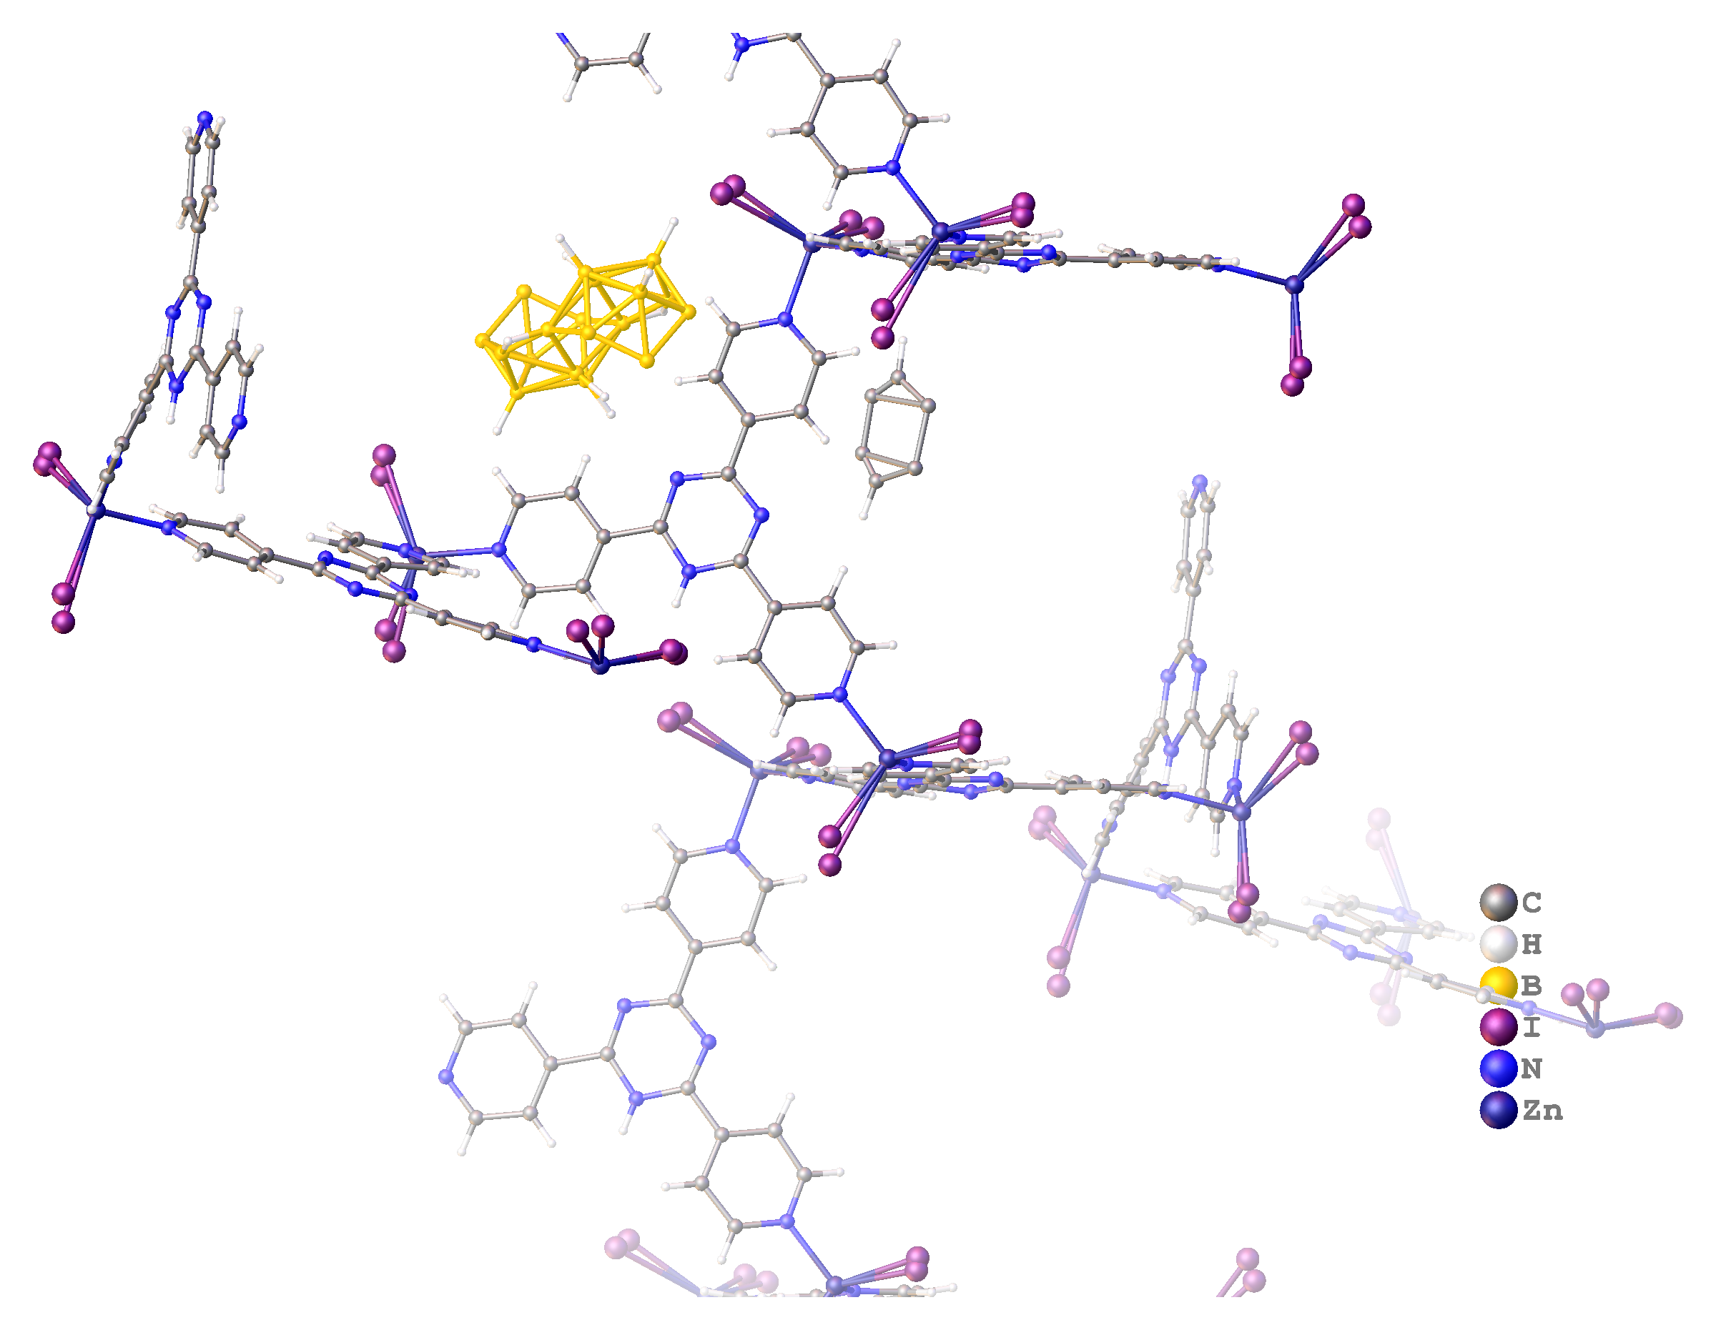

###### **Figure 1**. Structure of *anti*-B18H22 adsorbed into

[1] Hoshino, M., Khutia, A., Xing, H., Inokuma, Y., Fujita, M. (2016). *IUCrJ,* **3**, 139.

#### [2] Bould, J.; Ehn, M.; Tok, O.; Bavol, D.; Kučeráková, M.; Clegg, W.; Litecká, M.; Lang, K.; Kirakci, K.; Londesborough, M. G. S. (2024) *Angew. Chem. Int. Ed.* **63**.

This study was funded by the Czech Science Foundation grant no. 25-16442S.