Incommensurate magnetic modulations of the 2D-layered Ho₃Co described by superspace symmetry

S. Goswani,^{1,2} V. Petříček,¹ P.D. Babu,² M. S. Henriques¹

¹FZU - Institute of Physics of the Czech Academy of Sciences, Prague, Czechia

² UGC-DAE Consortium for Scientific Research, Mumbai Centre, Mumbai, India

henriques@fzu.cz
The rich rare-earth (R) intermetallic compounds R₃Co exhibit varied physical properties originating from the competition between exchange interactions and crystal field [1,2]. Their complex magnetic behavior, high spin ordering temperatures, magnetocaloric effect, giant magnetoresistance are naturally of fundamental interest, but also of great potential for technological applications such as cryocoolers and magnetoresistive devices [3]. They crystallize in the orthorhombic Fe₃C-type structure (space group Pnma). This structure is 2-dimensional, consisting of R₃Co sheets oriented along (001), with the R atoms located at two inequivalent positions. Surprisingly, most of the R₃Co magnetic structures are yet poorly described. The Ho₃Co compound remains probably the least studied compound of this isostructural series. It exhibits two antiferromagnetic transitions – one below the Néel temperature T_{N} (=21 K) and another at T_{T} (=9 K) previously identified as a spin re-orientation [4-6]. Single crystal magnetization and neutron diffraction performed on Ho₃Co (powder and single crystal) did not provide any clear magnetic model [4,7]. Here we present the description of the incommensurate modulated magnetic structures in terms of magnetic superpace formalism as refined from neutron powder data in Jana2020 [8]. In the temperature range 3 K≤T<T_{N}, the magnetic structure is described by an incommensurate propagation vector k=(α,0,0) with 0.1605<α< 0.1585 and a commensurate component k₀ = (0,0,0). For T_{T}<T≤ T_{N} the spin arrangement consists of fan-like (Ho) and cycloidal (Co) modulations. Below T_{T}, the presence of 3k and 5k harmonics results in an anharmonic ground state with the squaring of the modulation. The evolution of the magnetic modulations in Ho₃Co for 3 K≤T< T_{N}, is explained by two active irreducible representations under the Pnm′a(α00)000 magnetic superspace group, which allows the change of the structure with no further symmetry breaking. A significant moment contribution was detected in Co. The realized magnetic model will be discussed within the superspace symmetry approach, showing how it describes the complex modulations in a simple and robust form that is fully consistent with the macroscopic properties.

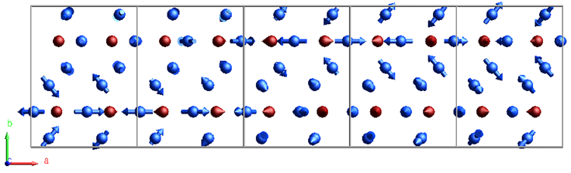

Figure 1. Spin modulation of Ho₃Co at 18 K for Ho (blue) and Co (red) represented in a 5×1×1 supercell of the parent orthorhombic unit cell. The modulation of Ho1 and Ho2 is described as fanlike, with a fan spanning of 100°. The fan plane of Ho1 is parallel to (101), whereas Ho2 spins are at an angle of 57° away from the a-axis. The modulation of the Co spins is a circular cycloidal restricted to be parallel to (101).

[1] N.V Baranov et al., Eur. Phys. J. B 16, 67 (2000); [2] N.V. Baranov et al., Physica B 324,179 (2002); [3] X. Zheng, B. Shen, Chin. Phys. B 26, 017501 (2017); [4] A. Podlesnyak et al., J. Magn. Magn. Mater. 272–276, 565 (2004); [5] J. Shen et al., J. Appl. Phys. 109, 07A931 (2011); [6] N.V. Baranov et al., J. Phys.: Condens. Matter 17, 3445 (2005); [7] T. Palewski et al., J. Magn. Magn. Mater. 258–259, 561 (2003); [8] V. Petricek et al., Z. fur Krist. – Cryst. Mater. 238, 271 (2023)
This work was co-funded by the European Union and the Czech Ministry of Education, Youth and Sports (Project TERAFIT, CZ.02.01.01/00/22_008/0004594).

