# Combining single crystal diffuse scattering and *ab initio* molecular dynamics simulations to understand framework dynamics in AlPO4-5

## Ella M. Schmidt1, M. Fischer1

### 1Faculty of Geosciences, University of Bremen, Bremen, Germany

### ella.schmidt@uni-bremen.de

Zeolites and zeotypes, including the aluminium phosphate framework materials AlPO4-5, exhibit an inherent structural flexibility due to the unique way their rigid building blocks are connected via shared oxygen atoms (Figure 1(a)). This structural flexibility is critical to their ability to accommodate a wide range of organic guest molecules and/or heteroatoms, where subtle distortions of the framework do not compromise the overall framework integrity.

The general framework structure of AlPO4-5 adopts the AFI topology and has been thoroughly studied using techniques such as NMR [1], single-crystal X-ray diffraction [2], neutron diffraction [3], and electron diffraction [4]. The average structure is typically described in the as a framework in which the Al-O2-P bond angle approaches 180° - see Figure 1(a). This configuration is considered energetically unfavourable and unrealistic, creating a form of bond frustration [4], that is alleviated by RUM-like distortions. To experimentally probe this distortion, we use synchrotron single crystal diffuse scattering (ESRF, ID28 dedicated diffuse scattering side station) on a calcinated AlPO4-5 sample. In addition to structured diffuse scattering, we observe weak, but resolution-limited sharp satellite reflections at **q** = (0,0,0.37) – see Figure 1(b). *Ab initio* molecular dynamics (AIMD) simulations performed on 3x3x6 supercells of the parent *P*6*cc* structure qualitatively reproduce these features. These simulations identify the observed phenomena as dynamic distortions that establish a persistent three-fold superstructure along the *c*-axis, offering new insights into the complex structural dynamics of AlPO4-5.

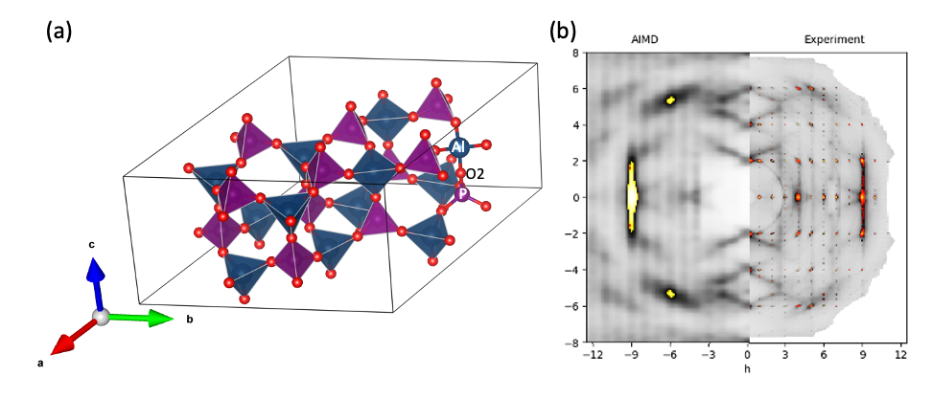

###### **Figure 1**. (a) Average structure of AlPO4-5. Al in blue, P in purple, O in red. (b) *h*0*l*-layer of the experimentally measured diffuse scattering on a calcinated sample, compared to the diffuse scattering calculated from the AIMD trajectory of a 3x3x6 supercell.

#### [1] Peeters, M. P. J., Van De Ven L. J. M., De Haan, J. W. & Van Hooff, J. H. C. (1993). *J. Phys. Chem.* **97**, 8254–8260.

#### [2] Klap, G. J. , van Koningsveld, H., Graafsma, H. & Schreurs, A. M. M. (2000). *Microporous and Mesoporous Materials.* **78**, 403-412.

#### [3] Ikeda, T., Miyazawa, K., Izumi, F., Huang, Q. & Santoro, A. (1999). *Journal of Physics and Chemistry of Solids*. **60**, 1531–1535.

#### [4] Liu, Y., Withers, R. L. & Norén, L. (2003). *Solid State Sciences*. **5**, 427–434.

EMS greatly acknowledges the support of D.A. Chaney (ESRF) for support during beam time. MF acknowledges financial support by the Deutsche Forschungsgemeinschaft (German Research Foundation, DFG) through a Heisenberg fellowship (project no. 455871835).