# Exploration of intrinsic dynamicity in Zinc metal-organic framework catalyst

## Xu Jia1, Chongting Ren1, Luc Van Meervelt1

### 1 Biomolecular Architecture, Department of Chemistry, KU Leuven, Belgium

Metal–organic frameworks (MOFs) with molecular-scale tunability provide a customizable platform for efficient organic synthesis catalysis.[1] By tailoring both ligands and coordination modes, catalytic sites could be immobilized within a porous framework, while substrates and products traverse the interconnected channels unhindered, offering promise in heterogeneous catalysis. To position MOFs as broadly applicable catalytic materials, it is imperative to conduct a systematic evaluation of their fundamental performance metrics.[2]

Herein, we report a Zn-MOF catalyst endowed with intrinsic dynamic behaviour and introduce a combined strategy of X-ray diffraction crystallography and *ab initio* molecular dynamics (AIMD) to evaluate framework dynamicity during catalysis. (Figure 1) High-throughput analysis of structural data, guided by AIMD, first identifies the flexible and rigid regions of the overall framework. We then probe the dynamic structural evolution under systematically varied temperatures, solvent environments, and substrate identities. Finally, by correlating these dynamic transformations with the performance of a multicomponent coupling reaction, we propose a novel “dynamic steric‐adaptation” mechanism that accounts for the observed reactivity enhancements. This integrative approach offers new mechanistic insight into MOF‐mediated transformations, and establishes a blueprint for designing dynamically adaptive porous catalysts for advanced organic syntheses.

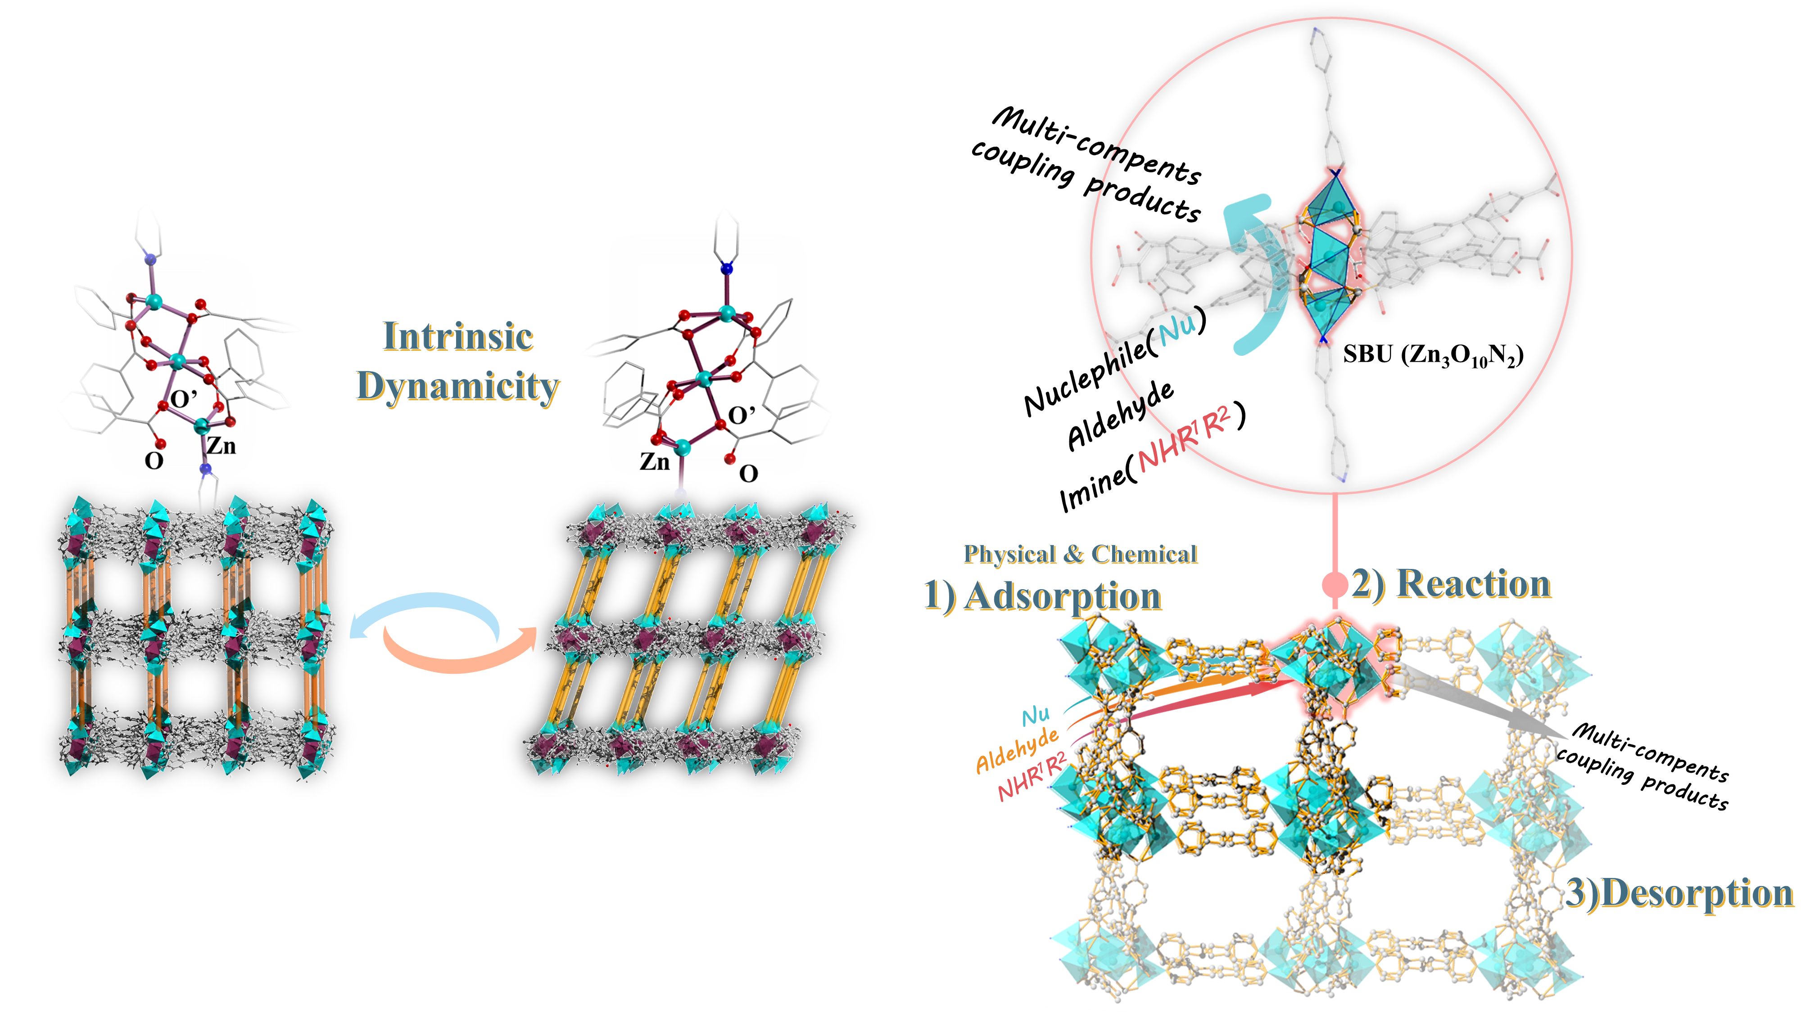

###### **Figure 1**. Framework and node transformations governing the intrinsic dynamicity of the Zn‐MOF and its application in multicomponent coupling reactions.

#### [1] Yaghi, O. M. (2019) *ACS Cent. Sci.* **5**, 1295.

#### [2] Pascanu, V., Miera, G. G., Inge, A. K. & Martín-Matute, B. (2019). *J. Am. Chem. Soc* **141**, 7223.