# DiSCaMB - a package for exploring quantum crystallography

## M. L. Chodkiewicz1, P. M. Dominiak2, K. Woźniak1

### 1University of Warsaw, Faculty of Chemistry, Warsaw, Poland 2University of Warsaw, Faculty of Chemistry, Biological and Chemical Research Centre, Warsaw, Poland

### ml.chodkiewicz@uw.edu.pl

Reaching beyond a commonly used spherical model of atomic electron densities led to a significant improvement in the accuracy of structural information derived from XRD experiments, especially in the case of hydrogen atom parameters. An application of aspherical atomic electron densities in crystallographic refinements is one of the main branches of quantum crystallography. A rapid development of this discipline is facilitated by the development of software packages that allow for testing new methods and ideas. DiSCaMB is one of them and was used in constructing and testing many new models applied in quantum crystallography. The source code of the current version has been recently released and a new major update is planned for August 2025.

In this presentation, we will outline the main features of the new version of the DiSCaMB[1] package and briefly mention its application (e.g., in research on ice polymorphs). The core part of the DiSCaMB package is a C++ library providing functionality for performing general crystallographic computations and the use and development of aspherical models of atomic electron density. The usage of the library is exemplified with the help of accompanying programs which can also be applied in real-life crystallographic calculations. The programs enable application of various quantum crystallographic models of atomic form factors (some of them unique for this package), such as the Hansen-Coppens multipole model based Transferable Aspherical Atom Model (TAAM), model used in Hirshfeld Atom Refinement and its generalizations to alternative partitions of atomic electron density, including recently introduced exponential Hirshfeld partition [2], transferable Hirshfeld Atom Model (THAM), and possibility to build HAR type model with fragments of a system of interest to speed up calculations.

The most useful functionalities of the C++ library have been exposed in Python wrapper. A graphical user interface (GUI, Fig. 1) facilitating the specification of the quantum crystallographic model has been developed. The GUI is written in Python in a modular way and the part responsible for interactive molecular/crystallographic visualization has been designed to be easily reusable in other projects.

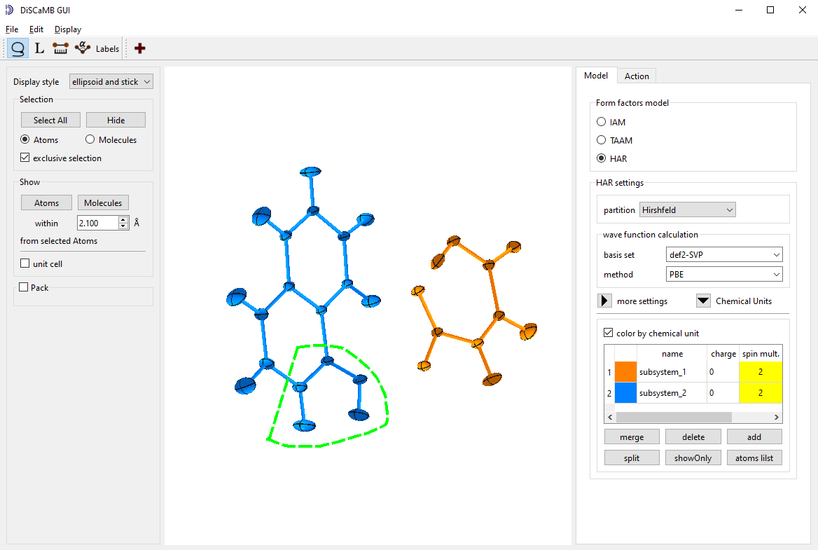

###### **Figure 1**. Graphical user interface (GUI) of DiSCaMB package.

###### [1] Chodkiewicz, M. L., Migacz, S., Rudnicki, W., Makal, A., Kalinowski, J. A., Moriarty, N. W., Grosse-Kunstleve, R. W., Afonine, P. V., Adams, P. D. & Dominiak, P. M. (2018). *J. Appl. Cryst.* **51**, 193–199.

#### [2] Chodkiewicz, M. & Woźniak, K. (2025). IUCrJ, 12, 74-87.

Support of this work by the National Science Centre, Poland, through OPUS 21 (grant No. DEC-2021/41/B/ST4/03010 awarded to KW) is gratefully acknowledged.