# The Cryostream concept - a generous gift to our community

## Alison J. Edwards1

### 1Australian Centre for Neutron Scattering, ANSTO, New Illawarra Rd, Lucas Heights, NSW, AUSTRALIA

### Alison.Edwards@ANSTO.gov.au

The invention of the Cryostream by Glazer and Cosier1 (See Fig.1) – published in April 1986 has facilitated a significant fraction of the crystallography reported during my now 40 year working life as a chemical crystallographer. The development of the “Wide Nozzle” option has greatly enhanced my ability to undertake challenging studies in chemical crystallography using single-crystal neutron diffraction. The modest request from the company that the paper, published in one of our Journals, be cited when their device is used has not been sufficiently followed for the impact of this technology to be adequately understood.

The open publication of the methodology made it available to anyone with the skills and resources (but perhaps lacking funds) to make use of this method, while those with access to greater levels of funding have had access to a well supported and reliable commercial product.

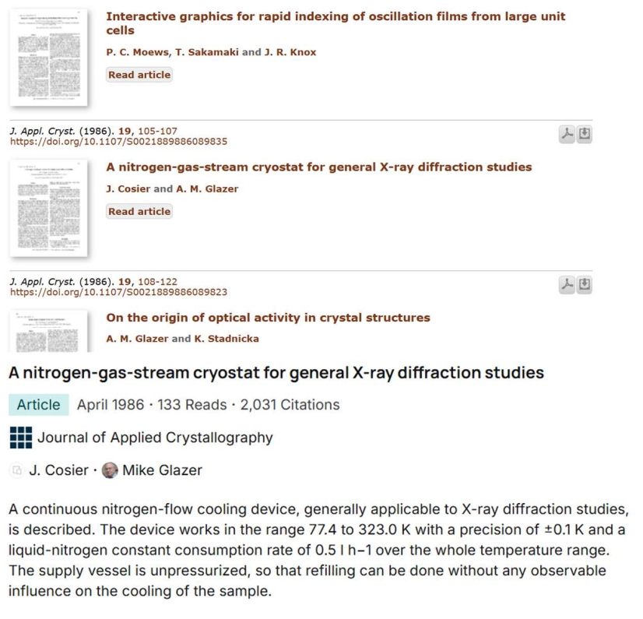

###### **Figure 1**. The seminal article introducing the Cryostream concept

#### [1] Cosier J., Glazer A.M. (1986). *J. Appl. Cryst.* **19**, 105

The interactions with Mike Glazer and John Cosier from my first visit to Oxford as a student and subsequently throughout my career, with the staff, past and present of the company they founded, Oxford Cryosystems are acknowledged with gratitude.