# Linear dichroism and polarized photoluminescence in single crystals of Pt-containing NCN-pincer compound

## V. Stsiapura, V. Vijayakumar Syamala, R. Kaminski, K. N. Jarzembska

### 1Faculty of Chemistry, University of Warsaw, Żwirki i Wigury 101, 02-089, Warsaw, Poland

### v.stsiapura@uw.edu.pl

Photoluminescence of Pt-containing NCN-pincer compounds features unique combination of high emission quantum yield and long decay lifetime (up to μs range) [1] – properties that are highly desirable for optical materials in photonic and optoelectronic applications. In this work we studied absorption and photoluminescence (PL) spectra as well as time-resolved emission kinetics of single crystals from Pt-containing NCN-pincer compound (**Pt-15**, Fig.1).

Steady-state and time-resolved emission measurements with ns-resolution were carried out using a SP2150 spectrograph (Teledyne) with a gated/ intensified CCD-camera (PI-MAX4, Teledyne) coupled to an inverted microscope Olympus IX73. Ns-pulsed laser NT230 (Ekspla, Lithuania) tuneable in UV and visible ranges with laser linewidth ~ 5 cm-1 was used as an excitation source. Absorption spectra in polarized light were measured by passing: 1) a focused beam of a tuneable laser or 2) an aperture-limited white light beam through a single crystal with subsequent analysis of optical transmission.

**Pt-15** crystal orientation with regard to polarization plane of the incident light has profound effects on both absorption and PL emission properties of the crystal. Measurements using polarized light incident normally to (011) plane of **Pt-15** crystal showed that absorption spectra within 400-530 nm range could be described as a combination of two spectral components, SC1(λ) and SC2(λ) (Fig. 1). While amplitude of the SC1(λ) component is practically constant, the SC2(λ) component shows strong linear dichroism and its contribution into the overall spectrum changes from ~0 to some maximal value depending on the polarizer angle.

The assumed presence of two excitonic states that determine absorption and emission properties of **Pt-15** crystals is further supported by results of PL studies. Regions with different degree of polarization in the PL emission spectra, as well as strong dependence of emission spectra on excitation wavelength reveal composite character of PL. We have found good correspondence between shapes of the PL excitation spectra measured at λem=490 nm and λem=520 nm and the shapes of the SC1(λ) and SC2(λ) components in the 440-530 nm spectral range. Differences in the emission properties of the two excitonic states are also revealed in the PL decay kinetics. Additional studies of **Pt-15** molecules in solution and PMMA films and quantum chemical calculations allowed to relate the found excitonic states to two low-lying triplet states, T1 and T2.

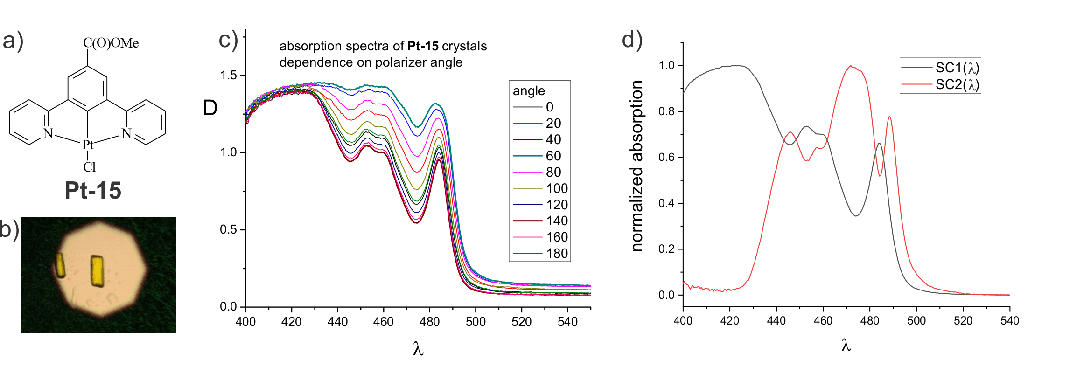

**Figure 1.** Structure of **Pt-15** molecule (a), image of **Pt-15** crystal (b), dependence of absorption spectra for **Pt-15** crystal on polarizer angle (c), spectral components SC1(λ) and SC2(λ) (d).

#### [1] Williams, J. A. G., Beeby, A., Davies, E. S., Weinstein, J. A., & Wilson, C. (2003). *Inorg. Chem.* **42**, 8609.

Authors are grateful to Professor P. R. Raithby (Bath, United Kingdom) for the compound we studied in this work. V.S. and K.N.J. thank the Ministry of Science and Higher Education in Poland for financial support (agreement No. 2022/WK/13). V.V.S. and K.N.J. acknowledge the SONATA BIS grant (No. 2020/38/E/ST4/00400) from the National Science Centre in Poland for financial support. Authors thank the Wrocław Centre for Networking and Supercomputing (Wrocław, Poland) for providing computational facilities (Grant No. 285).