# High Pressure Phase Transition in Groutite, MnO(OH)

## R. Gajda1, A. Huć1, P. Rejnhardt1, J. Parafiniuk2, P. Fertey3, K. Woźniak1

### 1Department of Chemistry, University of Warsaw, Pasteura 1, Warszawa, 02-089, Poland, 2Institute of Geochemistry, Mineralogy and Petrology, Department of Geology, University of Warsaw, Żwirki i Wigury 101, Warszawa, 02-089, Poland, 3Synchrotron SOLEIL, L’Orme des Merisiers,B.P. 48, 91 192 Saint Aubin, Gif-Sur-Yvette Cedex, France.

### romanbg@chem.uw.edu.pl

Groutite, α-Mn³⁺O(OH), is a mineral that belongs to the diaspore group. Groutite was discovered by John Walter Gruner [1] and named in honor of Frank Grout, an american petrographer, geologist, and mineralogist. There are currently four groutite structures deposited in the Inorganic Crystal Structure Database (ICSD). The two earliest entries in ICSD provide only basic information about the groutite structure [2, 3]. The work by Kohler [4] focuses mainly on structural changes triggered by temperature within the range from room temperature (RT) to 325°C. The work by Scheinost [5] describes results from X-ray absorption fine structure (XAFS) and X-ray absorption near-edge spectra (XANES) investigations. However, none of these studies investigated the behavior of groutite under high pressure.

We used X-ray synchrotron radiation in the pressure range from 0.65 GPa to 39.85 GPa to collect diffraction data for single crystals of groutite placed in a diamond anvil cell. It crystalizes in the orthorhombic *Pbnm* space group. Analysis of the reciprocal lattice planes and the intensities of the measured reflections revealed that above 30 GPa, a phase transformation begins in the structure. This transition is gradual, with observable changes in the intensity of specific reflections, particularly those that are forbidden in the *Cmcm* space group. Although we see significant decreases in the intensities of these reflections, many of them still have intensities significantly greater than zero and violates reflections conditions typical for *Cmcm* space group. This is accompanied by a smooth, continuous shrinkage in the unit cell volume and distortion of the MnO₆ octahedra. Analysis of the reflection intensities confirms that the observed changes are due to structural transformations and not experimental or sample effects. The starting *Pbnm* symmetry is preserved although the mineral transforms as a function of pressure close to the *Cmcm* space group symmetry. We propose a mechanism for this phase transition in the *Pbnm* space group, which includes split positions of the oxygen atoms (see Fig. 1).

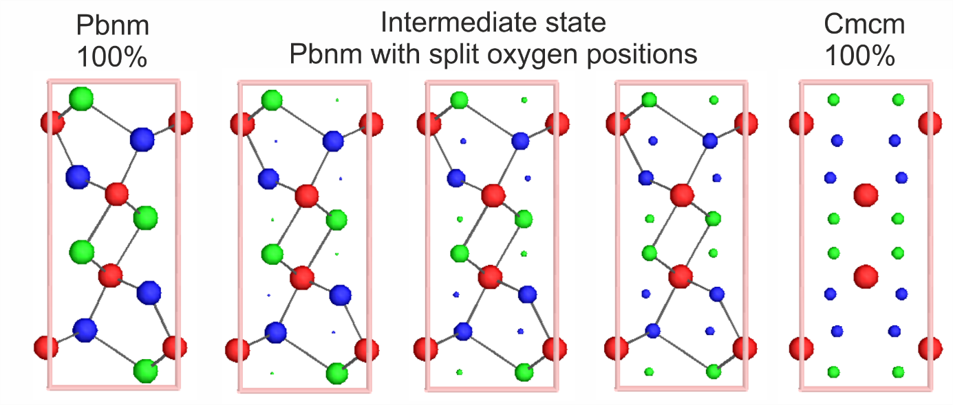

###### **Figure 1**. Steps of transformation between Pbnm and Cmcm space group. Red circles – Mn, green circles – O(1), blue circles – O(2). View along [001] direction.

#### [1] Gruner, J. (1947). *American Mineralogist*, **32**, 654–659.

#### [2] Collin, R. & Lipscomb, W. (1949). *Acta Crystallographica*, **2**, 104–106.

#### [3] Glasser, L. & Ingram, L. (1968). *Acta Crystallographica Section B-Structural Crystallography and Crystal Chemistry*, B **24**, 1233-1236.

[4] Kohler, T., Armbruster, T. & Libowitzky, E. (1997). *Journal of Solid State Chemistry*, **133**, 486–500.

#### [5] Scheinost, A.C., Stanjek, H., Schulze, D.G., Gasser, U. & Sparks, D.L. (2001). *American Mineralogist*, **86**, 139–146.