# Investigation of the local structure of Boron Carbide (B13C2)

## A. Piekara1, W. Sławiński1

### 1Faculty of Chemistry, University of Warsaw, Pasteura 1, 02-093 Warszawa

### ak.piekara@uw.edu.pl

### The local structure of boron carbide (B₁₃C₂) is being investigated to identify structural disorder and defects [1,2]. The primary objective is to characterize the local atomic distribution within the crystal using the Pair Distribution Function (PDF) and Reverse Monte Carlo (RMC) methods.

### A series of samples was synthesized using the Self-Propagating High-Temperature Synthesis (SHS) method to optimize the synthesis conditions. X-ray diffraction measurements were conducted to evaluate the influence of synthesis temperature on the local structure of B₁₃C₂. These advanced techniques are employed due to the limitations of conventional methods, such as Bragg single-crystal and powder diffraction with neutrons or X-rays, which do not yield sufficient information about local atomic arrangements in B₁₃C₂.

### Multiple XRD patterns were collected and subsequently transformed using the PDF approach [3]. The resulting real space PDF D(r) functions, compiled and presented in **Figure 1**, reveal characteristic features of the local structure. Further analysis using the Reverse Monte Carlo method is planned to comprehensively understand the material’s disorder.

A detailed understanding of defectiveness and disorder in B₁₃C₂ is essential for its technological applications. Although an ideal B₁₃C₂ crystal is predicted to exhibit metallic behaviour, experimental observations consistently show semiconducting properties, attributed to the presence of defects and structural disorder [4].

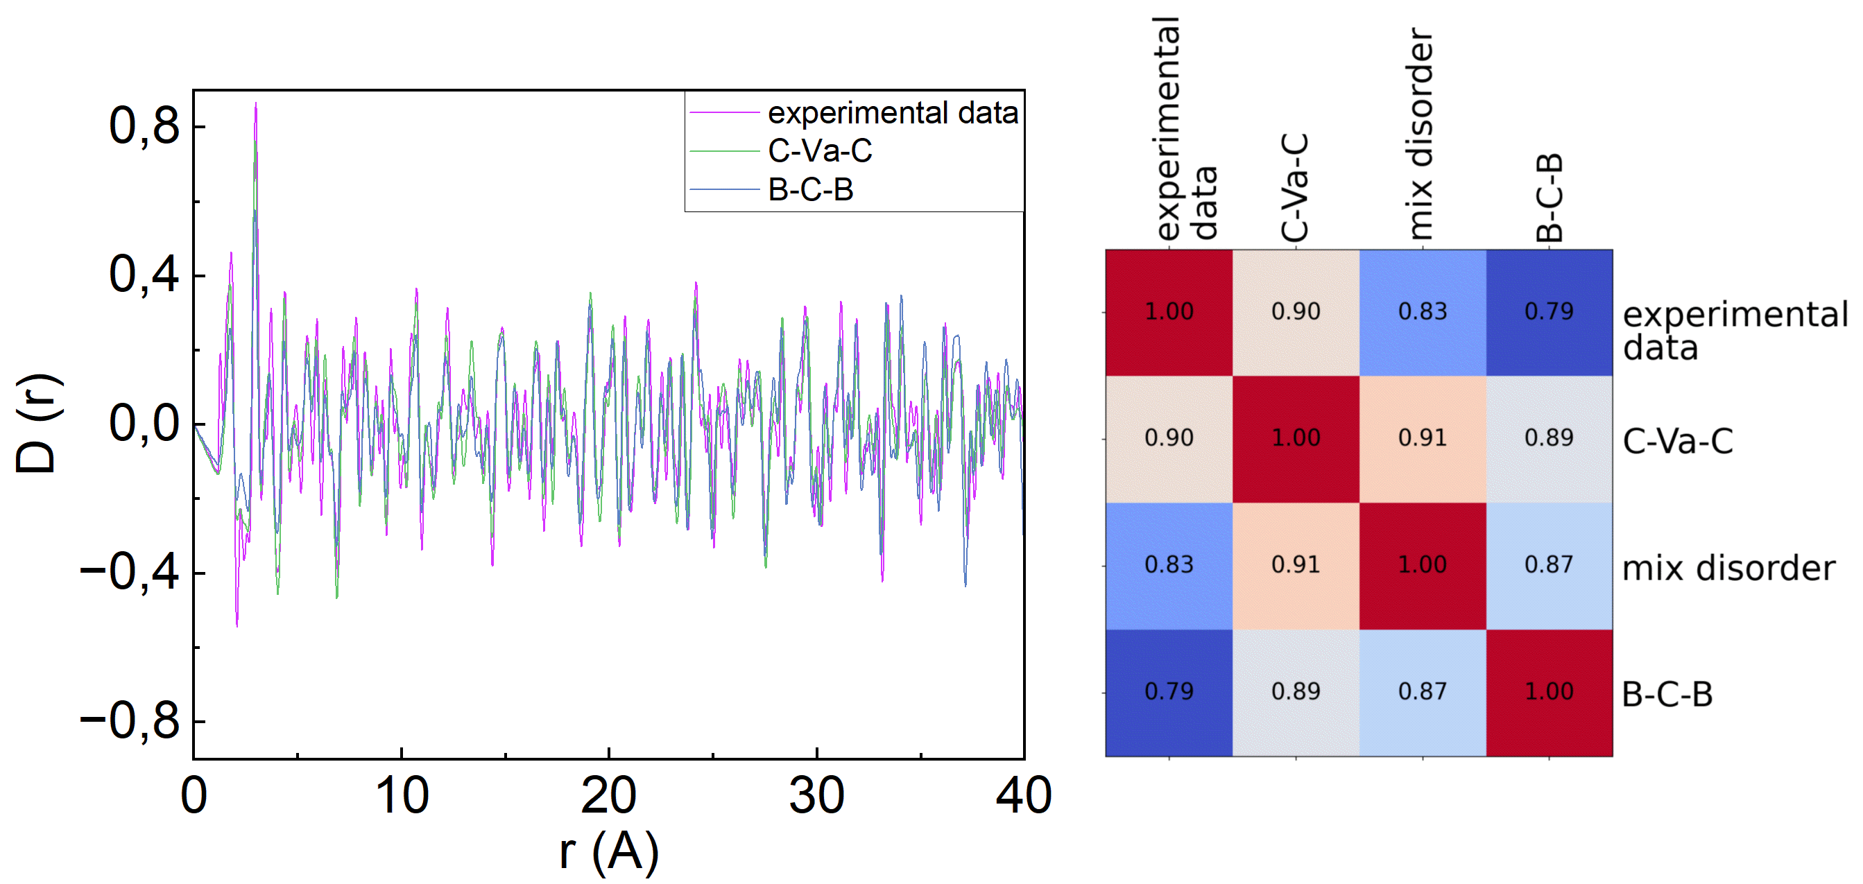

###### **Figure 1**. PDF simulation for different types of potential disorder in the crystal compared with experimental data.

#### [1] Mondal, S. et al., (2016), Disorder and defects are not intrinsic to boron carbide. Sci Rep 6.

#### [2] Balakrishnarajan, M. M., Pancharatna, P. D., Hoffmann, R., (2007) Structure and bonding in boron carbide:The invincibility of imperfections. New Journal of Chemistry.

[3] Sławiński, W. A., Kerr, C. J., Zhang, Y., Playford, H. Y., Dove, M. T., Phillips, A. E. & Tucker, M. G. (2024). RMCProfile7: reverse Monte Carlo for multiphase systems. J. Appl. Cryst.

#### [4] Pillai, H. G., Madam, A. K., Chandra, S. & Cheruvalath, V. M., (2019), Semiconducting B13C2 system:Structure search and DFT-based analysis. Mater Res Express 6.

This work has been financially supported by National Science Center, Poland 2023/49/N/ST5/02746.