# Structural Insights into Ternary Intermetallic Nickel Tetrelides

## V. Hlukhyy1

### 1Technical University of Munich, Lichtenbergstraße 4, D‑85748 Garching, Germany

### E‑Mail: viktor.hlukhyy@lrz.tum.de

Ternary transition metal tetrelides have attracted significant attention, not only for their fundamental importance within the field of intermetallic chemistry but also due to their wide range of functional physical and chemical properties, including thermoelectric behavior, superconductivity, and catalytic activity [1, 2].

Nickel exhibits exceptional structural flexibility in intermetallic compounds, owing to its completely filled d¹⁰ electronic configuration. This feature allows for diverse coordination geometries and bonding environments, contributing to the formation of numerous ternary intermetallic phases within *Ae*-Ni-*E* systems (*Ae* = alkaline-earth metal; *E* = Si, Ge), many of which adopt unique and complex crystal structures.

Crystal structures of such polar intermetallic compounds can often be described as assemblies of polyanionic **[Ni*nEm*]*ᵖ*⁻** substructures, within which electropositive ***Ae*²⁺** cations are embedded to ensure overall charge balance. However, unlike Zintl phases, they show more delocalized chemical bonding in their polyanionic networks compared to the classical 2-centered-2-electron chemical bonds. The structural dimensionality of these polyanionic networks varies systematically with the composition, particularly the relative content of the alkaline-earth metal. Equiatomic alkaline-earth nickel tetrelides serve as a simple example of how increasing the size of the cation results in a progressive reduction of the dimensionality of the [Ni*E*] polyanionic substructures: from complex three-dimensional (3D) networks, through two-dimensional (2D) layered assemblies, down to one-dimensional (1D) structures such as isolated chains or ribbons. Notably, the structures containing nickel exhibit remarkable diversity within 1:1:1 family [3, 4].

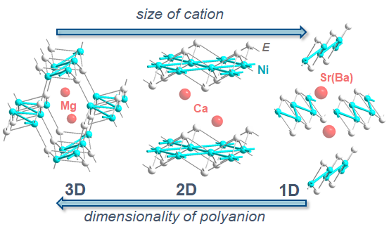

###### **Figure 1**. From three to one dimension in *Ae*Ni*E* compounds.

#### [1] Aydemir, U., Candolfi, C., Ormeci, A., Borrmann, H., Burkhardt, U., Oztan, Y., Oeschler, N., Baitinger, M., Steglich, F. & Grin, Y. (2012). *Inorg. Chem.*, **51**, 4730.

#### [2] Chen, Z., Yang, H., Hausmann, J. N., Mebs, S., Hlukhyy, V., Dau, H., Driess, M., Menezes, P. W., (2025). *Angew. Chem. Int. Ed.*, **64**, e202424743.

[3] Hlukhyy, V., Chumalo, N., Zaremba, V. & Fässler, T. F. (2008). *Z. Anorg. Allg. Chem.,* **634***,* 1249.

#### [4] Hlukhyy, V., Siggelkow, L., & Fässler, T. F. (2013). *Inorg. Chem.*, **52**, 6905.