# Unravelling cation ordering in Sn2SbS2I3

## D. M. Többens1, J. Breternitz1,2, Y. Tomm1, D. G. Porter3, A. Nicolson4, S. Schorr1,5

### 1 Helmholtz-Zentrum Berlin for Materials and Energy, Berlin, Germany, 2now Fachhochschule Münster, Department of Chemical Engineering, Münster, Germany, 3Diamond Light Source, 4University College London, 5Free University Berlin, Institute of Geological Sciences, Berlin, Germany

### daniel.toebbens@helmholtz-berlin.de

Chalcohalide mixed-anion crystals have seen a rise in interest as “perovskite-inspired materials” with the goal of combining the ambient stability of metal chalcogenides with the exceptional optoelectronic performance of metal halides. One promising candidate is Sn2SbS2I3. Recently it was shown by us [1] to have a disordered room-temperature structure, using first-principles cluster expansion and single-crystal X-ray diffraction.

However, due to the very low X-ray scattering contrast between isoelectronic Sn2+ and Sb3+ some unreliability remained. In order to remedy this, anomalous diffraction was used. A single-crystal was mounted on the cryo-cooler of beamline I16 at Diamond Light Source, which allows for low radiation energies. Accessible Bragg peaks were identified and their intensities collected with high-resolution energy scans (MEAD [2]) in the range of 3.8 – 4.8 keV, covering Sb-L and Sn-L absorption edges. The observed MEAD spectra at ambient condition were compared to simulations of competing structure models.

The Bragg peak with Miller index 022 unambiguously shows the site occupation by Sn and Sb to be switched from the classically assumed ordered structure in *Cmcm*. Instead, Sb and Sn share the sites within the [(Sn,Sb)2S2] chains, while Sn resides outwith. This agrees with our previous results [1]. 022 does not allow to distinguish complete Sn-Sb disorder in *Cmcm* from ordered arrangements in subgroup *Cmc*21, but the 021 peak proves a high degree of disorder (figure 1).

Subsequently, datasets were collected at low temperatures down to 10 K. These spectra did not indicate any significant structural changes; the cation disorder is retained at low temperatures. However, the method does not distinguish dynamic from static disorder.

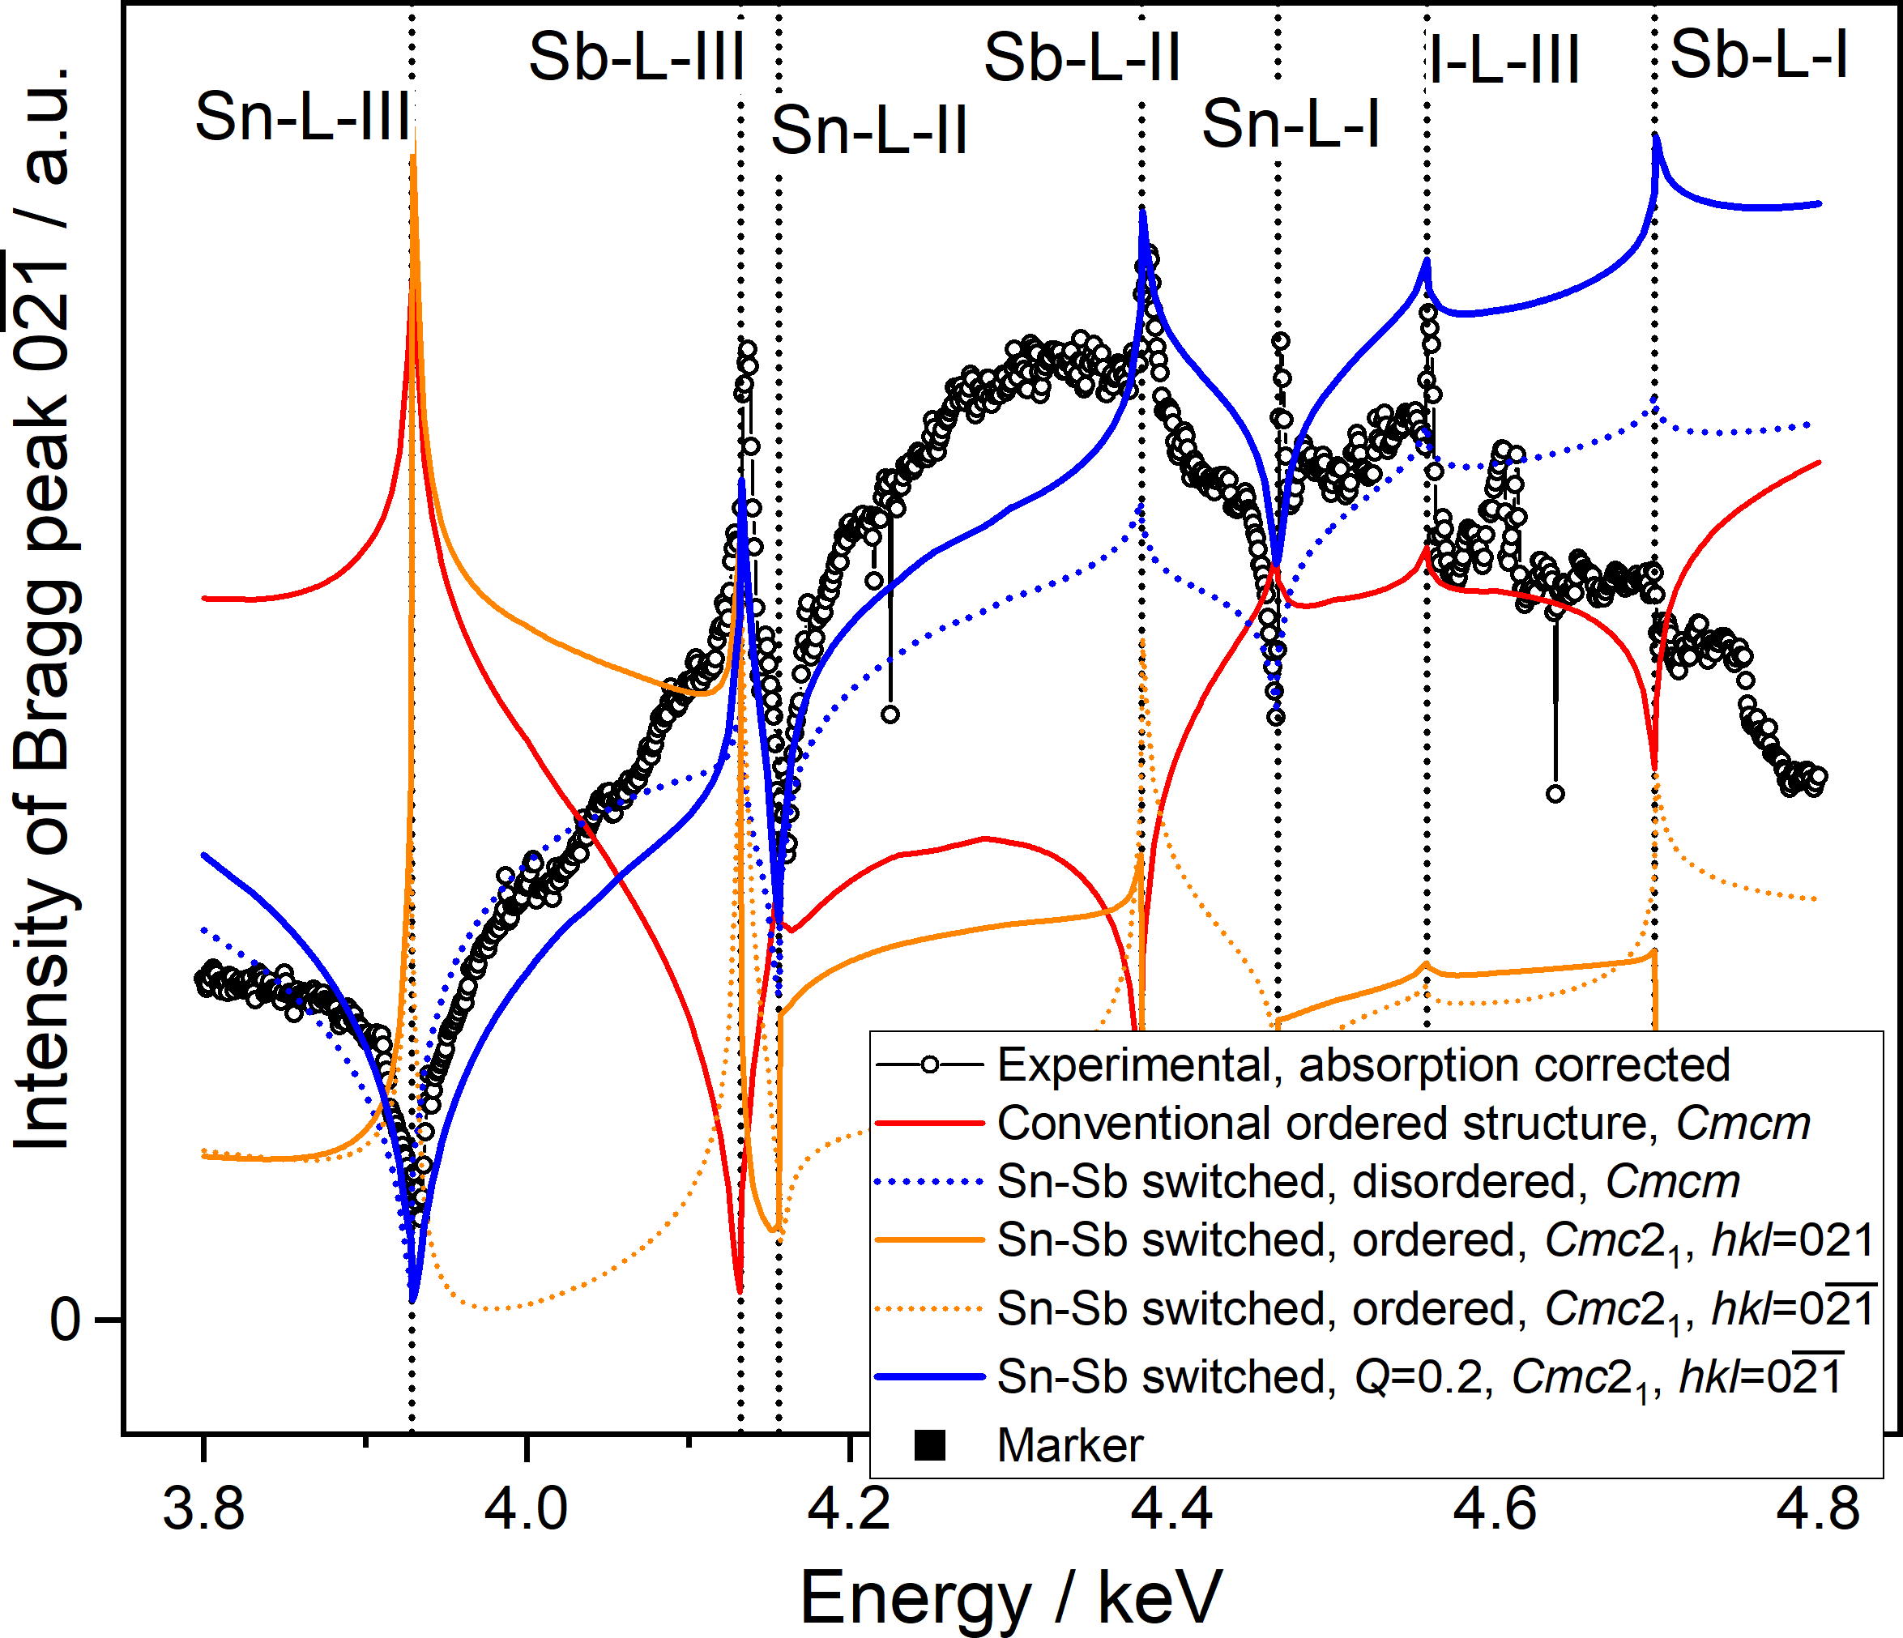

###### **Figure 1**. Experimental MEAD spectrum with selected model simulations

#### [1] Nicolson, A. *et al*. (2023) *J. Am. Chem. Soc.* **145**, 12509

#### [2] Többens, D. M. *et al.* (2020) *Acta Crystallographica* *B* **76**, 1027