# Two novel Cu(II) complexes with tetraimine 2,6-diacetylpyridine derivatives – Synthesis, Characterization, and Crystal Structure

## D. Triska1,2, P. Thomashausen1,2, N. D. Radnović2, M. S. Regojević2, G. N. Kaluđerović1,M. M. Radanović2

### 1 University of Applied Sciences Merseburg - Department of Engineering and Natural Sciences, Merseburg, Germany

### 2University of Novi Sad Faculty of Sciences, Trg Dositeja Obradovića 3, 21000 Novi Sad, Serbia

### dominik.triska@stud.hs-merseburg.de

The reactions of methanolic solutions of 2,6-diacetylpyridine-*bis*(hydrazone), and copper(II)-chloride in the presence of 2,3-/2,4-dihydroxybenzaldehyde in molar ratio 1:1:2 yielded single crystals of the complexes of with the formulaes [Cu(L)Cl2]·*n*MeOH (*n* = 1, 2). In both complexes, the condensation of the free amino groups of 2,6-diacetylpyridine-*bis*(hydrazone) with 2,3-dihydroxybenzaldehyde (L1) or 2,4-dihydroxybenzaldehyde (L2) took place, and the tetraimine ligand was obtained and coordinated to the metal center in an NNN tridentate manner. The complexes crystallized with one (**1**) and two MeOH molecules (**2**). Complexes are crystalline products stable in air and poorly soluble in water, alcohols, acetone, and acetonitrile but well soluble in DMF. The molar conductivity of their DMF solutions (**1**: 22 S⸱cm2⸱mol–1; **2**: 16 S⸱cm2⸱mol–1 for **2**) suggested their non-electrolytic nature but also indicated the partial substitution of chlorido ligands by the solvent molecules. The IR spectra and elemental analysis confirmed the composition and purity of the complexes, while SC-XRD proved their structure (Fig. 1).

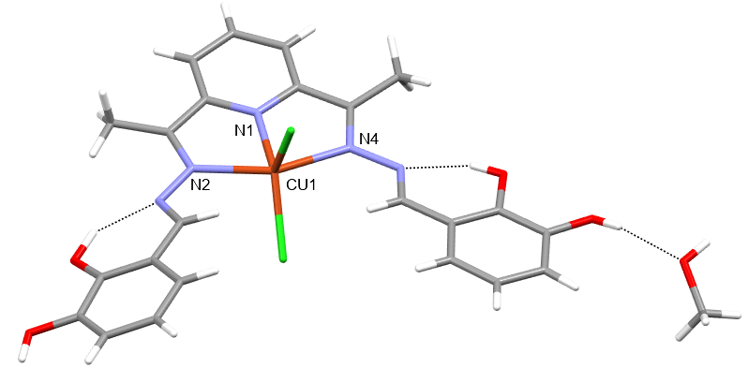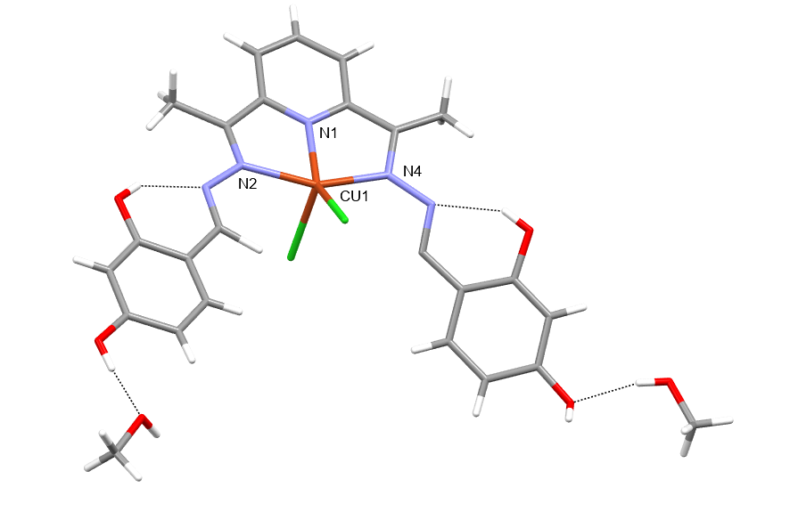

**Figure 1**. The molecular structures and with selected H-bonds in [Cu(L1)Cl2]·MeOH (**1**, left) and [Cu(L2)Cl2]·2MeOH (**2**, right).

Cu(II) is situated in a distorted environment (**1**: τ5 = 0.23; **2**: 0.17) of two azomethine nitrogen atoms and a pyridine nitrogen atom of the chelating ligand, as well as two chlorido ligands. This results in the forming of two fused five-membered metallocycles. These results enable the comparative analysis of two similar structures to estimate the influence of the OH-group position. As expected, in both structures, intramolecular H-bonds are formed between hydrazine nitrogen atoms as H-acceptors and OH-groups in position 2 as H-donors. Interestingly, an additional H-bond is formed between the OH-group in position 3 of the one 2,3-dihydroxybenzaldehyde derivative and the MeOH molecule in **1**. In contrast, in **2**, a MeOH molecule is H-bonded to one of each OH-groups in position 4.

#### [1] M. Radanović M and Barta Holló B (2023) Some Aromatic Schiff Bases and Their Metal Complexes. Schiff Base in Organic, Inorganic, and Physical Chemistry. IntechOpen. Available at: http://dx.doi.org/10.5772/intechopen.107405.

The authors gratefully acknowledge the financial support of the Ministry of Science, Technological Development and Innovation of the Republic of Serbia (Grants Nos.