# “Correlated disorder” is not disorder and can change lattice energies by >2.5 kcal/mol

## J. van de Streek1

### 1Avant-garde Materials Simulation, Alte Str. 2, 79249 Merzhausen, Germany

### jacco.vandestreek@avmatsim.eu

X-ray diffraction experiments measure an electron density that is a time and space average, and quantum-mechanical calculations can be used to deconvolute this time and space average into a detailed picture of molecular crystal structures at the atomic level. While continuing to validate our temperature-dependent lattice free energies[1], which have carefully calibrated error bars of approximately 0.25 kcal/mol for ordered, *Z*’=1 crystal structures of chemical compounds containing between 40 and 70 atoms, we encountered a number of puzzling outliers for crystal structures that had been published as 50:50 disordered. We spent several years searching for examples of disordered molecular crystal structures in the literature and calculating crystal structures, powder diffraction patterns, lattice energies and lattice free energies with a variety of structural models, and we realised that the outliers were due to a type of disorder that is largely unknown and fundamentally misunderstood in much of the crystallographic community: the disorder is only visible in the average crystal structure, the crystal structure has to be doubled in one direction and is then fully ordered in at least that one dimension, often even in two dimensions; we have dubbed this “correlated disorder”. We were able to show that although the experimental average electron density is modelled correctly (so all published experimental crystal structures are still correct), some molecular crystal structures published as 50:50 “disordered” are on a local level not disordered at all, but require a doubling of the unit cell resulting in a fully ordered atomistic model that in terms of atomic coordinates, unit-cell parameters and temperature-dependent lattice free energy allows for excellent agreement between density functional theory calculations and experiment whereas any traditional disorder model does not[2] (see Fig. 1). For most crystal structures published as disordered, we were able to prove the exact nature of the disorder (correlated or not) through the use of quantum-mechanical calculations of the crystal structures, the lattice energies and/or the lattice free energies. Some cases were so subtle that we have not yet been able to establish beyond reasonable doubt what the nature of the disorder is.

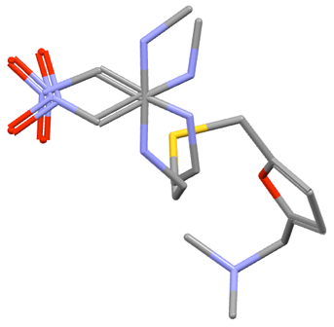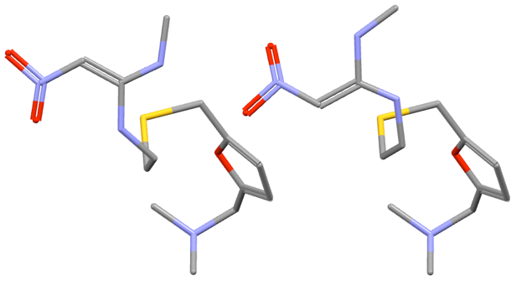

###### **Figure 1**. The asymmetric unit in the experimental crystal structure of Ranitidine HCl as published with 50:50 disorder (left) and the asymmetric unit of the doubled model with “correlated disorder” required for computational work that reproduced the experimental crystal structure and relative stability with respect to the other polymorph (right).

Because calculations on structures with “correlated disorder” require a doubling of the unit cell, and therefore a doubling of the number of degrees of freedom used in the crystallographic calculations, understanding the exact nature of the disorder is especially important for crystal structure prediction, where correct atomic coordinates, unit-cell parameters and lattice free energies are paramount; but even such a simple exercise as validating a crystal structure determined from powder diffraction data with density functional theory calculations will only be successful if the correct model, *i.e*. with or without doubled unit cell, is chosen.

#### [1] Firaha, D. *et al*. (2023). *Nature* **623**, 324.

#### [2] Van de Streek, J., Dietrich, H., Firaha, D., Ovchinnikov, A., Sasikumar, K. & Neumann, M. A. (2025). *IUCrJ*, In preparation.

All authors of reference [2] are gratefully acknowledged for having made this work possible.