# Generalizing Instamatic data collection framework for electron crystallography

## D. M. Tchoń1, S. Smeets2, L. Palatinus1

### 1Institute of Physics, Czech Academy of Sciences, Prague, Czech Republic, 2Netherlands eScience Center, Amsterdam, The Netherlands

### tchon@fzu.cz

Electron Diffraction can be a powerful addition to the toolkit of any modern crystallographer. By utilizing the strong interaction between incident electrons and electrostatic potential, it can be used to probe microcrystals invisible to optical lenses and X-ray diffraction alike. Despite requiring very limited sample quantities, it was repeatedly shown to produce reliable structures of MOFs, pharmaceuticals or proteins on a piece of equipment more accessible than any synchrotron or free-electron laser [1, 2].

During the development of 3D ED, many of its issues were identified and circumvented. Low coverage, radiation damage, or dynamical scattering were addressed by improving crystal tracking, introducing new experimental routines, or employing shutterless serial collection methods [3-5]. Many of these were first tested and implemented in the Python-based program Instamatic [6]. The software, developed to automate the collection of electron diffraction data, features a robust RESTful client-server architecture that allows for seamless integration of many common electron microscopes and cameras. However, due to its rapid centralized development, some of its recent routines prioritize scientific advancement over interoperability or verifiability.

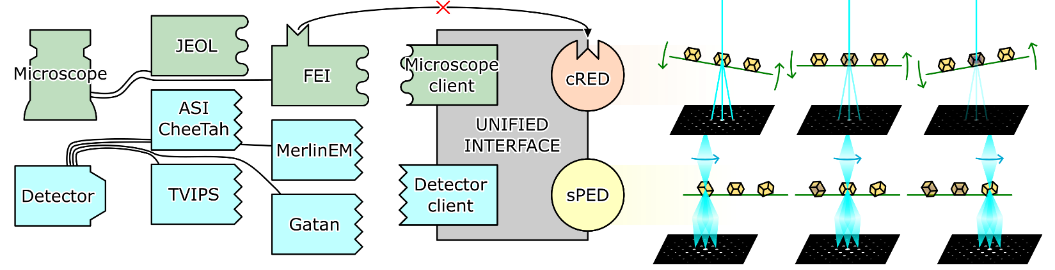

###### **Figure 1**. A symbolic representation of Instamatic’s internal structure. With experimental hardware (left) and protocols (right) decoupled, the same protocols e.g. cRED can be seamlessly executed on different hardware. Introducing a new protocol, such as serial precession-assisted electron diffraction studied in this project, requires then only knowledge of the existing, well-defined interface.

This work aims to develop a generalized experimental framework for serial ED experiments. By adapting existing algorithms and coupling them with new detection, tracking, and measurement methods, we hope to produce a piece of software capable of running state-of-the-art serial collection protocols on a large variety of available electron microscopes. Specifically, we plan to test the applicability of simple serial precession-assisted electron diffraction to racemic conglomerates and particularly damage-prone metal-organic frameworks.

Here we document the preliminary experimental results obtained thanks to technical improvements introduced in Instamatic. Certain generalizations made to the program core structure and interface are shown. Updates to selected bindings and interfaces, in particular the FEI Tecnai microscopes and ASI detectors, are presented.

#### [1] Gruene, T. & Mugnaioli, E. (2021). *Chem. Rev.* **2021**, pp. 11823–11834.

#### [2] Xu, H., Lebrette, H., Clabbers, M. T. B., Zhao, J., Griese, J. J., Zou, X. & Högbom, M. (2019). *Sci. Adv.* **5**, eaax4621.

#### [3] Zhang, D., Oleynikov, P., Hovmöller, S. & Zou, X. (2010). *Z. Kristallogr.*, **225**, pp. 94–102.

#### [4] Gemmi, M. & Lanza, A. E. (2019), *Acta Cryst.*, **B75**, pp. 495–504.

#### [5] Smeets, S., Zou, X. & Wan, W. (2018). *J. Appl. Cryst.* **51**, pp. 1262–1273.

#### [6] Smeets, S., Wang, B., Hogenbirk, E., Rainer, D. & Tchoń, D. M. (2025). *Instamatic (2.1.1)*. Zenodo.

Co-funded by the European Union (Physics for Future – Grant Agreement No. 101081515)