# Discovery of a new high-pressure phase of Posaconazole

## Banaz Fetah1, Daniel Markl1,2 , Cheryl Doherty3, Iain D. H. Oswald1

### 1 Strathclyde Institute of Pharmacy & Biomedical Sciences, University of Strathclyde, Glasgow, UK, 2 EPSRC Future Manufacturing Research Hub for Continuous Manufacturing and Advanced Crystallisation (CMAC), University of Strathclyde, Technology and Innovation Centre, UK, 3GlaxoSmithKline, Stevenage, UK

### [*banaz.fetah.2018@uni.strath.ac.uk*](mailto:banaz.fetah.2018@uni.strath.ac.uk)

Posaconazole (POSA) is an antifungal compound used to treat infections in immunocompromised individuals. However, it belongs to the BCS (Biopharmaceutics Classification System) class II drug meaning it has low solubility therefore its bioavailability is limited. There are fourteen different forms reported, of which only 2 have their crystal structures reported. Much less is understood about their properties [1]. Of the two structurally characterised forms, the thermodynamically stable form of POSA (Form I) crystallises in the monoclinic space group *P*21 with Z = 2 whilst Form II crystallises from the melt in the same space group *P*21 with Z =6. Form I is primarily used to produce oral suspensions [2].

Previous investigation of tablets of POSA by Huang et al. observed that Form I of POSA amorphised under compaction conditions at 0.4 GPa indicating a compression-induced phase transition [3]. They observed that there was 23% (w/w) transformation to the amorphous form at 0.4 GPa compared to 10% at 0.05 GPa. This is an important observation as a change to the amorphous product alters the bioavailability of the material. Our aim was to investigate the effect of pressure on POSA through the use of X-ray diffraction to enable us to elucidate the changes to the structure as a function of applied pressure. High pressure was applied to POSA using a diamond anvil cell (DAC; 0-5 GPa). On compression, we observed that Form I undergoes a phase transition between 0.17-0.25 GPa due to a sudden change in the unit cell parameters. Our results show that POSA transforms to a new high-pressure polymorph where there is a tripling of one of the axes and a reduction in symmetry to *P*1. The asymmetric unit changes from Z=2 to Z=6 induced by a change in the conformation of the molecule; this form is different to Form II. We observe a rotation in the end groups of the molecule, particularly the triazole ring (Figure 1). This change is significant enough to cause a change in symmetry and move to a more complex description of the structure bringing the amorphous form one step closer.

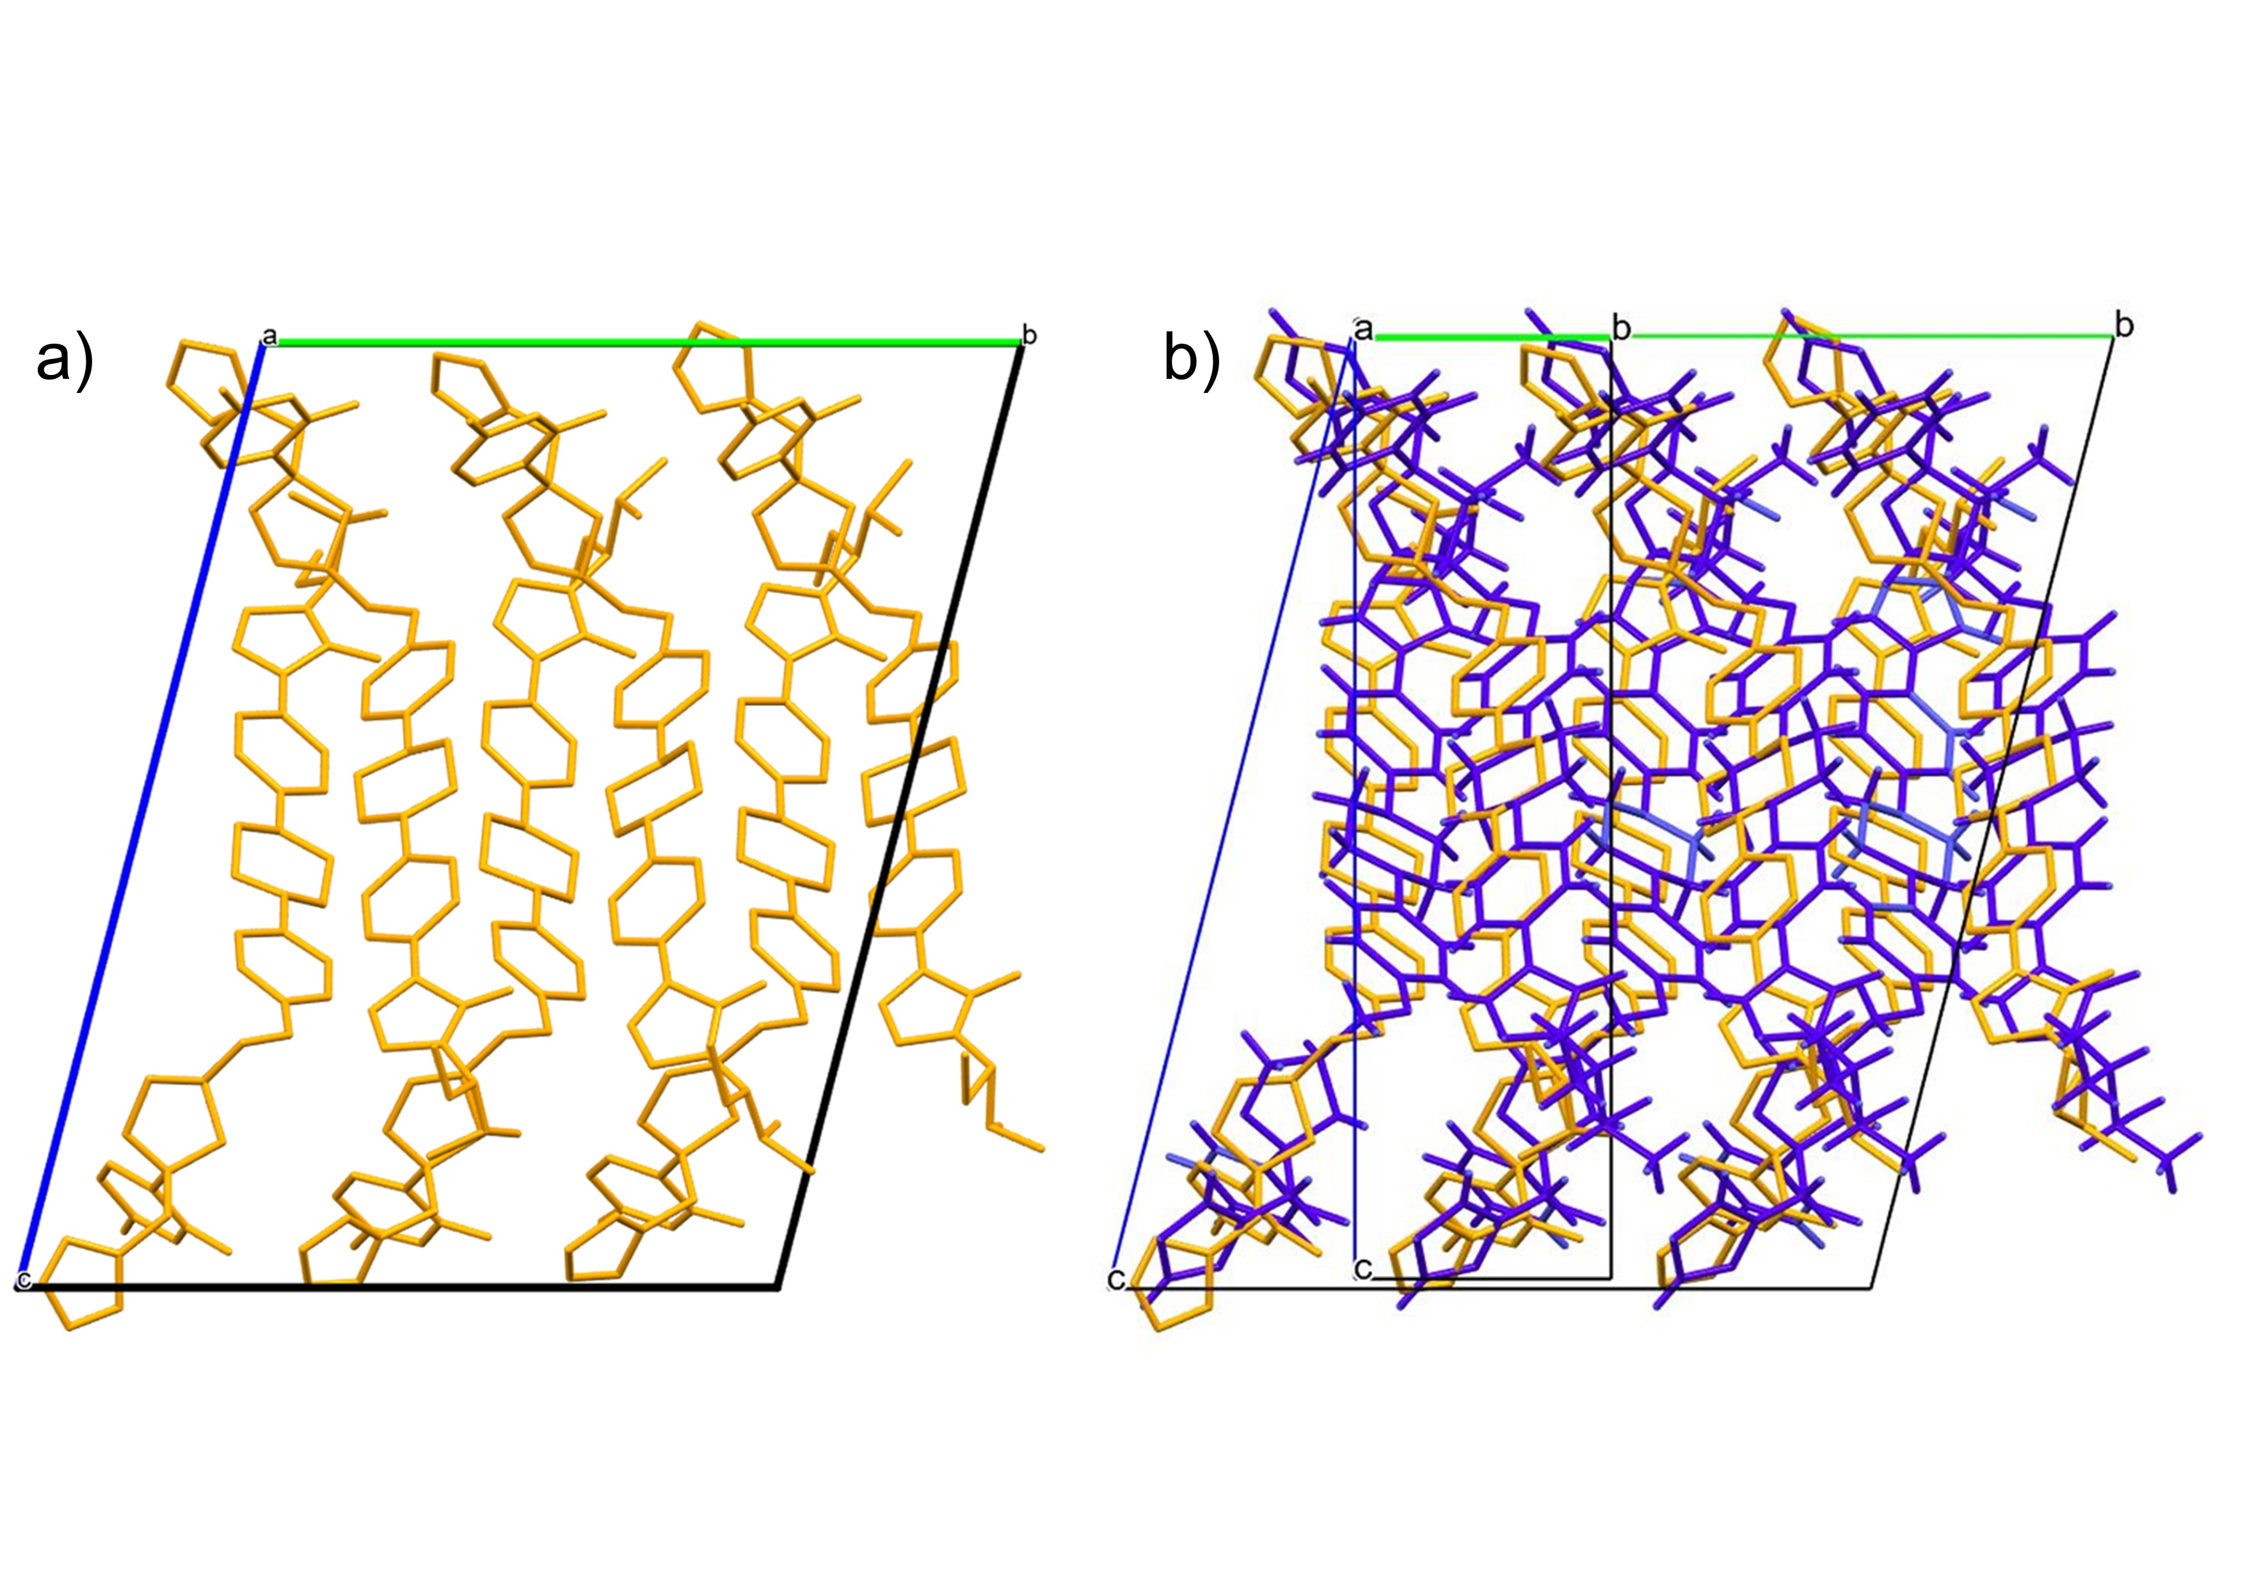

###### **Figure 1.** Crystal structures of Posaconazole. The structures are shown looking down the crystallographic a-axis. Figure a) Ambient form (P21): Blue b) Both ambient form and High-pressure form (P1): Orange.

#### [1] Guidetti, M.; Hilfiker, R.; Kuentz, M.; Bauer-Brandl, A.; Blatter, F. Water-Mediated Phase Transformations of Posaconazole: An Intricate Jungle of Crystal Forms. European Journal of Pharmaceutical Sciences 2024, 195, 106722. <https://doi.org/10.1016/j.ejps.2024.106722>.

#### [2] Lykouras, M.; Orkoula, M.; Kontoyannis, C. Formation and Characterisation of Posaconazole Hydrate Form. Pharmaceuticals 2022, 16 (1), 65. <https://doi.org/10.3390/ph16010065>.

#### [3] Huang, C.; Klinzing, G.; Procopio, A.; Yang, F.; Ren, J.; Burlage, R.; Zhu, L.; Su, Y. Understanding Compression-Induced Amorphization of Crystalline Posaconazole. Mol. Pharmaceutics 2019, 16 (2), 825–833. <https://doi.org/10.1021/acs.molpharmaceut.8b01122>.