Characterising Particle-to-Crystal Transitions: Analytical Approaches and Implications for 3DED

G. L. Mangan¹, A. A. Stewart²

¹Quantum Detector Ltd, Campus, R103, Fermi Avenue Harwell, Oxford OX11 0QX, ²Department of Chemistry, University College London, 20 Gordon Street, London, United Kingdom, WC1H 0AJ

Andy.Stewart@ucl.ac.uk
The interaction between electrons and atomic potential is substantially stronger than X-ray scattering from electron density. This enhanced interaction strength enables electron crystallography to resolve structures from crystals too small for effective analysis via laboratory-based powder diffractometers, where peak broadening would prevent reliable indexing and structure solution [1].
Whilst this capability to examine extremely small material volumes is advantageous[2], it raises an important question: what happens when the crystal volume becomes too small to generate sufficiently sharp Bragg peaks? Figure 1 show the scattering from a range of unit cells volumes down a zone axis for Strontium Titanate, demonstrating the evolution of the scattering into Bragg peaks.
Direct methods fundamentally assume that Bragg peaks are adequately sharp, presupposing sufficient crystallinity within the measured material [3]. This ensures diffraction peaks originate from a volume containing enough repeating unit cells to make the average structure reliably representative of the underlying crystal.
An insufficient number of repeating units fails to produce adequately sharp Bragg peaks, leaving substantial scattering in the background or continuous scattering regime, which is consequently excluded from average crystal structure reconstruction. This raises the critical question: at what point should this become a concern for crystallographers?
In this presentation, we explore how many unit cells are required for an average crystal structure solved by electron crystallography to be truly representative of the material volume from which data was recorded. We present a methodology for determining this crucial metric.
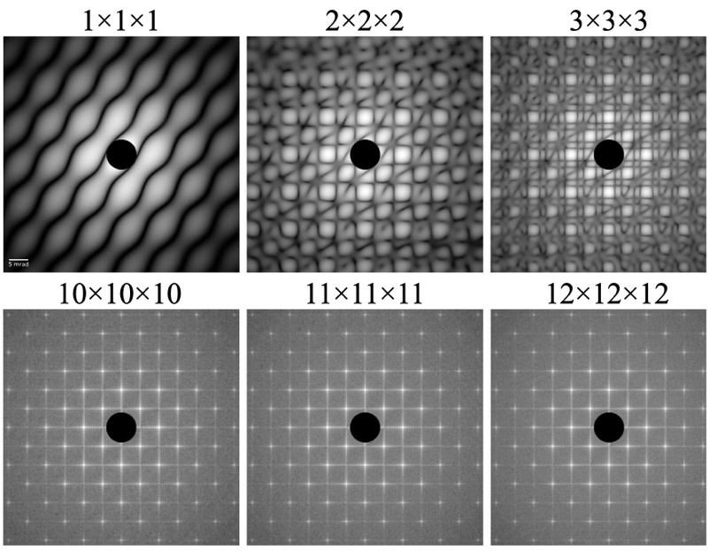

Figure 1. Volumes of Strontium Titanate unit cells simulated by multi-slice calculations,

displayed on logarithmic scale, the centre of the patterns are omitted for clarity of display.

[1] Stephens, P. W., J. Appl. Cryst. (1999), 32, 281-289.

[1] Gemmi, M., Mugnaioli, E., Gorelik, T. E., Kolb, U., Palatinus, L., Boullay, P., Hovmöller, S., & Abrahams, J. P. (2019), ACS Central Science, 5, 1315–1329.

[2] Ewald, P. P. (1940). Proceedings of the Physical Society, 52, 167–174.

