# Degradation of a Pt-based Medium Entropy Alloy Catalyst – An operando X-Ray Scattering Study

## S. Punke1, T. Kunzmann2, N. Schlegel1, R. K. Pittkowski1, K. M. Ø. Jensen1, M. Arenz2

### 1 University of Copenhagen, Universitetsparken 5, 2100 Copenhagen, Danmark, 2 University of Bern, Freiestrasse 3, 3012 Bern, Switzerland, 3 ESRF – The European Synchrotron, 71 Av. des Martyrs, 38000 Grenoble, France

### spu@chem.ku.dk

Proton Exchange Membrane Fuel Cells (PEMFCs) are promising applications to defossilize fuels in heavy-duty vehicle applications [1]. While state-of-the-art Pt-based catalysts demonstrate high activity, the scarcity of Pt limits the scalability of this technology. Reducing Pt content while maintaining or improving catalyst performance presents long-term stability challenges.

This study investigates the degradation behavior of (Pt)(FeCoNi) Medium Entropy Alloy (MEA) nanoparticles. MEAs offer tuneable catalytic properties due to their multidimensional compositional space. We synthesized (Pt)(FeCoNi) MEA nanoparticles using an incipient wetness impregnation approach, focusing on catalysts calcined at 400 °C, and 500 °C [2]. The 400 °C samples form a solid solution with a *fcc* phase; and the 500 °C samples exhibits both a *fcc* and intermetallic phase. This temperature-dependent phase formation enables a comparative analysis of degradation behavior. Operando X-ray Diffraction (XRD), Total Scattering with Pair Distribution Function (PDF) analysis, and anomalous Small-Angle X-ray Scattering (SAXS) at the Pt K-edge are combined to investigate catalyst degradation. This multimodal approach enables the deconvolution of different degradation mechanisms induced by an accelerated stress test (AST). SAXS enables tracking of morphological changes, while XRD and PDF offer insights into the evolution of crystal structure. These techniques reveal structural and morphological changes driven by non-noble metal leaching resulting in the emergence of a Pt-enriched *fcc* phase. Our results suggest the formation of a Pt shell with a (Pt)(FeCoNi) core, regardless of the initial phase, as seen in **figure 1**.

By integrating advanced structural characterization, this study provides critical insights into the degradation mechanisms of HEA electrocatalysts, contributing to the understanding of these complex catalysts and thus paving the way for future more stable and efficient PEMFCs.

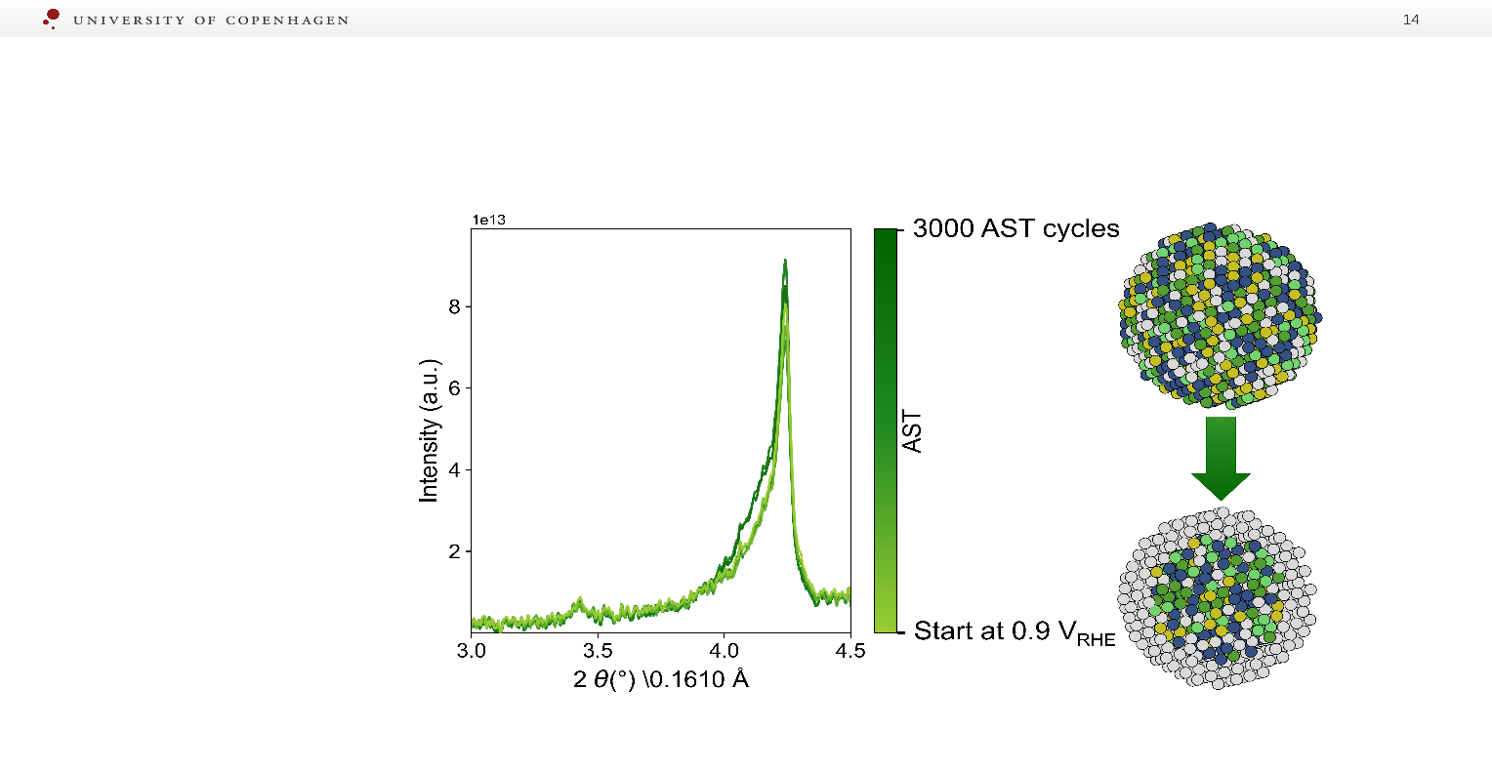

###### **Figure 1**. XRD data collected throughout the AST for the MEA calcined at 500°C. Data collected at the beginning of the AST is visualised light green, whereas data after the final AST cycle are colored in dark green. The XRD shows an additional strained Pt phase emerging as a shoulder at lower scattering angles, whereas the intermetallic phase does not appear to change. The combination of both indicates a formation of a Pt shell with a (Pt)(FeCoNi) core.

[1] Cullen, D. A.; Neyerlin, K. C.; Ahluwalia, R. K.; Mukundan, R.; More, K. L.; Borup, R. L.; Weber, A. Z.; Myers, D. J.; Kusoglu, A. *Nature Energy* **2021**, *6* (5), 462-474.

[2] Schlegel, N.; Punke, S.; Clausen, C. M.; Friis-Jensen, U.; Sapnik, A. F.; Stoian, D.; Aalling-Frederiksen, O.; Gautam, D.; Rossmeisl, J.; Pittkowski, R. K.; Arenz, M.; Jensen K. M. Ø. (2025) *Chem. Mat.* **2025**, *37* (3), 939-953.