# X-ray structural analysis of unique polymorph of acetylene-gold(I)-phosphine under variable temperature and pressure conditions

## A. Prężyna1, A. Zwolenik1, A. Makal1

### 1 Biological and Chemical Research Centre, Faculty of Chemistry, University of Warsaw

### a.zwolenik@uw.edu.pl, am.makal@uw.edu.pl

Gold(I) complexes have attracted extensive research interest in recent years, particularly regarding the relationship between the existence and nature of Au···Au interactions and the physical and photophysical properties of the resulting materials. These compounds hold great potential for applications in pressure sensors, light sensors, and optoelectronic devices [1].

PirEt mono is one of the stable polymorphs of acetylene-gold(I)-phosphine. Unlike other polymorphs of this compound, it does not exhibit aurophilic interactions, and its crystal structure consists of isolated molecules with two different ligands. This unique characteristic makes it an ideal reference for studying the properties of other polymorphs. However, a comprehensive understanding of its intrinsic behaviour is necessary before making further comparisons. To achieve this, a series of variable-temperature and high-pressure X-ray diffraction experiments were conducted.

This compound crystallises as a twin in the monoclinic system, which poses significant challenges for data processing, particularly in high-pressure experiments. To improve data completeness, the crystal was oriented in a diamond anvil cell following the procedure described by Tchoń et al. [2], showed on Fig. 1. This approach, along with the appropriate data reduction for a twinned compound, enabled a series of experiments in the pressure range up to 2.0 GPa and the temperature range from 100 to 310 K. The study revealed anomalous behaviour of this compound under both temperature and pressure variations, highlighting its complex structural response to external stimuli.

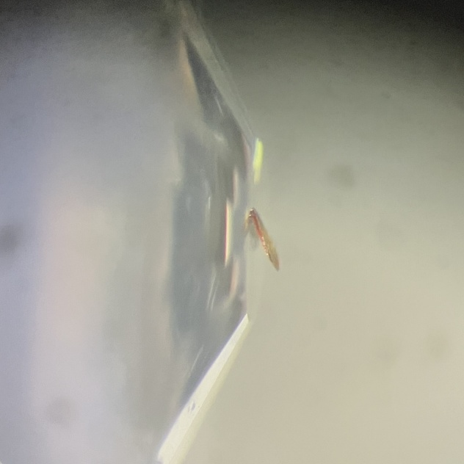

###### **Figure 1**. Single crystal of PirEt mono oriented on a drop of glue on a diamond from diamond anvil cell.

#### [1] Mirzadeh, N., Privér, S. H., Blake, A. J., Schmidbaur, H., Bhargava, S. (2020). *Chemical Reviews*, **120**, 7551–7591.

#### [2] Tchoń, D., Makal, A. (2021). *IUCrJ*, **8**, 1006-1017

This study was financially supported by the National Science Centre Poland (grant No. DEC-2021/41/B/ST4/02760 awarded to AM).