# Pressure effects in a charge-transfer complex *p*-benzoquinone:resorcinol

## S. Batmanghelich, M. Rusek, A. Katrusiak

*Department of Materials Chemistry, Adam Mickiewicz University of Poznan,*

### shibat@amu.edu.pl

The first organic charge-transfer complex was synthesized in 1844 by Friedrich Wöhler through the interaction between 1,4-benzoquinone (*p*Bq) and hydroquinone (Hq) [1]. The charge transfer between the electron-acceptor *p*Bq and the electron-donor Hq leads to the semiconducting properties of this class of compounds [2, 3], making them efficient cathodes in aqueous batteries [4].

In this study, an isomeric form of the Qh-like complex of *p*Bq with resorcinol (*m*-dihydroxybenzene) has been synthesized from a 1:1 ratio of resorcinol and *p*Bq. Unlike other complexes in this family, Rs does not transit to the diketo form, and by going through an aging reaction becomes less stable compared to the other isomeric complexes. The interatomic distances and π-stacking changes of the complex were studied under ambient pressure, 0.13, 2.00 and 3.00 GPa, in the diamond anvil cell (DAC). The compression of this orthorhombic structure, reduces the pitch angle φ, which in turn enhances the π-stacking of molecules (Figure 1a). The increased π-stacking and the reduced dπ distance, increases the charge transfer between molecules and decreases the energy gap *Eg*. The UV-Vis spectra measured as a function of pressure, confirms the changes (Figure 1b).

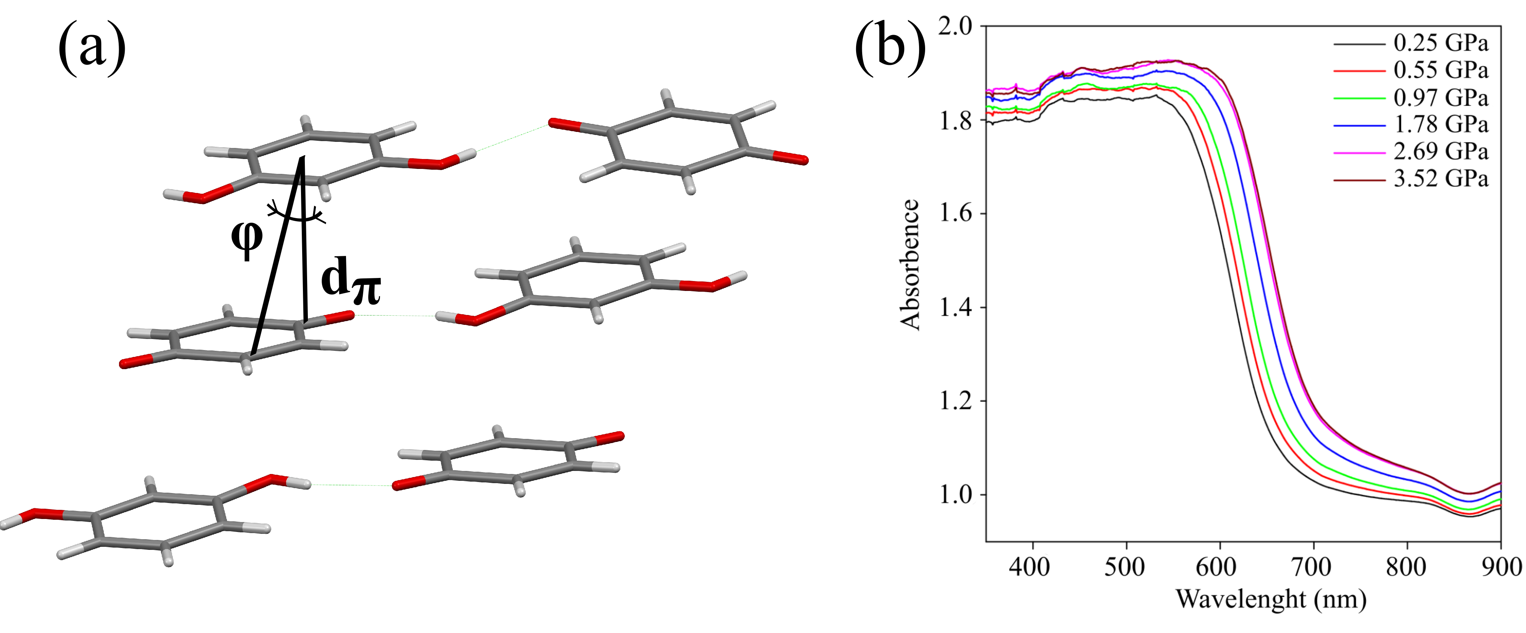

###### **Figure 1**. (a) *p*Bq:Rs molecules π-stacked into columns arranged in layers and, (b) UV-Vis spectrum of the changes of the absorption wavelength of *p*Bq:Rs complex as a function of pressure

#### [1] Wöhler, F. (1844). *Justus Liebigs Ann. der Chemie.* **51**, 145-163.

#### [2] Molčanov, K., Kojić-Prodić, B., Roboz. (2006). *Acta. Cryst. Sect. B.*, **62**, 1051–1060.

#### [3] Inoue, H., Hayashi, S., Imoto, E. (1964). *Bull. Chem. Soc. Jpn.*, **37**, 336–340.

#### [4] Barathi, P., Vinothbabu, P., Sampath, S. (2023). *J. Energy Storage.*, **74**, 109154.