# Tunable surface charge in two-dimensional MOFs *via* interlayer functionalization

## Chongting Ren1, Xu Jia1, Luc Van Meervelt1

### 1 Biomolecular Architecture, Department of Chemistry, KU Leuven, Belgium

### chongting.ren@kuleuven.be

Reticular chemistry has demonstrated unparalleled control over the construction of extended frameworks, and two-dimensional metal–organic frameworks (2D MOFs) in particular exhibit exceptional performance in catalysis, separations and sensing.[1,2] Harnessing the anisotropy arising from in-plane coordination/covalent extension and out-of-plane van der Waals stacking, we have developed a layer-intercalation strategy that introduces imidazole- and sulfonate-functionalized ligands into layered MOF sheets to afford two opposite surface charged 2D frameworks (Fig. 1).

The first, *Im-2Dn*, is a positively charged monolayer with a hexagonal close-packed topology network, in which half of the metal sites are functionalized by imidazole. The second, *SO3-2Dn*, is a negatively charged multilayer in which nitrogen-donor ligands link one-dimensional chains along one axis, and formate bridges knit these chains into a two-dimensional network, achieving full node functionalization. Recognizing the critical importance of crystallinity for definitive structural characterization, we collected high-quality single-crystal diffraction data combined in-house X-ray diffraction with synchrotron measurements at SOLEIL PROXIMA-2A.[3] Rigorous structural refinement reveals the intrinsic topologies and spatial distribution of the charged functionalities. These rare examples of reticular architectures bearing free-standing charged groups not only expand the design palette of MOFs but also lay a firm foundation for applications in non-neutral ion adsorption, tailored fluorescence responses, and electrochemical systems.

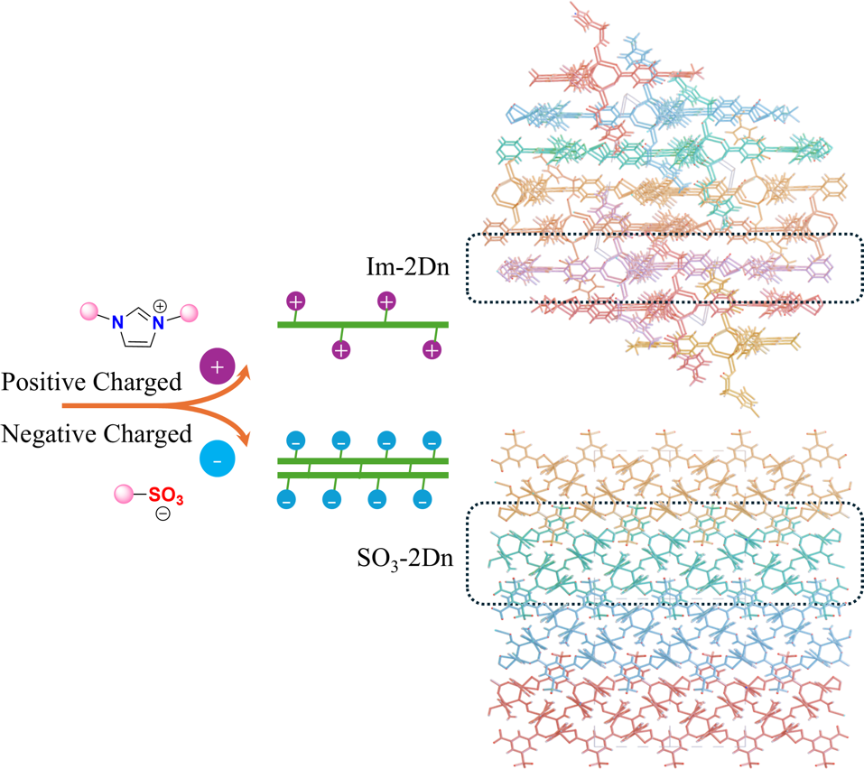

###### **Figure 1**. The interlayer-insertion synthesis strategy, surface charges and crystal structures of *Im-2Dn* and *SO₃-2Dn*.

#### [1] Chakraborty, G., Park, I. -H., Medishetty, R. & Vittal, J. J. (2021) *Chem. Rev.* **121**, 3751.

#### [2] Campbell, M. G., Sheberla, D., Liu, S. F., Swager, T. M. & Dincă, M. (2015) *Angew. Chem. Int. Ed.* **54**, 4349.

#### [3] Savko, M., Fox, G., Stura, E. & Shepard, W. (2016) Acta Cryst. **A72**, s191.