# Analysis of individual nanocrystals in phase mixtures by 3D electron diffraction

## C. Jandl1, J. Merkelbach1, L. Samperisi1, G. Steinfeld1, G. Santiso-Quinones1, D. Stam1

### 1ELDICO Scientific AG, Switzerland Innovation Park Basel Area, Hegenheimermattweg 167A, 4123 Allschwil, Switzerland

### jandl@eldico.ch

Mechanochemistry is an interesting alternative to traditional chemical synthesis as it reduces both the production of waste solvent material and energy consumption for heating the reaction, which makes it an inherently “green” branch of chemistry. However, the procedure also has analytical challenges as incomplete reactions and potential byproducts lead to phase mixtures as primary reaction products. Furthermore, the mechanical stress prevents the formation of large crystals that would be necessary for single crystal X-ray diffraction (SC-XRD) as a method for structure elucidation. On the other hand, powder X-ray diffraction (PXRD) is an established method to identify known phases in a mixture, but will reach its limits when the structure of an unknown phase needs to be determined.

3D electron diffraction (3D ED, also called microED or simply ED) can tackle these challenges: First, it can work with nano-sized crystallites (below 1 µm in thickness). Second, the use of an electron beam typically 1 µm or lower in diameter allows to selectively illuminate individual crystallites during data collection without interference from other components. Measurements from different phases can then be grouped according to unit cells and used for structure determination of each phase. 3D ED allowed us for instance to determine the structure of a supramolecular host-guest assembly of tetrakis-4-(4-pyridyl)phenylmethane (TPPM) and benzyl alcohol obtained by liquid-assisted grinding (Fig. 1) [1].

In another study, quininium aspirinate was prepared as an “X-ray amorphous” solid (according to PXRD) by neat grinding and ball milling, but 3D ED could still detect crystalline particles in the sample, underlining the sensitivity of the method to minor components [2]. Such seed crystals can have major influence on the stability of a solid form and indeed it could be shown that these samples quickly convert to the crystalline form upon exposure to solvent vapours. The ability to determine crystal structures even from minor components makes 3D ED the perfect tool to screen phase mixtures for by-products, impurities, decomposition products, polymorphs etc. – not just in the field of mechanochemistry.

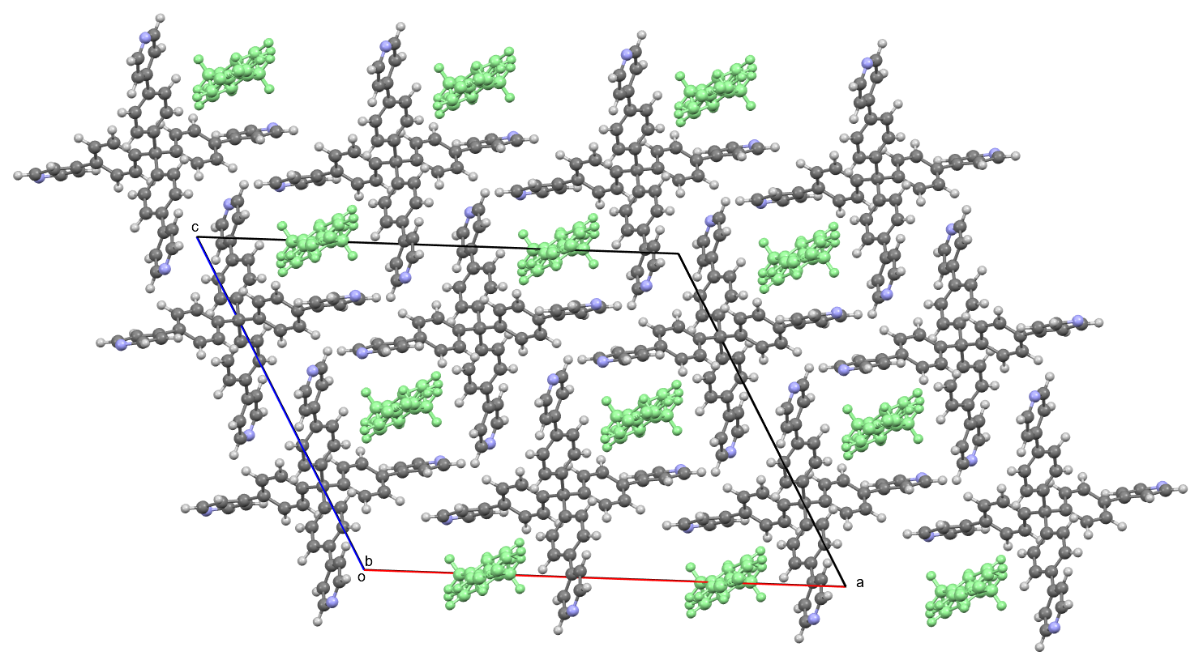

###### **Figure 1**. Structure of a mechanochemically synthesised supramolecular tetrakis-4-(4-pyridyl)phenylmethane (TPPM) framework with disordered benzyl alcohol guest molecules.

#### [1] Marchetti, D.; Pedrini, A.; Massera, C.; Faye Diouf, M. D.; Jandl, C.; Steinfeld, G. & Gemmi, M. (2023). *Acta Crystallogr. Sect B*, **79**, 432.

#### [2] Pagola, S.; Howard, J.; Merkelbach, J. & Stam, D. (2025). *RSC Mechanochemistry*, accepted.