# Normal Modes Refinement (NoMoRe) for accurate anisotropic displacement parameters in high pressure SC-XRD measurements.

## Łukasz Cieszyński1, Anna Hoser1, Anna Makal1

### 1University of Warsaw, Faculty of Chemistry, Ludwika Pasteura 1, 02-093 Warsaw

### l.cieszynski@student.uw.edu.pl

Despite the valuable insights provided by high-pressure crystallography, due to low data completeness, challenges remain in the accurate determination of ADPs.

Recently, we introduced Normal Modes Refinement (NoMoRe) [1] – a novel refinement method, which enable for refinement of lattice dynamical models from DFT calculations against single crystal X-ray diffraction data. During normal mode refinement only few lowest frequencies obtained from DFT are refined against X-ray diffraction data, next obtained frequencies are used for ADPs calculations and thermodynamic properties estimation. As in NoMoRe, we are not refining ADPs directly, but only few frequencies, we are refining significantly less parameters than in the case of routine refinement.

To verify the utility of NoMoRe in high pressure single crystal diffraction experiments, we applied NoMoRe to data collected in SC-XRD and artificially culled by a Python script [2] to simulate high-pressure dataset for two model compounds - benzophenone alpha and beta polymorphs. Next we compared ADPs obtained from routine least squares refinement and after NoMoRe using Similarity Index [3] as well as refined frequencies. Finally we calculated thermodynamic properties of the two systems as a function of a diamond anvil cell opening angle.

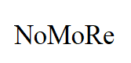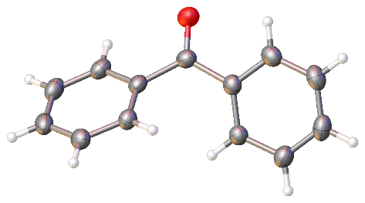 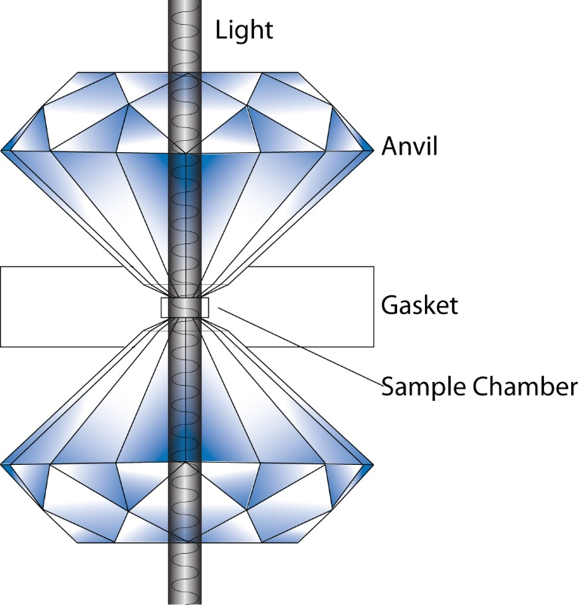

###### **Figure 1**. Benzophenone in diamond anvil cell [4]

[1] Hoser, A. A. & Madsen A. (2016). *Dynamic quantum crystallography: lattice-dynamical models refined against diffraction data. I. Theory*. Acta Cryst. A72, 206-214

[2] Tchoń. D. and Makal A. (2021). Maximizing completeness in single-crystal high-pressure diffraction experiments: phase transitions in 2°AP IUCrJ **8**, 6, 1006–1017

#### [3] Tchoń D. (2022). Similarity index. DTools. <https://dtools.pl/similarity/>

[4] Diamond Anvil Cell Schematic. <https://www.jsg.utexas.edu/lin/mineral-lab/>

*Financial support from the Polish National Science Centre (SONATA17 grant 2021/43/D/ST4/03136) is kindly acknowledged.*