# Discovery of new polymorphs of metal organic frameworks *via* mechanochemical screening

## Ivana Brekalo1, Katarina Lisac1, Joseph R. Ramirez2, Petra Pongrac3, Srećko Valić1, Andreas Puškarić1*,* Yizhi Zhu1, Michael Ferguson4, Joseph M. Marrett4, Mihails Arhangelskis5, Tomislav Friščić5 and K. Travis Holman2

### 1Division of Physical Chemistry, Ruđer Bošković Institute, Zagreb, Croatia, 2Department of Chemistry, Georgetown University, Washington, D.C., USA, 3Faculty of Chemical Engineering and Technology, University of Zagreb, Zagreb, Croatia, 4School of Chemistry, University of Birmingham, Birmingham, UK, 5Faculty of Chemistry, University of Warsaw, Warsaw, Poland,

### ibrekalo@irb.hr

Zeolitic Imidazolate Frameworks (ZIFs) are a class of MOFs built from tetrahedral metal centers and imidazolate linkers. These materials can adopt many zeolitic and nonzeolitic topologies, and their many potential applications such as separations, gas capture, and catalysis, are all highly dependent on their solid form.[1] For example, the archetypal ZIF representative zinc imidazolate (Zn**Im**2), is known to exist in at least 18 topologies[2], which commonly appear concomitantly. Furthermore, ZIFs are often quite flexible so many of these topologies can appear in multiple distinct crystallographic forms, often depending on the incorporated guests. Mechanochemistry has recently emerged as an excellent method for preparing MOFs, as it is fast, quantitative in yield, independent of solubility and creates little waste.[3] Importantly, it can be effectively applied to ZIF syntheses, and the ZIF solid form outcome can be controlled by using different additives, such as liquids or salts.[4]

We here demonstrate the use of commercially available liquid templates as structure-directing agents in the mechanochemical synthesis of new solid forms of zinc imidazolate (Zn**Im**2). We show that multiple Zn**Im**2 forms can be prepared using LAG screening, including new forms of the **crb** topology, and can often interconvert. Furthermore, we use previously validated periodic DFT modeling[5] to explain the observed synthetic results, and in some cases predict the outcomes of screening.

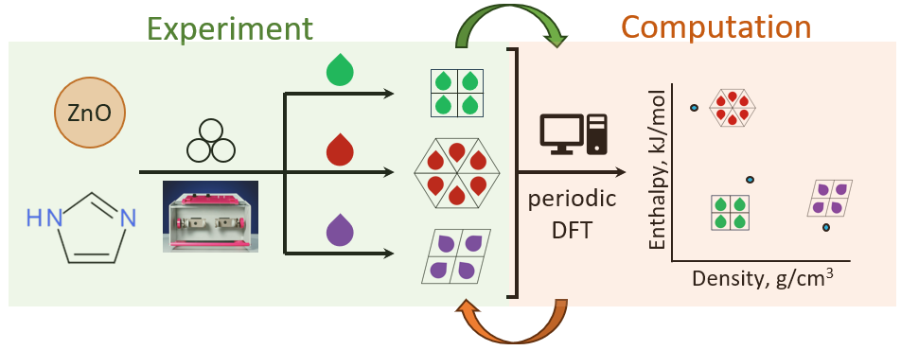

###### **Figure 1.** Schematic representation of the dependence of form outcome of the mechanochemical synthesis of Zn**Im**2 on liquid additives, and the interplay of computation and experiment.

#### [1] B. Chen, Z. Yang, Y. Zhu, Y. Xia, *J. Mater. Chem. A* **2014**, *2*, 16811–16831.

#### [2] S. Guo, *et al. Inorg. Chem. Front.* **2022**, 9, 2011–2015.

#### [3] T. Stolar, K. Užarević, *CrystEngComm* **2020**, *22*, 4511–4525.

#### [4] P. J. Beldon, *et al.* *Angew. Chem. Int. Ed.* **2010**, *49*, 9640–9643

#### [5] Z. Akimbekov, *et al.* *J. Am. Chem. Soc.* **2017**, *139*, 7952–7957.