**Using phase diagrams with microseeding to prepare crystal samples for advanced data collection techniques**

**P. D. Shaw Stewart1, S. A. Kolek1, J. Stubbs2, P. F. M. Baldock1**

*1Douglas Instruments Ltd, East Garston, Hungerford RG17 7HD, United Kingdom, 2School of Biological Sciences, University of Southampton, Southampton SO17 1BJ, United Kingdom*

Serial data collection and microED techniques typically require “slurries” of tiny, well-ordered crystals [1]. Neutron diffraction requires very large single crystals.  Making samples for these techniques often requires many rounds of optimization and larger volumes. To guide them in making samples, protein crystallizers often keep a notional phase diagram in mind that has four zones: an undersaturated zone where protein always remains in solution, a metastable zone where crystals will grow when seeds are added, a crystal nucleation zone where crystals appear spontaneously, and a protein precipitation zone. However, the shape of real-life phase diagrams can vary, and it is very helpful to determine the phase diagrams of target proteins experimentally. In collaboration with the University of Southampton, Douglas Instruments has introduced a new workflow comprising the following steps:

1. Set up a phase diagram by dispensing drops that cover the whole interesting region of the phase diagram, without seed crystals. This allows the upper and lower boundaries of the crystal nucleation zone to be determined (indicated by the red lines below).
2. Repeat, this time adding a suspension of crushed seed crystals [2] to determine the lower boundary of the metastable zone (blue line).
3. Choose one or more conditions from the phase diagram and dispense a seed stock dilution series to determine the most appropriate dilution of seeds.
4. Set up another phase diagram, this time zooming in on the most promising conditions, and using diluted seed stock.
5. Scale up from microbatch to batch (eg 100 µL) as required.

Each experiment above requires only three ingredients: protein, a crystallization cocktail (which might contain seeds), and a diluent. Experiments can be performed either in microbatch, which is faster and easier to scale up, or in a “balanced” vapor diffusion setup where the reservoir solution exactly matches the concentration of the drop (apart from the protein). We present case studies in which phase diagrams were used to enhance control and crystal quality for both routine and advanced data collection.

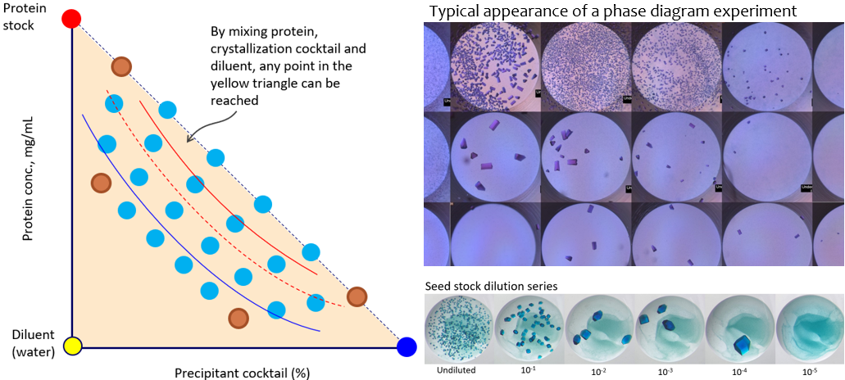

[1] Stubbs, J., Hornsey, T., Hanrahan, L.B. Esteban, R. Bolton, M. Maly, S. Basu, J. Orlans, D. de Sanctis, J. Shim, Shaw Stewart, P. D., A.M. Orville, I. Tews and West, J. (2024). *IUCrJ*  **11.**

[2] D'Arcy, A., Villard, F., Marsh, M.  (2007). *Acta Cryst.* **D63**(4):550-4.