Latest Advancements In Laboratory Powder XRD instrumentation From Anton Paar

Pedro Hurtado, Barbara Puhr, Benedikt Schrode, Tom Faske, Fazilet Gürer

Anton Paar GmbH, Graz, Austria

pedro.hurtado@anton-paar.com

Modern multi-user laboratories require powder X-ray diffraction (XRD) systems that deliver exceptional data quality across a wide range of applications and sample types, all while maintaining high efficiency and ease of use. The XRDynamic 500 automated multipurpose powder diffractometer from Anton Paar addresses these needs by combining advanced capabilities—including grazing incidence XRD, non-ambient XRD, small-angle X-ray scattering (SAXS), and pair distribution function (PDF) analysis—into a single, highly automated platform capable of handling multiple samples in succession without user intervention.

At the core of the XRDynamic 500 is the TruBeam™ concept, featuring a large goniometer radius, evacuated beam path, automated optical component switching, and fully automated alignment routines. These innovations collectively ensure high-resolution, high signal-to-noise data acquisition with minimal setup time—even for novice users.

This contribution will highlight the instrument’s performance through multi-user application examples addressing common challenges such as minor phase identification and advanced techniques like non-ambient XRD and SAXS. Operando XRD studies on battery assemblies will also be presented, demonstrating the instrument’s versatility and technical strengths.

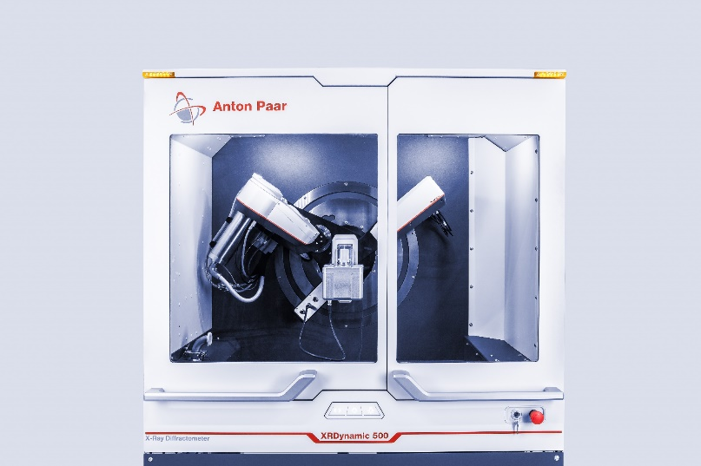

Figure 1. The XRDynamic 500 automated multipurpose powder X-ray diffractometer.