## The Breathing Box: Improving X-ray Diffraction Data Through Adaptive 3D Profile Fitting

## L. C. Folkers1, P. Celani1

### 1STOE & Cie GmbH, Hilpertstrasse 10, 64295 Darmstadt, Germany

### folkers@stoe.com

During the integration step in X-ray diffraction data processing, the intensities of measured peaks are extracted. Since each measurement includes some background signal, a key task of the integration software is to distinguish this background from the true peak intensity—without discarding too many low-intensity reflections. Traditionally, the peak area is defined using a fixed-size profile, and the background intensity is estimated from a surrounding area of fixed dimensions.

STOE’s new integration software, INTEGRATE3D, introduces adaptive integration profiles that adjust their shape and size dynamically around each reflection across consecutive frames, with no or minimal user intervention. This, coupled with a robust description of the background [1], results in variable integration areas and improves the I/σ(I) statistics. Integration of weak reflections is performed via *ab initio* 3D profile fitting [2,3], rather than relying on learned profiles. This approach particularly benefits datasets with weak reflections, yielding more accurate estimates of intensities (I) and improved I/σ(I). However, even average datasets show improved results when processed with INTEGRATE3D.

We will demonstrate the capabilities of INTEGRATE3D using two representative datasets: one featuring a wavelength/sample mismatch, and another reflecting a typical measurement scenario—highlighting the method’s innovativeness and advantages for weak and strong data.

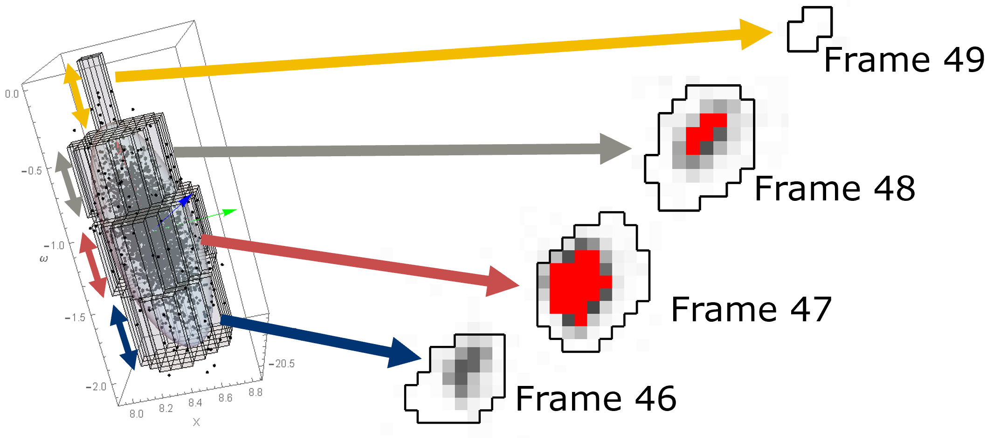

###### **Figure 1** Schematic indicating the change of integration box size over consecutive frames.

[1] Parkhurst, J. M., Winter, G., Waterman, D. G., Fuentes-Montero, L., Gildea, R. J., Murshudovb, G. N., Evans, G., *J. Appl. Cryst.,* **49**, 2016.

#### [2] Duisenberg, A. J. M., Kroon-Batenburg, L. M. J., Schreurs, A. M. M., *J. Appl. Cryst.*, **36**, 2003.

#### [3] Schreurs, A. M. M., Xian, X., Kroon-Batenburg, L. M. J., *J. Appl. Cryst.,* **43**, 2010.