**Probing the modulation of enzyme kinetics by multi-temperature, time-resolved serial crystallography**

**E.C. Schulza,b,c*†, A. Prestera, D. von Stettend,G. Gorea, C. E. Hattonc, K. Bartelsa, J.P. Leimkohlb, H. Schikorab, H. M. Ginne, F. Tellkampb*†, P. Mehrabib,c*†**

*a) University Medical Center Hamburg-Eppendorf (UKE), Hamburg, Germany. b) Max-Planck-Institute for the Structure and Dynamics of Matter, Hamburg, Germany. c) Institute for Nanostructure and Solid State Physics, University of Hamburg, Hamburg, Germany. d) European Molecular Biology Laboratory (EMBL), Hamburg, Germany. e) Deutsches Elektronen Synchrotron (DESY), Hamburg, Germany.*

*\*Corresponding author(s). E-mail(s):* [*ec.schulz@uke.de*](mailto:ec.schulz@uke.de)*;* [*friedjof.tellkamp@mpsd.mpg.de*](mailto:friedjof.tellkamp@mpsd.mpg.de) *;* [*pedram.mehrabi@uni-hamburg.de*](mailto:pedram.mehrabi@uni-hamburg.de) *;*

*†These authors contributed equally to this work.*

The vast majority of protein structures are determined at cryogenic temperatures, which are far from physiological conditions. Nevertheless, it is well established that temperature is an essential thermodynamic parameter for understanding the conformational dynamics and functionality of proteins in their native environments. Time-resolved crystallography is a technique that aims to elucidate protein function by examining structural alterations during processes such as ligand binding, catalysis, or allostery. However, this approach is typically conducted under ambient conditions, which may obscure crucial conformational states, that are only visible at physiological temperatures.

In this study, we directly address the interplay between protein structure and activity via a novel method that enables multi-temperature, time-resolved serial crystallography experiments in a temperature window from below 10 °C to above 70 °C.

Via this 5D-SSX, time-resolved experiments can now be carried out at physiological temperatures and with long time delays, providing new insights into protein function and enzyme catalysis. Our findings demonstrate the temperature-dependent modulation of turnover kinetics for the mesophilic beta-lactamase CTX-M-14 and the thermophilic enzyme xylose isomerase, within the full protein structure.

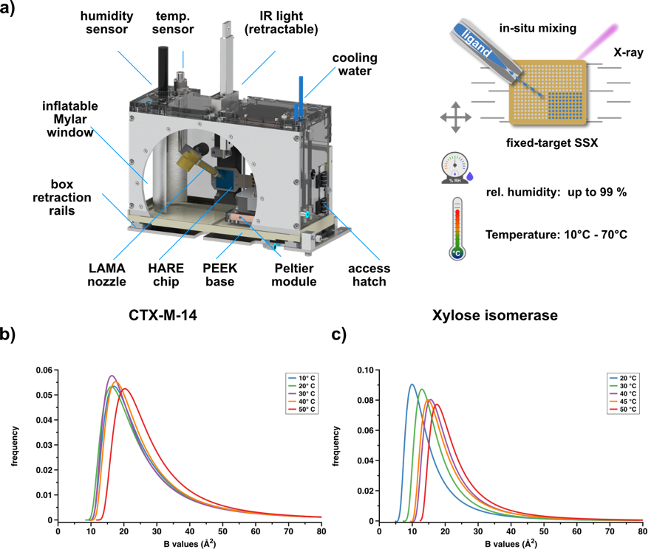

**Figure 1:** The environmental control box enables recording multi-temperature serial crystallography data. a) The environmental control box, the portal translation for the LAMA nozzleis hidden for clarity (further details in the supplementary material). b,c) ADPs of CTX-M-14 and XI for models derived from data recorded at different temperatures, fitted to a shifted inverse gamma distribution.