# Organic cocrystal as a platform for simultaneous investigation of different high-pressure phenomena – a case study of 1,2-bis(4-pyridyl)ethane and diphenic acid cocrystal

## M. Kaźmierczak1, E. Patyk-Kaźmierczak1

### 1Faculty of Chemistry, Adam Mickiewicz University in Poznań, Uniwersytetu Poznańskiego 8, 61-614 Poznań, Poland

### ewapatyk@amu.edu.pl

High-pressure investigation of Brønsted-Lowry acid-base cocrystals built of simple organic molecules can provide valuable insights into the impact of compression on crystalline materials stabilized by strong hydrogen bonds. These systems serve as excellent models for studying pressure-induced modifications of hydrogen bonds [1], as well as proton transfer and cocrystal-to-salt transformations [2]. Recently, an acid-base cocrystal was even shown to exhibit exceptional negative linear compressibility (NLC) [3]. Studying such straightforward systems can facilitate a deeper understanding of the behavior of more complex systems with similar intermolecular interactions.

Herein, we introduce a new cocrystal composed of 1,2-bis(4-pyridyl)ethane (ETY) and diphenic acid (DIP), which was studied under high pressure. The coformers were carefully chosen to investigate two key aspects: pressure-induced proton transfer and the structure-property relationship underlying the crystals' compressibility. The bidentate nature of both the acid and base molecules makes it possible for two proton transfer reactions to take place, providing new data that can help establish the relationship between Δp*Ka* and the pressure required to induce proton transfer. Concurrently, the conformation of ETY has previously been shown to be largely unchanged by compression, a feature linked to significant NLC in its cocrystal with fumaric acid [3]. At the same time, the structure of DIP directs molecular aggregation via hydrogen bonds to form a zig-zag motif – a motif whose deformation can give rise to NLC, with DIP molecules acting as hinges.

In summary, we report the crystal structure of the ETY·DIP cocrystal (Fig. 1) under ambient conditions and reveal its high-pressure phase transitions. Moreover, we discuss the relationship between pressure-induced changes in the conformation of ETY and DIP and the compressibility of the ETY·DIP cocrystal, as well as changes in the protonation state of the coformers.

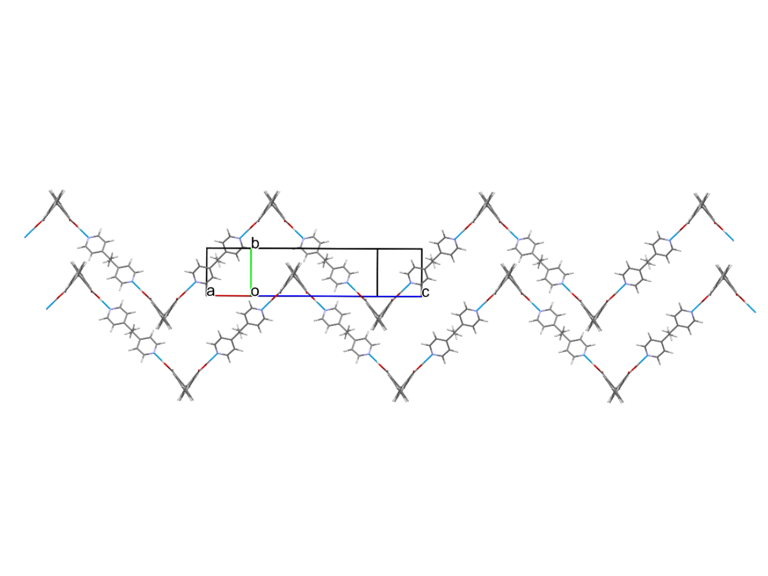

###### **Figure 1**. Fragment of the crystal structure of ETY·DIP at 0.1 MPa/298 K showing two H-bonded zig-zag chains.

#### [1] Ward, M. R., Bull, C. L., Funnell, N. P., Warren, M. R. & Oswald, I. D. H. (2023). *International Journal of Pharmaceutics* **647**, 123514.

#### [2] Patyk-Kaźmierczak, E., Izquierdo-Ruiz, F., Lobato, A., Kaźmierczak, M., Moszczyńska, I., Olejniczak, A. & Recio, J. M. (2024). *IUCrJ* **11**, 168–181.

#### [3] Patyk-Kaźmierczak, E. & Kaźmierczak, M. (2024). *Chem. Commun.* **60**, 10310–10313.

The funding from National Science Centre, Poland (grant No. UMO-2020/39/D/ST4/00260) is kindly acknowledged.