Convergence Study of a Gradient-Descent Algorithm for Bloch Amplitude Refinement Under the Kinematical Approximation

A. Chatziagapiou^{1,2} and K. Bethanis¹

¹Physics Laboratory, Biotechnology Department, Agricultural University of Athens, 75 Iera Odos, ²Department of Mathematics, Aegean College, Athens, 17 Panepistimiou Str.

kbeth@aua.gr
A novel algorithm, grounded in physical principles within the first-order Born approximation, is proposed as an initial step toward an ab initio solution for crystal structure determination using three-dimensional electron diffraction (3D-ED). The method aims to iteratively solve the phase problem formulated through the Schrödinger equation in reciprocal space [1, 2], updating the complex Bloch amplitudes - which encode experimental information in space group P1 - via C_{g} = (1/g²) Σ_{h} V_{g-h}C_{h} and reconstructing the electrostatic potential through V_{h} = (1/4πh²) Σ_{g} C_{g}C*_{g-h}. In the convergence mode, a gradient descent algorithm minimizes the functional M = |V_{h} - V_{h}^{exp}|² [3] to iteratively refine the moduli and phases of both the complex Bloch amplitudes and complex electrostatic potential (scheme 1). The phase-extension mode incorporates these updates to promote reflections to "reliable" status once their computed values sufficiently match the experimental data, thereby expanding the known phase set. The algorithm has been implemented in Python and its validity assessed through a convergence study (Fig. 1) applied to a dataset of histidine in space group P2₁2₁2₁, kindly provided by Prof. T. Gruene. All experimental values were normalized prior to analysis.
 | 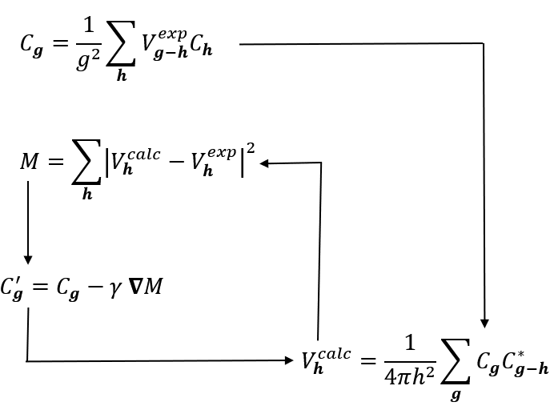 |  | Scheme 1: Algorithm flow chart
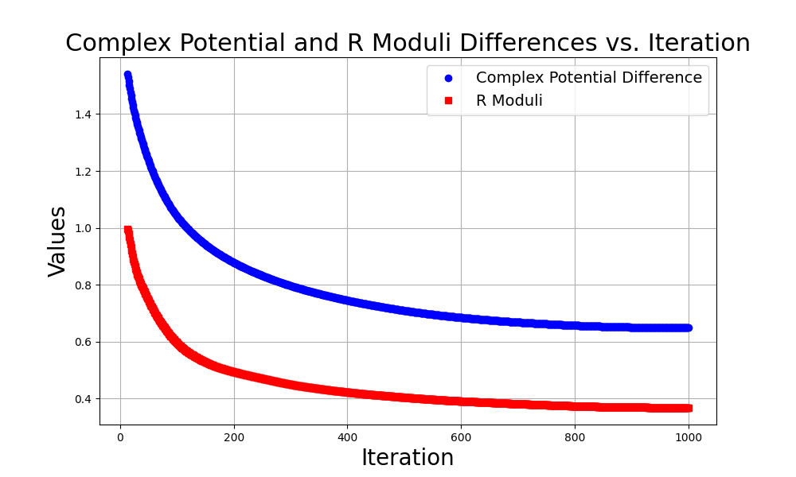 |  | 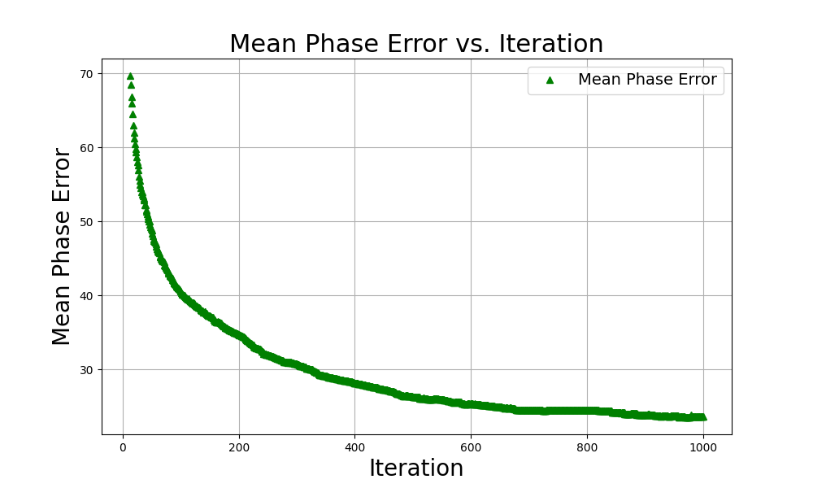

Figure 1. (Left) Convergence of R_{moduli}​ (red) and the differences between complex V^{calc}​ and V^{exp} (blue). (Right) Convergence of the mean error of the calculated phases. Correct phases are obtained after refinement with SHELXL.
[1] Bethanis, K., Tzamalis, P., Hountas, A. & Tsoucaris, G. (2008). Acta Cryst. A64, 450-458.
[2] Bethanis, K., Tzamalis, P., Hountas, A. & Tsoucaris, G. (2002). Acta Cryst. A58, 265-269.
[3] Hountas, A. & Tsoucaris, G. (1995). Acta Cryst. A51, 754-763.
The authors gratefully acknowledge Prof. T. Gruene for kindly providing the dataset.

