Host-Guest Chemistry of Helical Copper(I) Coordination Polymers

E. Ganczar¹, W. Bury¹, P. Gawryszewska¹, V. Kinzhybalo², A. Białońska¹

¹Faculty of Chemistry University of Wrocław, ul. Joliot-Curie 14, 50-383 Wrocław (Poland),
²Institute of Low Temperature and Structure Research, Polish Academy of Sciences, ul. Okólna 2, 50-422 Wrocław (Poland)

emilia.ganczar2@uwr.edu.pl
Compounds with the characteristic supramolecular structure of the host−guest type are found in the area of continuous interest of the scientific world. Such compounds are attractive in the context of their physicochemical and structural properties that can be properly designed and modified [1]. Due to the architectures of the host, the host-guest crystals can be divided into two main categories: molecular complexes where convex guests adjust to a concave host, and compounds in which the packing of the host leads to the formation of the empty spaces (channels or sheets) in which guest molecules may be deposited [2]. The presence of channels in the crystal structure is attractive in the context of the exchange of guest molecules, which is used in heterogeneous catalysis, selective molecular separation, gas storage or chemical sensors.
An interesting group of compounds are copper(I) coordination compounds with Schiff bases based on 4-amino-1,2,4-triazole. Reported previously copper(I) coordination compounds with N-[(E)-(4-chlorobenzylidene)-4H-1,2,4-triazol-4-amine (4ClPhtrz) and N-[(E)-(4-bromobenzylidene)-4H-1,2,4-triazol-4-amine (4BrPhtrz) have the ability to breathe. Their structure is built up of cationic X-shaped units self-assembled in a way allowing the formation of characteristic 1D channels occupied by solvent molecules (Fig.1a). Desolvation of the system leads to considerable reversible reorganization of its structure [3-4]. It turns out that the substitution of a halogen atom at the para- position of the phenyl ring of such Schiff bases is crucial for the formation of these characteristic architectures able to breathe. The introduction of an additional halogen atom at the meta- position promotes the formation of a one-dimensional coordination polymer (Fig. 1b). Changing the structural properties of such systems results in changes in their properties. The coordination polymer exhibits a very rare helicity, in which the metal ions are arranged in a helical pattern. Self-recognition of the neighbouring polymeric chains leads to the formation of one-dimensional channels occupied by solvent molecules, which can be easily removed by thermal treatment without violating the host framework, resulting in the formation of a porous material that reveals its ability to capture CO₂ and small organic molecules. The discussed copper(I) coordination polymers also exhibit deep-red emission at 77 K, which is not so common for copper(I) compounds. On the poster, the structural, sorption and spectroscopic properties of helical polymers built up from copper(I) salts and N-[(E)-(3,4-dichlorobenzylidene)-4H-1,2,4-triazol-4-amine (34dClPhtrz) ligand will be presented.
 | 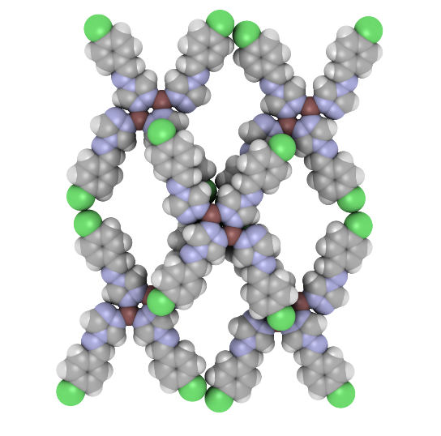 |  | 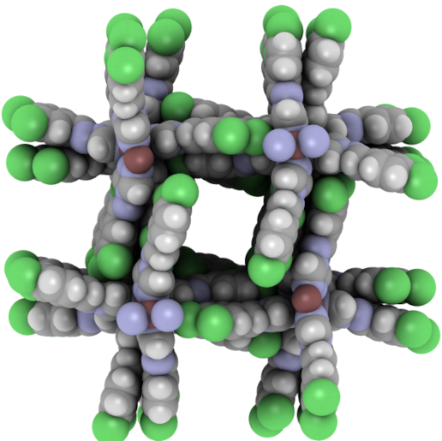
 | a) |  | b)
Figure 1. a) Discrete copper(I) coordination system built up from monohalogenated triazole Shiff base; b) the copper(I) helical one-dimensional polymer built up from dihalogenated triazole Shiff base. [A – anion (CF₃SO₃, ClO₄, BF₄)].
[1] Steed, J. W. & Atwood, J. L. (2022). Supramolecular Chemistry, pp. 537. John Wiley & Sons.
[2] Cram, D. J. & Cram, J. M. (1997) Container molecules and their guests, pp.1-12. R. Soc. Chem.
[3] Białońska, A., Drabent, K., Filipowicz & Siczek, M. (2013). CrystEngComm, 15, 9859.
[4] Ganczar, E. & Białońska, A. (2023). Acta Cryst. B79, 392.

