X-ray based multi-modalities to understand complex (nano)material systems with applications in biomedicine

D. Stefanita^{1,2}, L. Krupnik^{1,2}, R. Zboray^{1,3}, B. Silva¹, A. Neels^{1,2}

¹Empa - Swiss Federal Laboratories for Materials Science and Technology, Dübendorf, Switzerland

²Department of Chemistry, University of Fribourg, Fribourg, Switzerland

³ARTORG Center, University of Bern, Bern, Switzerland

antonia.neels@empa.ch
In multidisciplinary research, the development of new models for X-ray tools holds potential in application areas such as materials and life sciences. Bridging the different worlds of X-ray diffraction, scattering and imaging overcomes gaps between methods, allowing a holistic approach [1-4]. The combination of 3D morphological and structural understanding of materials is key to the discovery of mechanisms taking place in complex systems. Functionalized (nano)materials and their interaction with body fluids or human tissue triggered our attention to the systematic study of materials-bio interactions.
Today, applications of (nano)particles in medicine are increasingly important. However, when particle systems are transferred to a biological environment, their interactions become complex and are not yet fully understood. We investigate biomedically relevant systems having in mind that only materials system understanding will enable us to steer and to enhance functionalities, and at the end will maximize medical outcome and the benefit for patients. We will illustrate our holistic approach by showing two representative examples: 1) the interactions of antibiotics with the CaSO₄ support structure in local antibiotic treatment in bone and joint infections, and 2) the monitoring of nanoparticle interactions with their biologically relevant environment [5-7] (Fig. 1).
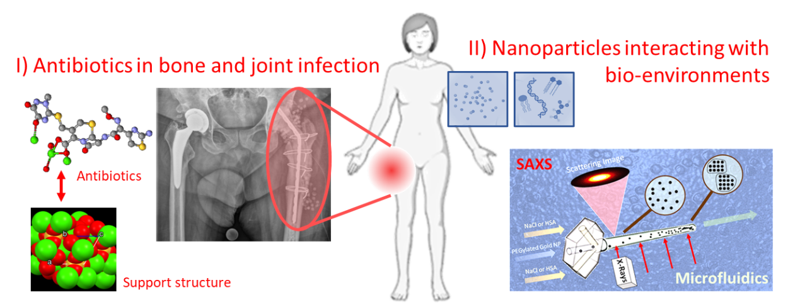
Figure 1: Materials science in biomedicine. I (left): study of interactions of antibiotics with the CaSO₄ support structure used in local antibiotic treatment in bone and joint infections, and II (right): study of nanoparticle interactions with their biologically relevant environment.

[1] Saghamanesh, S., Richter, H., Neels, A., Zboray, R. (2022). Appl. Sci., Special Issue 'X-ray Medical and Biological Imaging', 12, 3798.
[2] Saghamanesh, S., Dimitriu LaGrange, D., Reymond, P., Wanke, I., Lövblad, K. O., Neels, A., Zboray, R. (2022). Scientific Reports, 12, 2778.
[3] Maurya, A. K., Parrilli, A., Kochetkova, T., Schwiedrzik, J., Dommann, A., Neels, A. (2021). Acta Biomaterialia, 169.
[4] Schönweger, F., Sprecher, C. M., Milz, S., Dommann-Scherrer, C., Meier, C., Dommann, A., Neels, A., Wahl, P. (2020). Materials, 13, 4713.
[5] Iranpour Anaraki, N., Liebi, M., Ong, Q., Blanchet, C., Maurya, A.K., Stellacci, F., Salentinig, S., Wick, P. & Neels, A. (2022). Adv. Funct. Materials, 32, 2110253.
[6] Krupnik, L., Avaro, J., Liebi, M., Iranpour Anaraki, N., Kohlbrecher, J., Sologubenko, A., Handschin, S., Rzepiela, A.J., Appel, C., Totu, T., Blanchet, C.E., Barton Alston, A. E., Digigow, R., Philipp, E., Flühmann, B., Silva, B.F.B., Neels, A., & Wick, P. (2024). Journal of Controlled Release, 368, 566.
[7] Krupnik, L., Joshi, P., Kappler, A., Flühmann, B., Alston, Digigow, R., Wick, P. & Neels, A. (2023). European Journal of Pharmaceutical Sciences, 188, 106521.

