# Modulation and modularity in natural and synthetic sulfosalts

## B. Stöger1

### 1X-ray Center, TU Wien, Geitreidemarkt 9, 1060 Vienna, Austria

### bstoeger@mail.tuwien.ac.at

The sulfosalt group is a chemically heterogeneous family of sulfide (S2-) or, more rarely, selenide (Se2-) or telluride (Te2-) minerals [1]. Sulfosalts stand out for their *modular* character. Most sulfosalts can be derived from sheets or rods of PbS- (NaCl type) or SnS-like structures combined in various ways, leading to a surprisingly complex crystal chemistry and crystalliztion behavior. Many sulfosalts form domain structures, either by twinning or intergrowths of related structures. At the domain boundary are located modules shared by the adjacent domains. The symmetry of modular structures is described by *space groupoids* [2]. The choice of module may not be unique (Fig. 1).

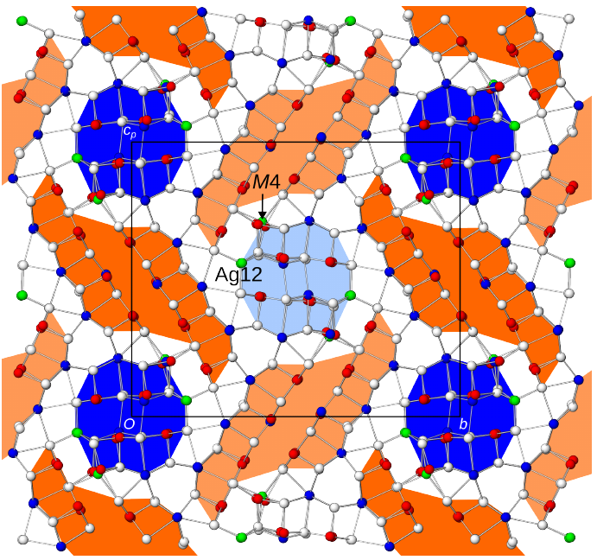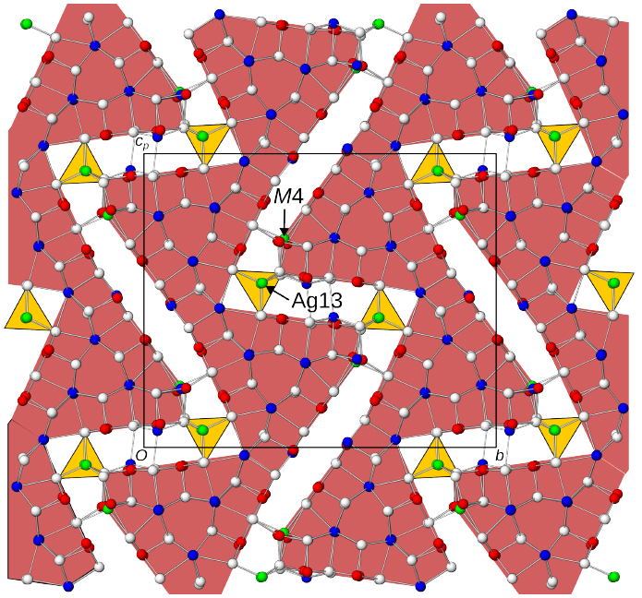

###### **Figure 1**. Two distinct module choices in proto-owyheeite, emphasizing (left) crystal chemistry and (right) twinning.

Moreover, sulfosalts typically are commensurately or incommensurately *modulated* (positionally and occupationally) (Fig. 2), leading to challenging refinements. Both, modularity and modulation represent generalizations of classical space group symmetry. Recent examples of natural and synthetic sulfosalts are discussed to demonstrate the complexities and interplay of both phenomena.

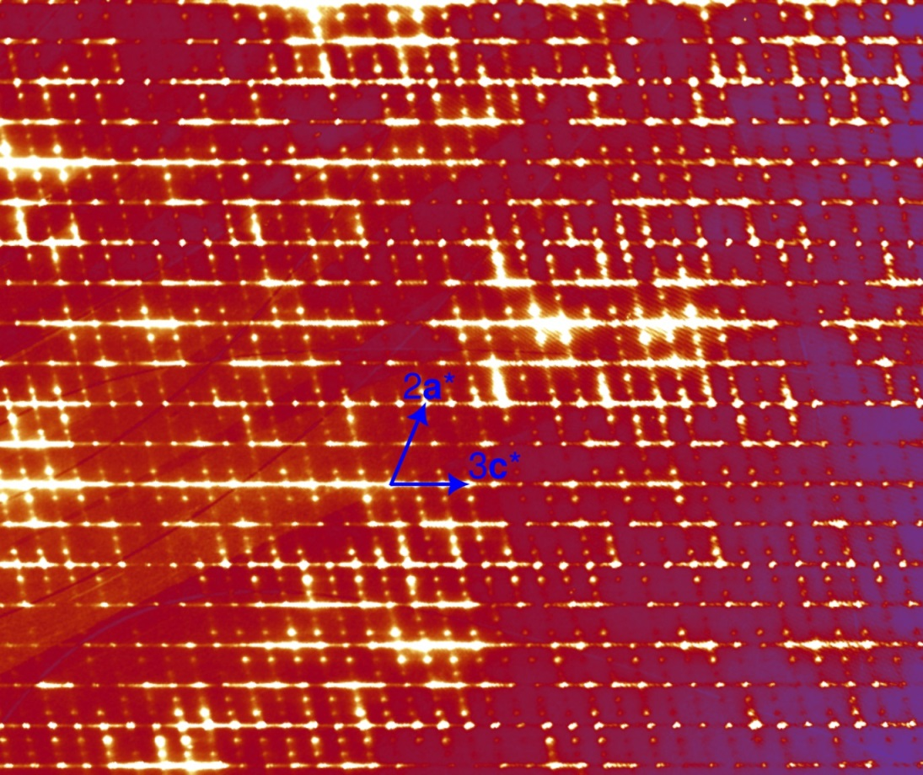

###### **Figure 2**. *h* = 4 plane of natural johnjamborite (ideal formula Pb112Sb68As60S304) showing threefold superstructure reflections. The commensurate modulation wave vector is **q** = ⅓**a**\*−⅓**b**\*.

#### [1] Moëlo Y., *et al.* (2008). *Eur. J. Min.* **20**, 7.

#### [2] Ito, T.-i., & Sadanaga, R. (1976). *Proc. Japan Acad.*, **52**, 119.