Enhancing Crystal Detection for SerialED on Lacey Grids

A. Vypritskaia¹, T. Yang¹, X. Zou¹

¹Department of Chemistry, Stockholm University, Sweden

angelina.vypritskaia@su.se
Automating crystal detection is key to scaling up electron diffraction (ED) experiments, especially for beam-sensitive samples like MOFs and pharmaceuticals. While threshold-based detection methods [1, 2] work on uniform TEM grids, they often fail on lacey carbon due to its complex, irregular background—randomly shaped pores and varying contrast make it difficult to reliably find crystals.
To address this, we developed a neural network-based approach that learns to recognize and remove the lacey carbon background from TEM images. By subtracting the grid pattern before applying thresholding, the method significantly improves crystal identification. This not only enhances accuracy but also reduces unnecessary data collection and shrinks overall file sizes.
Integrated into a SerialED pipeline, our approach enables faster, more targeted, and more reliable screening of nanocrystals. It supports higher data quality and throughput, while minimizing beam exposure and manual intervention. This development is a step toward fully automated, high-throughput structure determination of complex and heterogeneous crystalline samples.

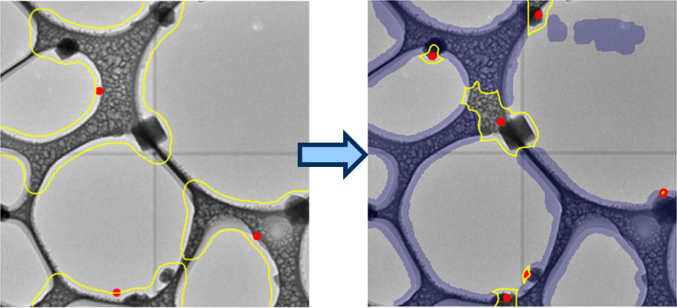

Figure 1. Crystal identification on a lacey carbon grid covered with ice, using thresholding without (left) and with (right) prior background removal. Yellow outlines indicate detected crystal boundaries, red dots mark supposed crystal centers, and blue regions highlight the identified carbon grid.

[1] Smeets, S., Zou, X. & Wan, W. (2018). J. Appl. Crystallogr. 51, 1262.

[2] Bücker, R., Hogan-Lamarre, P., Mehrabi, P., Schulz, E.C., Bultema, L.A., Gevorkov, Y., Brehm, W., Yefanov, O., Oberthür D., Kassier, G.H. & Dwayne Miller, R.J. (2020). Nat. Commun. 11, 996.
This research is supported by EU Horizon 2020 MSCA project NanED (No 956099), the Swedish Research Council (VR) and Knut and Alice Wallenberg Foundation (KAW).

