# Towards quantitative evaluation of grazing incidence X-ray diffraction data

## F. Gasser1, S. John1, J. Smets2, J. Simbrunner3, M. Fratschko1, R. Ameloot2, H.-G. Steinrück4,5, R. Resel1

### 1Institute of Solid State Physics, Graz University of Technology, Petersgasse 16, 8010 Graz, Austria, 2Center of Membrane Separations, Adsorption, Catalysis and Spectroscopy (cMAXS), KU Leuven, Celestijnenlaan 200f, 3001 Leuven, Belgium, 3Department of Neuroradiology, Vascular and Interventional Radiology, Medical University Graz, Auenbruggerplatz 9, 8036 Graz, Austria, 4Institute for a Sustainable Hydrogen Economy (INW), Forschungszentrum Jülich GmbH, Marie-Curie-Straße 5, 52428 Jülich, Germany, 5Institute of Physical Chemistry, RWTH Aachen University, Landoltweg 2, 52074 Aachen, Germany

### fabian.gasser@tugraz.at

Grazing incidence X-ray diffraction (GIXD) is widely used for the structural characterisation of thin films, particularly for analysing the phase composition and the orientation distribution of crystallites [1]. While qualitative evaluation tools are well established [2], a widely applicable and systematic procedure for extracting quantitative information has not yet been developed.

As a first step towards such a methodology, we present an approach that enables accurate quantitative analysis through the evaluation of radial line profiles extracted from GIXD measurements. To ensure the reliability of the extracted intensities, correction factors were derived for state-of-the-art GIXD setups accounting for the polarisation of the incident beam, solid angle variations, absorption effects, the transmission coefficient, and the Lorentz correction. The corrections were validated by measuring GIXD patterns of model systems, including powders and uniplanar thin films as well as single crystals. Integrated intensities were extracted and compared with calculated structure factors of the corresponding compounds, confirming the accuracy of the derived correction factors [3].

Building on this foundation, quantitative analysis of measured GIXD data was performed for a variety of samples. An algorithm was developed to compute radial line profiles based on known crystal structures. By fitting the calculated line profiles to the experimental data extracted from GIXD measurements, precise quantitative information on orientation distribution and phase composition was obtained, along with additional parameters such as mosaicity and total crystal volume. The method was demonstrated on several thin film systems, including ZIF-8 thin films [4] comprising both unoriented and preferentially oriented crystallites as shown in Fig. 1, anthraquinone thin films exhibiting three distinct preferential orientations, and binaphthalene thin films composed of two coexisting phases with differing orientation distributions.

Overall, this work provides a systematic and broadly applicable framework for extracting quantitative information from GIXD data [5]. Moreover, the derived intensity correction factors offer significant potential for improving crystal structure solutions from thin films.

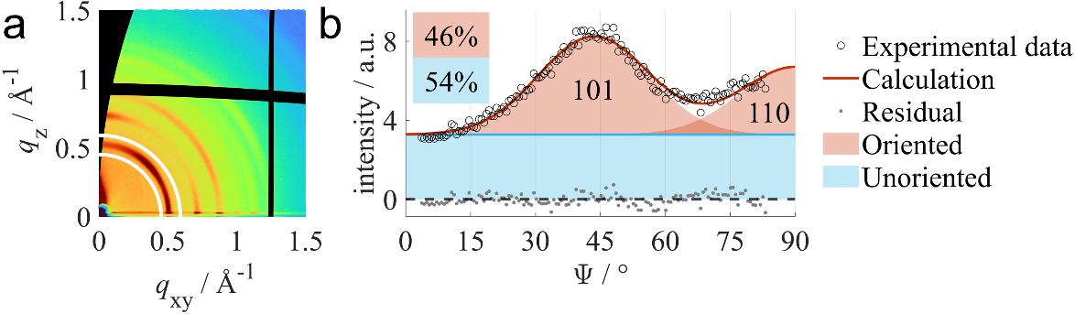

###### **Figure 1**. (a) Measured GIXD pattern of a ZIF-8 thin film and (b) extracted radial line profile from the data within the solid white lines. The data was fitted assuming a thin film consisting of unoriented (blue) and preferentially oriented crystallites (red).

#### [1] Werzer, O., Kowarik, S., Gasser, F., Jiang, Z., Strzalka, J., Nicklin, C. & Resel, R. (2024). Nat. Rev. Methods Primers, 4, 1–20.

#### [2] Schrode, B., Pachmajer, S., Dohr, M., Röthel, C., Domke, J., Fritz, T., Resel, R. & Werzer, O. (2019). J Appl Cryst 52, 683–689.

#### [3] Gasser, F., Simbrunner, J., Huck, M., Moser, A., Steinrück, H.-G. & Resel, R. (2025). J. Appl. Cryst., 58, 96–106.

#### [4] Smets, J., Rubio-Giménez, V., Gándara-Loe, J., Adriaenssens, J., Fratschko, M., Gasser, F., Resel, R., Brady-Boyd, A., Ninakanti, R., De Feyter, S., Armini, S. & Ameloot, R. (2025). Chem. Mater. 37, 400–406.

#### [5] Gasser, F., John, S., Smets, J., Simbrunner, J., Fratschko, M., Rubio-Giménez, V., Ameloot, R., Steinrück, H.-G. & Resel, R. (2025). J. Appl. Cryst., arXiv:2503.20625.

We acknowledge Elettra Sincrotrone Trieste for providing access to its synchrotron radiation facilities and we thank Luisa Barba and Giorgio Bais for assistance in using bemline XRD1.