# Hydrogen bond donating large pore MOFs for catalysis

## Christophe M.L. Vande Velde1, Leili Esrafili-Dizaji1

### 1University of Antwerp, Faculty of Applied Engineering, Dept. of Biochemical and Chemical Technology, iPRACS, Groenenborgerlaan 171, 2020 Antwerp, Belgium

### christophe.vandevelde@uantwerpen.be

In the quest for reusable active heterogeneous hydrogen-bond donating organocatalysts that are well-characterizable [1-3], we have prepared a multitude of large pore MOFs based on ditopic, tritopic and tetratopic urea and squaramide linkers (Fig. 1). We are presenting here the structures of some of the more interesting examples, as well as preliminary catalytic test data from a Friedel Crafts alkylation of indole with between beta-nitrostyrene (Fig.2).

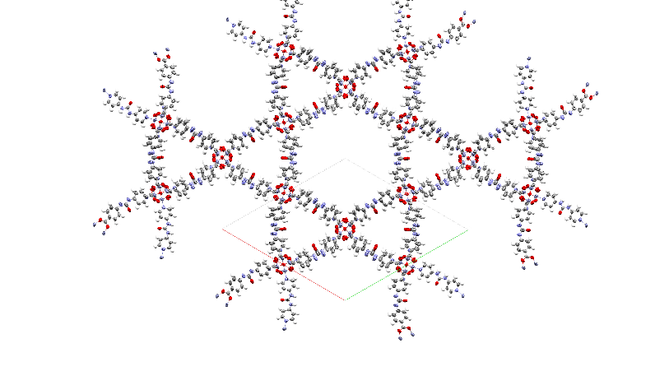

**Figure 1**. Mixed urea-squaramide UA-157 and UA-143, and hexagonal channel-type urea-based UA-3

**Figure 2**. Catalytic data on Friedel-Crafts test reaction with UA-3 as a catalyst

[1] X. Zhang, Z. Zhang, J. Boissonnault, S.M. Cohen. (2016) *Chem. Commun.*, **52**, 8585-8588

[2] C.M. McGuirk, M.J. Katz, C.L. Stern, A.A. Serejant, J.T. Hupp, O.K. Farha, C.A. Mirkin*(*2015) *J. Am. Chem. Soc.***137**, 2, 919–925

[3] L.Esrafili, O. Cheung, P. Adriaensens, E. Dervaux, L.T. Galsby, P.Z. Moghadam, C.M.L. Vande Velde, (2025) RSC Advances, submitted

The authors thank the FWO Vlaanderen for the postdoctoral mandate of LE and the funding for the diffractometer via project I012324N.