# Azolate Coordination Networks for Adsorptive Purification of Light Hydrocarbons

## S. Mukherjee1

### 1Department of Chemical Sciences, Bernal Institute and Research Ireland Centre for Pharmaceuticals (SSPC), University of Limerick, Limerick V94 T9PX, Ireland

### Email: [Soumya.Mukherjee@ul.ie](mailto:Soumya.Mukherjee@ul.ie)

State-of-the-art for commodity purifications, *e.g.*, cleaning commodity chemicals, air, and water is highly energy-intensive. Traditional physisorbents, including zeolites, and >100,000 metal-organic frameworks (MOFs, composed of organic ligands) can reduce this energy footprint, but are limited by cost, performance and/or stability issues.[1] To address this, our group is developing a new class of energy-efficient azolate coordination networks that feature “*the best of both Worlds*”: A) inorganic ligands and azolates-derived hybrid compositions that offer electrostatically strong binding sites for gas sorbates like carbon dioxide and light hydrocarbons (*e.g.*, acetylene, propyne); B) ultramicropores, *i.e.*, narrow pore sizes < 0.7 nm, ideal for tightly binding to the foregoing sorbates of relevance.[2] Amenability to bottom-up design approaches along both aspects, following the first principles of crystal engineering is poised to deliver (and control) several high-volume gas/water purifications.[3] In this context, we have developed an isostructural family of four previously unreported azolate coordination networks, ACNs,[4] and examined their CO2 and C2H2 affinities through gas adsorption studies. Built from a tetrazole-pyridyl ligand, M'F62- (M' = Si, Ge, Ti, and Zr) anionic pillars, and Cu(II), these three-dimensional (3D) ***pcu*** topology ACNs demonstrate transient porosity.[5, 6] Despite the absence of guest-accessible channels along their structures, the activated ACNs exhibit A) clear temperature-independent microporosity to CO2; B) temperature-dependent microporosity to C2H2 (only under ambient conditions, but not under cryogenic conditions). The latter anomalous sorption trend for C2H2, alongside the rare example of transient porosity renders this case study an ideal potential blueprint to design temperature-regulated transiently porous and/or nonporous sorbent analogues of the future, by simply tweaking their compositions at will. On top of this, ongoing solid-state 13C CP/MAS NMR results and molecular dynamics calculations have complemented our findings thus far. Further, three new families of ACNs were developed from an azole-pyridyl mixed series of ligands: an imidazole, a triazole, and a tetrazole, a series along which nitrogen atoms were purposely increased one at a time. Whereas our in-house Cambridge structural database (CSD) survey suggests all three ligands are new,[7] all the resulting 3D ACNs exhibited high efficiency in light hydrocarbon separations, such as in C3H4/C3H6, C3H6/C3H8 and C3H6/C2H4 respectively. Thanks to the isoreticular ACN platform, light hydrocarbon separation performances were further optimised by modulating pore chemistry through anion variation. To this end, substitution of methyl (CH3) and fluorine (F) functionalities near the coordinating metal centres was found to directly control the ACNs’ dimensionality, affording 1D and 0D structures, respectively. Whereas the findings establish azole-pyridyl ligands' versatility in the crystal engineering of coordination networks, the foregoing examples entail a profound control of sorption properties stemming from direct control of their structures. This, in essence, underpins the vision of modern crystal engineering: controlling the functions by leveraging the control over forms.[2, 8]

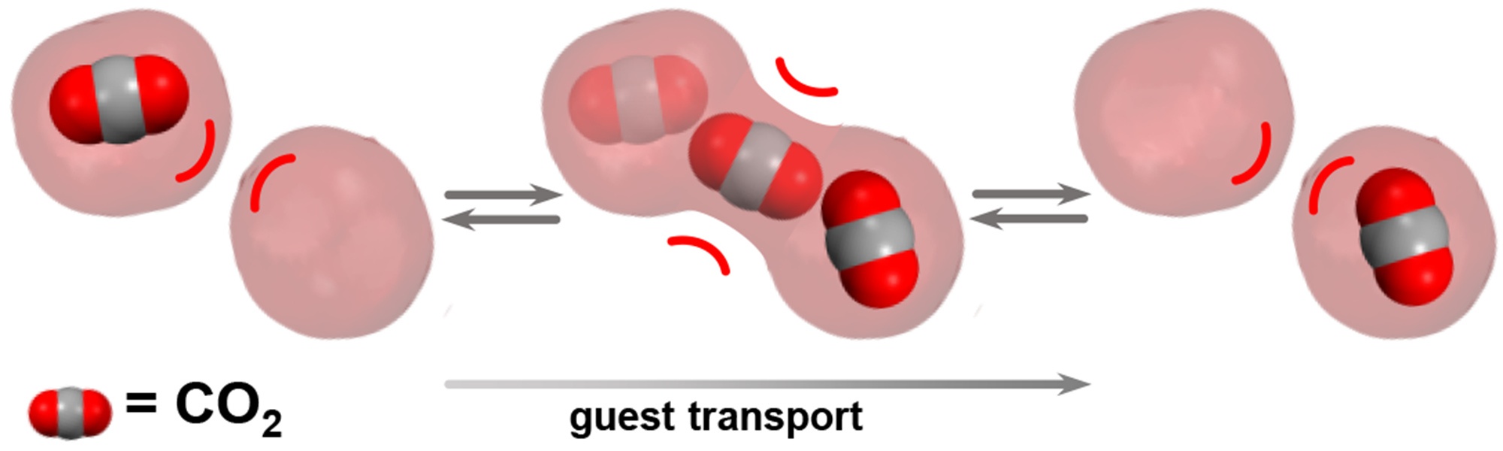

**Figure 1**. Porosity “*without pores*”: we uncover a crystal engineering strategy with potential to enable the design of transient porosity in an array of underexplored coordination networks.[3]

[1] Barsoum, M.L., et al., *The Road Ahead for Metal–Organic Frameworks: Current Landscape, Challenges and Future Prospects.* ACS Nano, 2025. **19**(1): p. 13-20.

[2] Mukherjee, S. and M.J. Zaworotko, *Crystal Engineering of Hybrid Coordination Networks: From Form to Function.* Trends Chem., 2020. **2**(6): p. 506-518.

[3] Braga, D., *Crystal engineering: from promise to delivery.* Chem. Commun., 2023. **59**(95): p. 14052-14062.

[4] Zhang, J.-P., et al., *Metal Azolate Frameworks: From Crystal Engineering to Functional Materials.* Chem. Rev., 2012. **112**(2): p. 1001-1033.

[5] Koupepidou, K., et al., *A Needle in a Haystack: Transient Porosity in a Closed Pore Square Lattice Coordination Network.* Angew. Chem. Int. Ed., 2025. **64**(14): p. e202423521.

[6] van Heerden, D.P., et al., *High Pressure In Situ Single-Crystal X-Ray Diffraction Reveals Turnstile Linker Rotation Upon Room-Temperature Stepped Uptake of Alkanes.* Angew. Chem. Int. Ed., 2021. **60**(24): p. 13430-13435.

[7] Groom, C.R., et al., *The Cambridge Structural Database.* Acta Crystallogr. B, 2016. **72**(2): p. 171-179.

[8] Hollingsworth, M.D., *Crystal Engineering: from Structure to Function.* Science, 2002. **295**(5564): p. 2410-2413.

Research Ireland award 21/PATH-S/9454, and SSPC Research Funding Award AzAds are acknowledged.