# Engineering Thermochromism in Low-Dimensional Perovskites through Halogen Bonding

## G. Cavallo, A. Stergiou, P. Metrangolo

### SupraBioNanoLab, Department of Chemistry, Materials, and Chemical Engineering “Giulio Natta”, Politecnico di Milano, via Luigi Mancinelli 7, 20131 Milan, Italy

### gabriella.cavallo@polimi.it

In recent years halogen bonding (XB) - the attractive interaction involving halogen atoms as electrophilic sites - has found widespread applications in materials science and crystal engineering. Its unique features, *-* namely directionality, tunability, hydrophobicity, and donor atom size - have enabled the design of sophisticated supramolecular functional systems for a wide range of applications.[1] In particular, its intrinsic reversibility has made the XB a new platform for the development of multi-stimuli responsive materials.

More recently, XB has also entered the field of hybrid organic inorganic halide perovskites (HOIHPs), where it has proven to be especially useful in controlling molecular packing and crystallization, improving stability, and reducing surface trap states. [2,3] The rich halogen chemistry of HOIHP semiconductors places XB-based strategies in the spotlight as a novel approach to suppress phase transitions in HOIHPs and obtain stable structures.[4] However, if properly controlled, these polymorphic transitions could also be leveraged in the design of new low-energy-input stimuli responsive materials, opening the way to a plethora of innovative applications

In this communication, a bimodal iodine-terminated alkylammonium cation has been studied as a supramolecular modulator of the crystalline organization of a 2D-HOIHP. Utilizing heat as an external stimulus a controlled and reversible single crystal-to-single-crystal phase transition was observed. [5] Controlling the conformation of the cation, the modulation of the interlayer XB formation was achieved. The new perovskite phase has discrete structural and photophysical properties, as evidenced by variable temperature investigation by single-crystal X-ray diffraction, solid-state NMR, UV-Vis and photoluminescence spectroscopies.

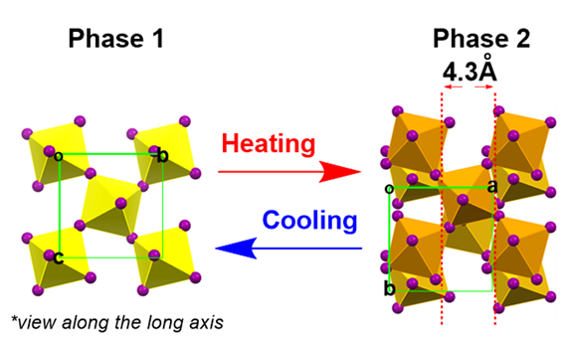

###### **Figure 1**. Reversible “sliding” of adjacent [PbI42-]∞ layers in 2D-HOIHP via tuning of the XB interactions under an external stimulus

#### [1] Cavallo, G., Metrangolo, P., Milani, R., Pilati, T., Priimagi, A., Resnati, G. & Terraneo, G. *Chem. Rev*. (2016), **116**, 2478.

#### [2] Metrangolo, P., Canil, L., Abate, A., Terraneo, G. & Cavallo, G. *Angew. Chem. Int. Ed.* (2022), **61**, e202114793.

#### [3] Ball, M. L., Milić, J. V. & Loo, Y.-L. *Chem. Mater*. (2022), **34**, 2495.

[4] Chakraborty, R., Sheikh, T. & Nag, A. *Chem. Mater.* (2022), **34**, 288.

#### [5] Stergiou, A., Metrangolo, P. & Cavallo, G. *Manuscript under revision.*

We acknowledge the financial support from the MUR, project SHINE (PRIN2022, no. 20225SYHXM).