## Gold supramolecular chemistry beyond aurophilic phenomenon: new and less known interactions

## E. Priola1, A. Giordana1, E. Diana1, M. Lopresti2, A. Frontera3, L. Operti1

### 1Università degli Studi di Torino, Department of Chemistry, Via Pietro Giuria 7, 10125 Torino, Italy 2Dipartimento di Scienze ed Innovazione Tecnologica, Università degli Studi del Piemonte Orientale “Amedeo Avogadro”, Italy 3Department of Chemistry, Universitat de les Illes Balears, Crta de Valldemossa km 7.5, 07122 Palma de Mallorca, Baleares

### emanuele.priola@unito.it

### To the end of twentieth century, gold supramolecular chemistry, especially in the solid state, but also in solution, has known a renewed interest.[1] The discovery of the powerful tool of the “aurophilic interaction”, for which gold cationic centers are attracted together, made possible a new word of possibilities of engineering crystal structures or supramolecular entities in solution.[2] This has been possible for the notable strength of this interaction: the attraction of charge-like entities is possible, as in the parallel case of hydrogen bond. The properties that aurophilicity- showing compounds can obtain are innumerable: the most studied is luminescence, but vapochromism and non-classical behaviour to pressure and temperature are other examples.[3]

Recently, a growing attention is focalized on other weak interactions that can be observed in the solid state chemistry of both gold(I) and gold(III) coordination complexes: the name assigned to this family of contact is regium bond or coinage bond.[4] These contacts involve linear (for gold(I)) or square planar (for gold(III)) complexes that attract nucleofilic sites like halogens or oxygen/nitrogen in the second sphere. The electrostatic nature of these interactions is clear from the charge density analysis, but also in this case it bis possible to observe charge like molecules that interacts. This presentation will show the last results in the identification and study of these peculiar interactions.

a)b)

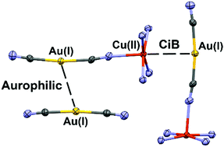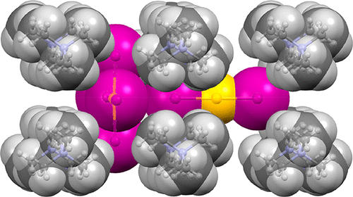

###### **Figure 1**. Examples of coinage bonding in differing systems.

[1] Schmidbaur, H., Schier, A. (2012) Chem. Soc. Rev., 41, 370.

[2] Katz, M. J., Sakai, K., Leznoff, D. B. (2008) Chem. Soc. Rev., 37, 1884

[3] Blake, A. J., Donamaría, R., Lippolis, V., López-de-Luzuriaga, J. M., Monge, M., Olmos, M. E., Seal, A., Weinstein, J. A. (2019). Inorg. Chem., 58, 8, 4954.

[4] Li, J., Feng, Q., Wang, C., Mo, Y. (2023) Phys. Chem. Chem. Phys., 25, 15371