# Crystallography beyond Independent Atom Model

## Krzysztof Woźniak1

### 1 Department of Chemistry, University of Warsaw, Pasteura 1, 02093 Warszawa, Poland kwozniak@chem.uw.edu.pl

### Traditional crystallography assumes atoms as non-interacting entities (spherical Independent Atom Model, IAM). Quantum crystallography replaces this with a quantum-mechanically derived electron density, which accounts for bonding and delocalization. One may say that modern Quantum Crystallography is an interdisciplinary field that combines the study of atomic and molecular structures in solids with quantum mechanics to obtain more accurate and detailed descriptions of electron densities and atomic positions and interactions in crystals. My simplified definition of Quantum Crystallography is given in the title of my lecture.

### In this lecture, I will present the main results in the field of quantum crystallography that we have obtained in our group over the last years. They will concern both experimental quantitative studies of electron density in minerals using multipole refinement combined with high pressure and, especially, the results of validation of Hirshfeld Atom Refinement (HAR).

### I will begin with presentation of examples of our early results on experimental charge density studies of grossular[1], langbeinite[2] and hsianghualite[3] under pressure and complement them by presenting our results of experimental charge density studies of phase transitions in calcite[4] and natrochalcite[5].

### Then we will switch over to validation of HAR by comparison of our results with the outcome of wast neutron and IAM X-ray studies performed for 70 compounds [6] for which structural and electron density results were deposited in CSD and will also show details of our studies on multiple crystals of hydrated -oxalic acid [7] and results of testing applicability of HAR to organic & metalorganic structures, MOFs &COFs.[8-10]. Next, will present our search for the best aspherical atom model aiming at understanding limitations of the model ( tests of HAR settings, alternative partitions, exponential HAR) [11-14].

Will finish off with our HAR and PDF results of studies of different polymorphs of H2O and D2O ices[14-18]. Using PDF analysis of neutron powder diffraction data and Reverse Monte Carlo (RMC) refinement, it is possible to determine individual positions of D2O molecules in a large box simulation of a “large box” of the crystal lattice. Will discuss some new structural effects in the crystal structures of ices.

 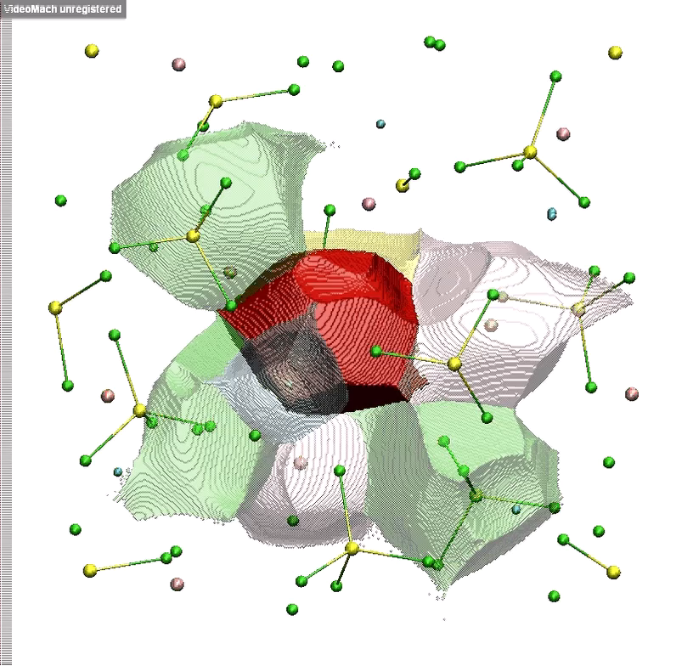 Obraz zawierający tekst, mapa, diagram, zrzut ekranu

Zawartość wygenerowana przez sztuczną inteligencję może być niepoprawna. 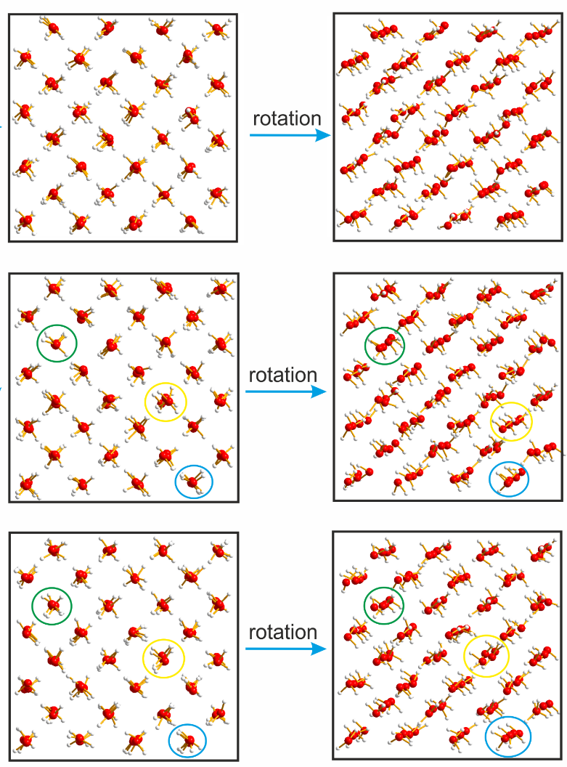

###### **Figure 1**. (From the left) Relocation of electron density at F1 ion in hsiangualite[3], atomic basins in the crystal lattice of langbeinite[2], evolution of H-bonding in natrochalcite[5], fragment of the unique, local structure of ice VII[18].

[1] Gajda et al., IUCR J, 7 (2020) 383-392 (IUCRJ Highlight)

[2] Gajda et al., IUCR J, 9 (2022) 146-162

[3] Stachowicz et al., Scie Reports, 13 (2023) 1609

[4] Stachowicz et al. Nature Geosciene (2025) submitted

[5] Rejnhardt et al. JACS (2025) submitted.

[6] Woińska et al., Science Adv, 2(5) (2016) e1600192

[7] Sanjuan-Szklarz et al.,IUCRJ,7(2020)920-933 (IUCRJ Highlight)

[8] Xu et al., Chem Comm, 59 (2023) 8799-8802 (Hot paper)

[9] Woińska et al., Chem Comm., 57 (2021) 3652-3655,

[10] Woinska et al. (2025) JACS submitted.

[11] Chodkiewicz et al., IUCRJ, 7(6) (2020) 1199-1215,

[12] Chodkiewicz et al., IUCRJ, 11(2) (2024) 249–259

[13] Chodkiewicz et al., IUCRJ, 9 (2022)298-315 (Highlight)

[14] Chodkiewicz, et al. IUCRJ, 12(1) (2025) 74-87

[15] Chodkiewicz et al., IUCRJ, 9 (2022) 573-579 (Highlight)

[16] Chodkiewicz et al., IUCRJ, 11(5) (2024) 730-736,

[17]Gajda et al., IUCRJ, 12(3) (2025) 288-294

[18] Sławiński et al., Nature Comm., (2025) submitted

This work is supported by the National Science Centre, Poland, through the OPUS 21 grant No. DEC-2021/41/B/ST4/03010 awarded to KW