## Hydrogen storage in hydrogen hydrates at high pressure

### **Tomasz Poręba1, Leon Andriambariarijaona 2, M. Rescigno1,3, R. Gaal1, Livia Bove1,2,3**

### 1 Laboratory for Quantum Magnetism, Institute of Physics, École Polytechnique Fédérale de Lausanne, CH-1015 Lausanne, Switzerland

### 2 Sorbonne Université, UMR CNRS 7590, Institut de Minéralogie, de Physique des Matériaux et de Cosmochimie, 75252 Paris, France

### 3 Dipartimento di Fisica, Università di Roma La Sapienza, 00185 Roma, Italy

### Email of communicating tomasz.poreba@epfl.ch)

Hydrogen hydrates are promising functional materials for clean energy storage and offer alternative to the current cryo-compressed hydrogen storage technology, insuring low production and operational costs, environmentally benign nature, and lower risk of flammability. Hydrogen hydrate clathrate sII phase transitions into to the so-called “filled ice” forms above 0.8 GPa. In filled ice, the water frame assumes one of the known ice phases, and hydrogen occupies definite positions in the ice channels. Up to ~3 GPa, five different phases have been reported (C-1, C0, C1, C1’, and C2 respectively), with increasing hydrogen-to-water ratio [1-2]. Recently, a new C3 phase with a hydrogen-to-water ratio of 2:1[2] forming above 40 GPa, upon laser heating (~1200 K), and being stable up to 90 GPa, has also been observed.

It has been shown that the C2-form of hydrogen hydrate (H2O·H2/ D2O·D2), which is constituted by an ice Ic skeleton, transforms into pure cubic ice Ic releasing molecular hydrogen upon decompression at 100 K [3]. However, the mechanism and kinetics of C2 hydrogen loss is not well-defined. It was suggested to progress through sample amorphization, though no evidence of an amorphous intermediate state was observed by neutron diffraction. We have recently determined, *via* high-pressure neutron powder diffraction experiments, that the unit cell volume of the C2 phase- produced in a Paris-Edinburgh (PE) cell at 3 GPa, and then recovered at ambient pressure and 78 K - continuously decreases upon heating above 100 K at ambient pressure. This indicates, at least partial, controlled hydrogen release without loss of crystallinity up to 130 K and the capability of C2 to store hydrogen up to 100 K at ambient pressure. Additionally, we present insights into structural deformation, phase boundaries, hydrogen content and mechanisms of formation of C2 under extreme pressure and/or low-temperature conditions. [4].

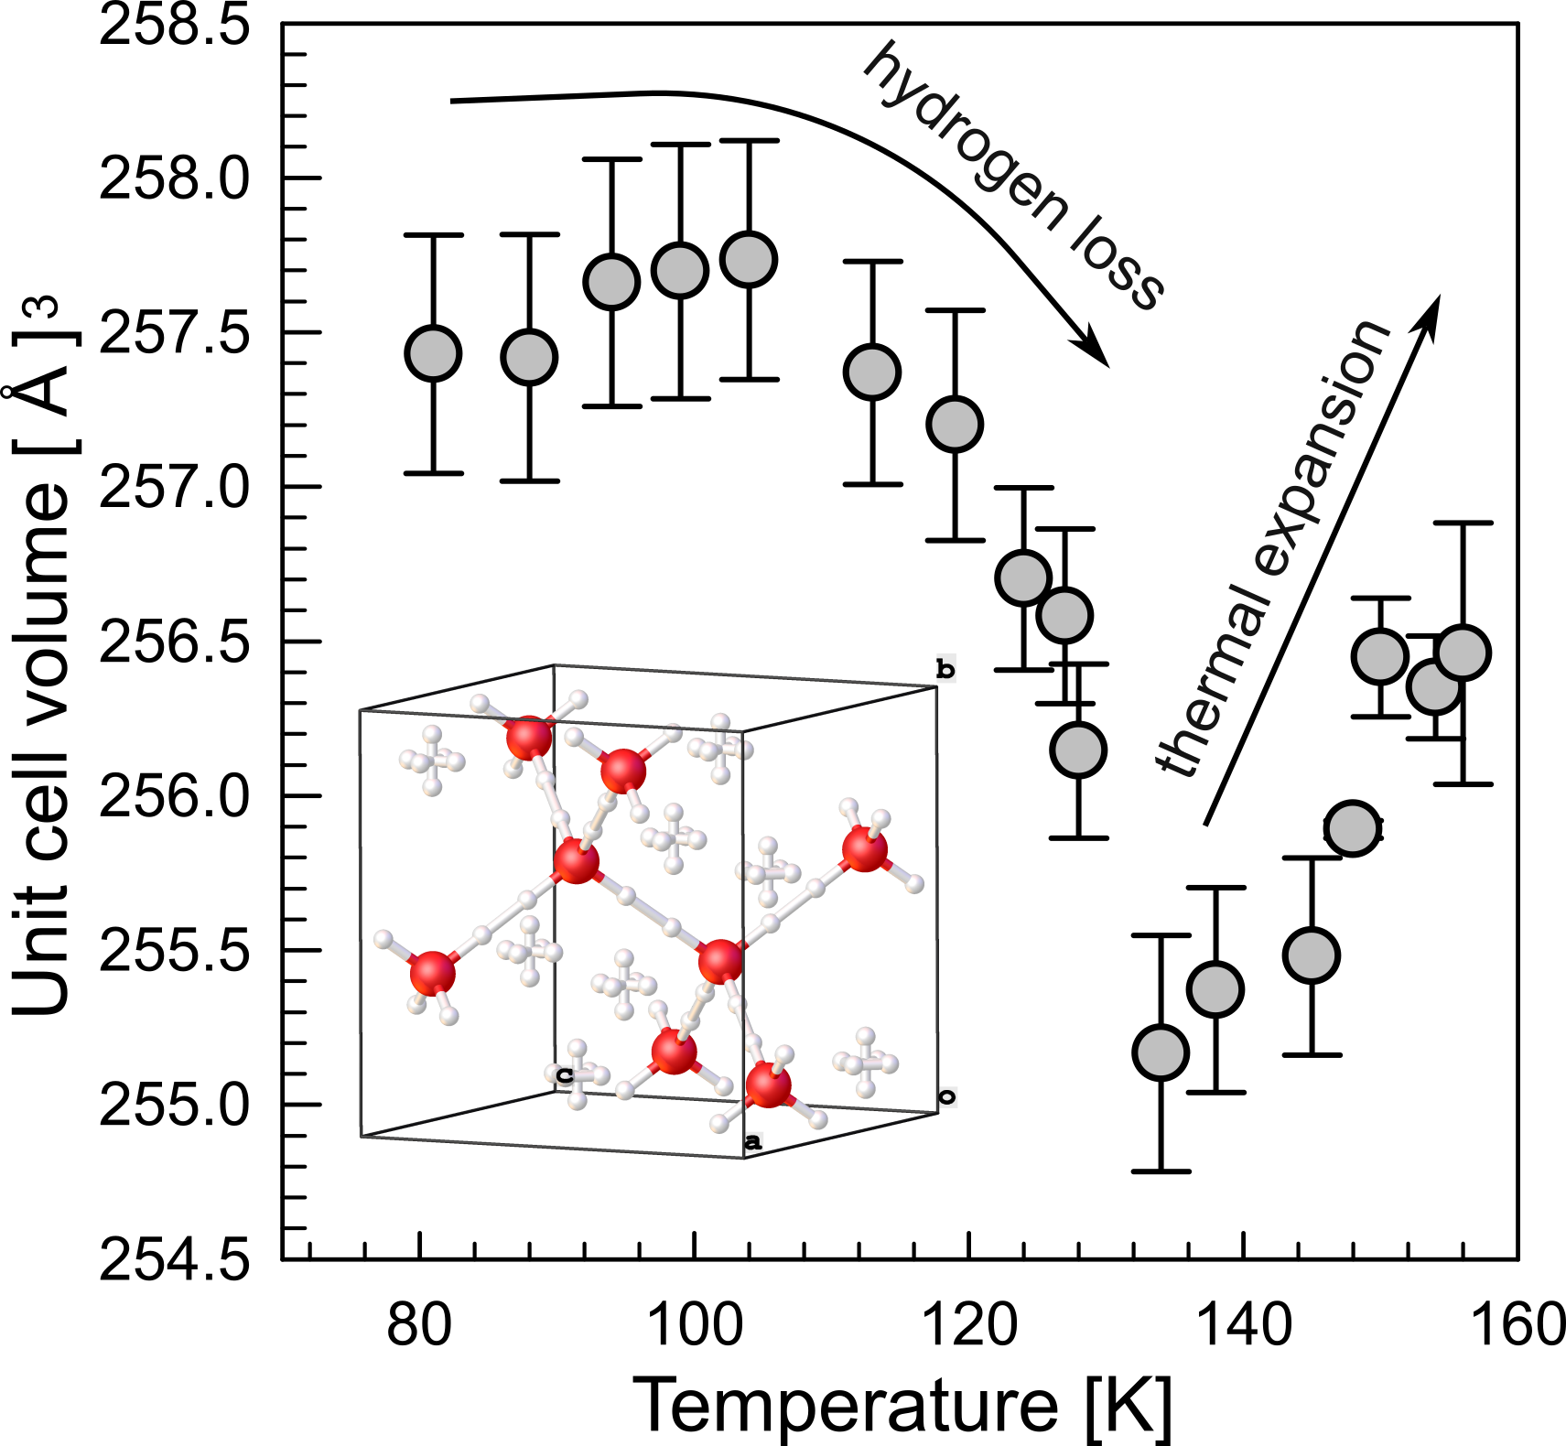

**Figure 1** Unit cell volume variation during thermal decomposition of C2 hydrogen hydrate tracked with neutron powder diffraction (D20 at ILL). Inset: contents of the unit cell of C2 (oxygen in red)

#### **[1] Ranieri, U. et al. PNAS, 120, 52 (2023).**

#### **[2] Hirai, H. et al. Prog Earth Planet Sci 10, 3 (2023)**

#### **[3] Komatsu, K., Machida, S., Noritake, F. et al. Nat Commun 11, 464 (2020)**

#### **[4] Poreba, T., Andriambariarijaona L., et al. in preparation (2024) .**