# Advanced cryo-trapping time-resolved crystallography: SPITROBOT-2 enables investigation of protein dynamics with millisecond time resolution

## M. Spiliopoulou1*, C.E. Hatton2, M. Kollewe3, J.P. Leimkohl3, H. Schikora3, F. Tellkamp3, P. Mehrabi2, E.C. Schulz1

### 1 Institute of Biochemistry and Signal Transduction, University Medical Center Hamburg-Eppendorf (UKE), 2 Institute for

### Nanostructure and Solid-State Physics, Universität Hamburg, HARBOR, Hamburg, Germany, 3 Max-Planck-Institute for Structure

### and Dynamics of Matter, Hamburg, Germany

### * m.spiliopoulou@uke.de

Time-resolved crystallography represents an optimal methodology to investigate the structure and dynamics of protein function, while in the context of enzymatic catalysis, it enables the direct visualization of transient intermediates along the reaction coordinate.   
However, it demands considerable resources and expertise. In contrast, cryo-trapping represents a more accessible alternative that can be employed to stabilize and characterize discrete enzymatic intermediates. While manual cryo-trapping is limited to relatively long delay times, the *SPITROBOT* crystal plunger enables semi-automated sample preparation with sub-second time resolution in a humidity and temperature-controlled environment [1]. When used in conjunction with liquid application method for time-resolved analyses (LAMA) techniques [2], it requires only minimal sample volumes for *in-situ* mixing based reaction initiation. Also, compliance with the SPINE standard allows for seamless integration into automated high-throughput workflows. *SPITROBOT-2* is now available as an integrated benchtop instrument with an accessible delay time of up to 23 ms. The present study demonstrates successful *SPITROBOT-2* cryo-trapping *via* ligand binding and conformational changes using three independent protein model systems: xylose isomerase (XI), human insulin (HI) and bacteriophage T4 lysozyme (T4L). Collectively, these improvements increase the convenient access to cryo-trapping time-resolved crystallography and thus providing efficient tools to advanced research in structural enzymology.

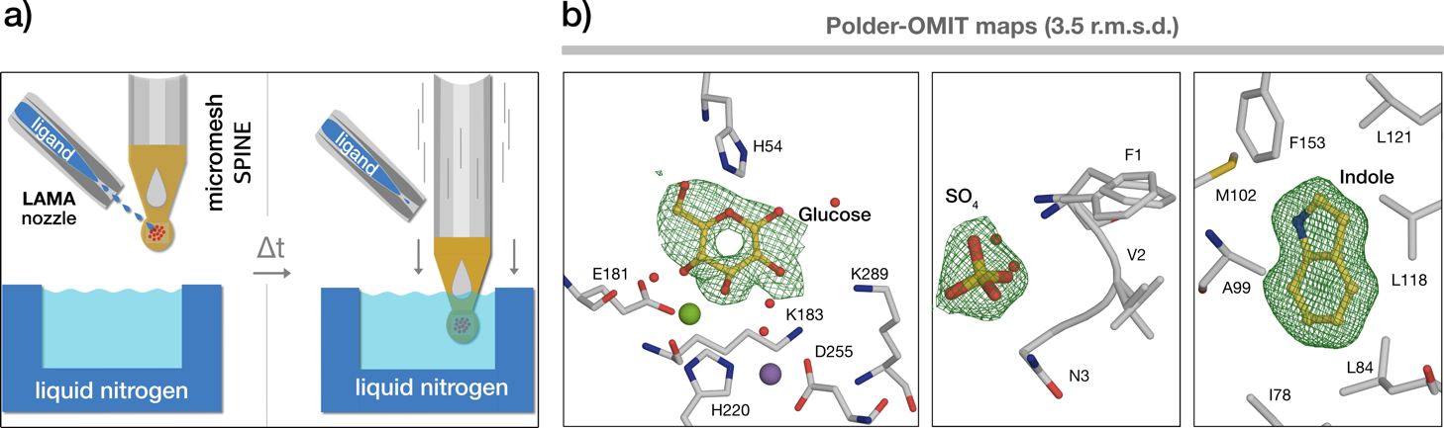

###### **Figure 1**. *SPITROBOT-2* cryo-trapping process and results: a) Crystals deposited on a micro-mesh are treated with the LAMA method for reaction initiation and plunge-frozen in liquid nitrogen after a defined delay time. b) Polder-OMIT maps for the binding events in three protein systems: XI, HI and T4L (from left to right) – *unpublished data*.

[1] Mehrabi, P., Schulz, E. C., Agthe, M., Horrell, S., Bourenkov, G., Von Stetten, D., Leimkohl, J.-P., Schikora, H., Schneider, T. R., Pearson, A. R., Tellkamp, F. & Miller, R. J. D. (2019). *Nat Methods* **16**, 979–982.

[2] Mehrabi, P., Sung, S., Von Stetten, D., Prester, A., Hatton, C. E., Kleine-Döpke, S., Berkes, A., Gore, G., Leimkohl, J.-P., Schikora, H., Kollewe, M., Rohde, H., Wilmanns, M., Tellkamp, F. & Schulz, E. C. (2023). *Nat Commun* **14**, 2365.